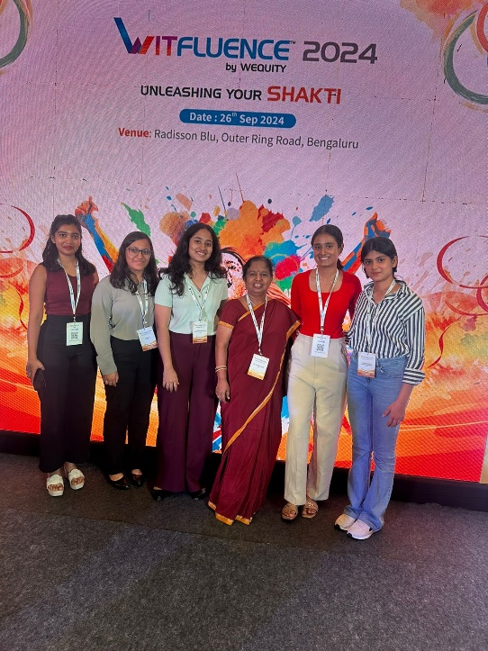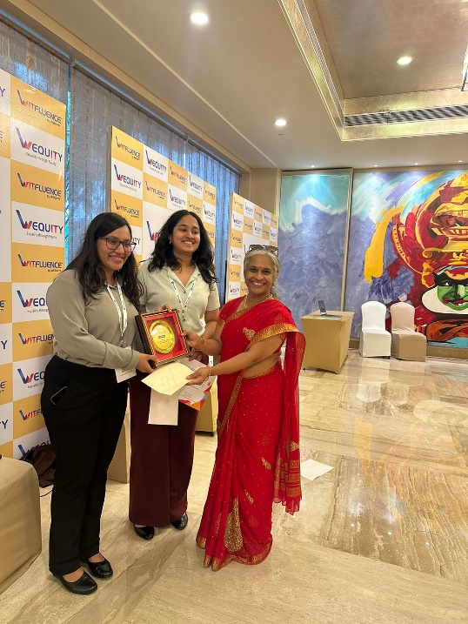

***WITFLUENCE Annual Conference held on 26th Sept 2024 at Radisson Blu, Bangalore. Team comprising of Lakshmi and Varuni, final year medical electronics students were honoured with a 3rd place award for Best Innovative Technology Model for their project of Yoga Pose Corrector at the live model showcase.***

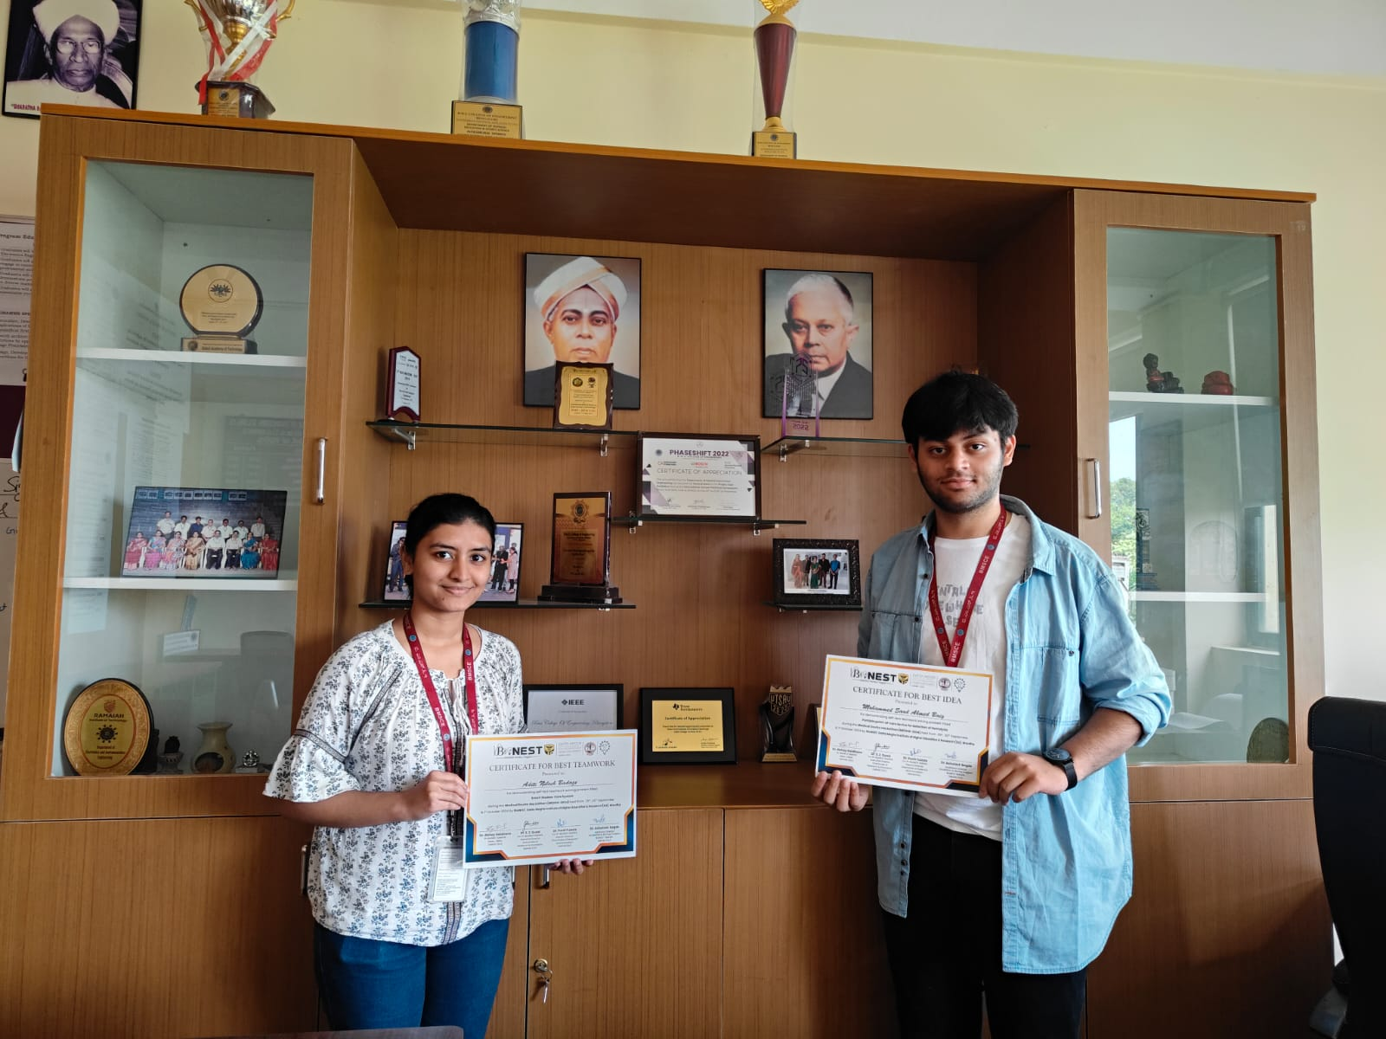

***Congratulations to Aditi Nilesh Badage & Mohammed Saad for the achievement in MEDHA 2024 hackathon***

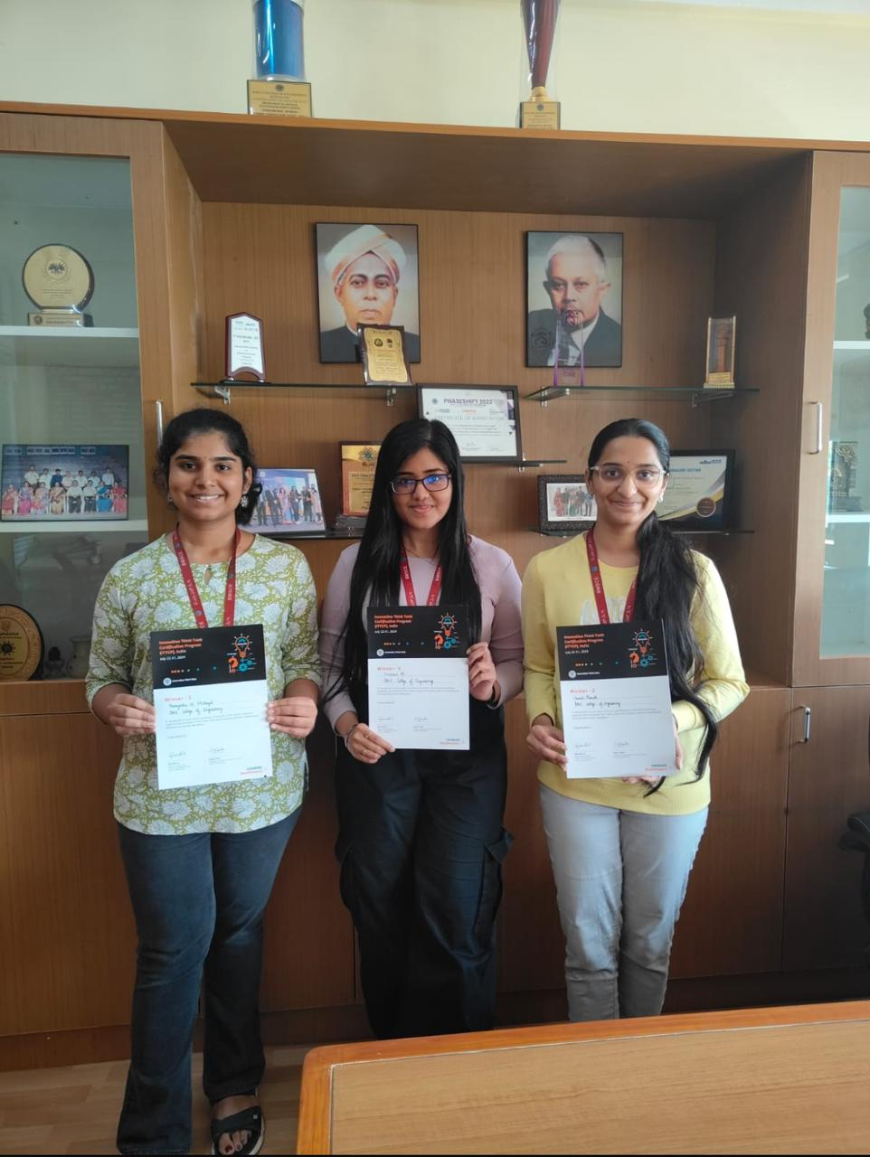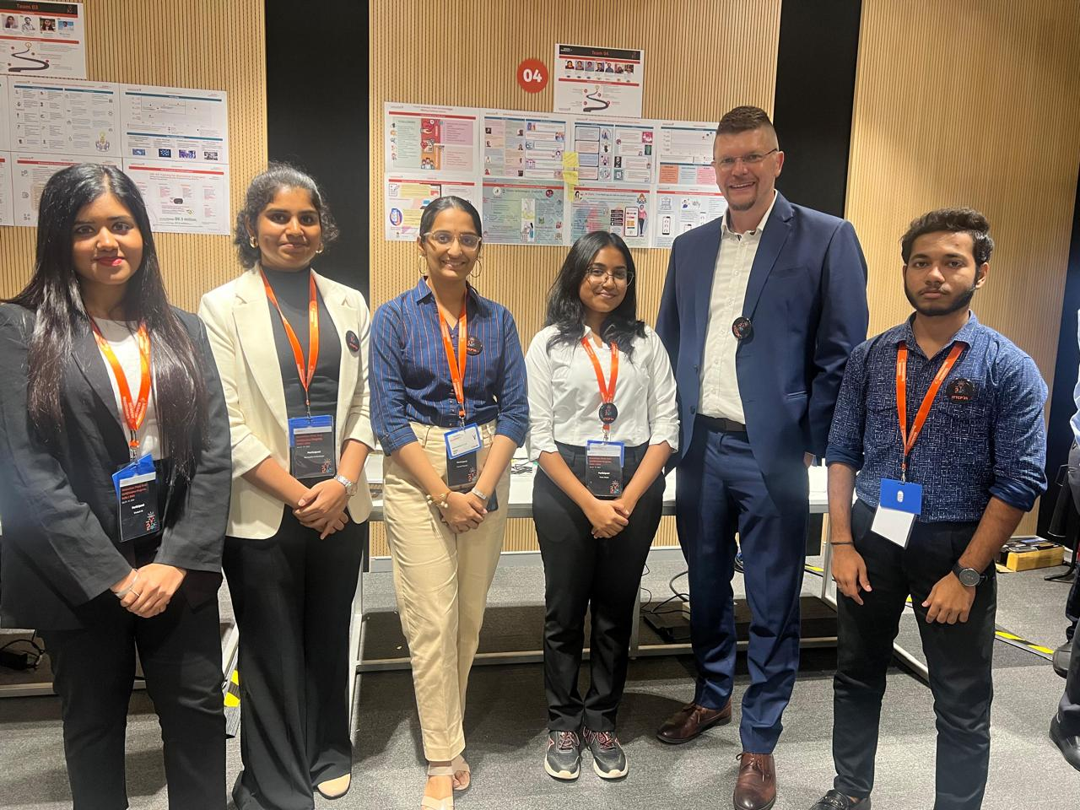

***Congratulations to Pranati Phanish, Vivekah M and Namyatha N Mulbagal, students of Medical electronics participated in the Innovation Think Tank Certification Program (ITTCP) organized by Siemens Healthineers and secured the 3rd place***

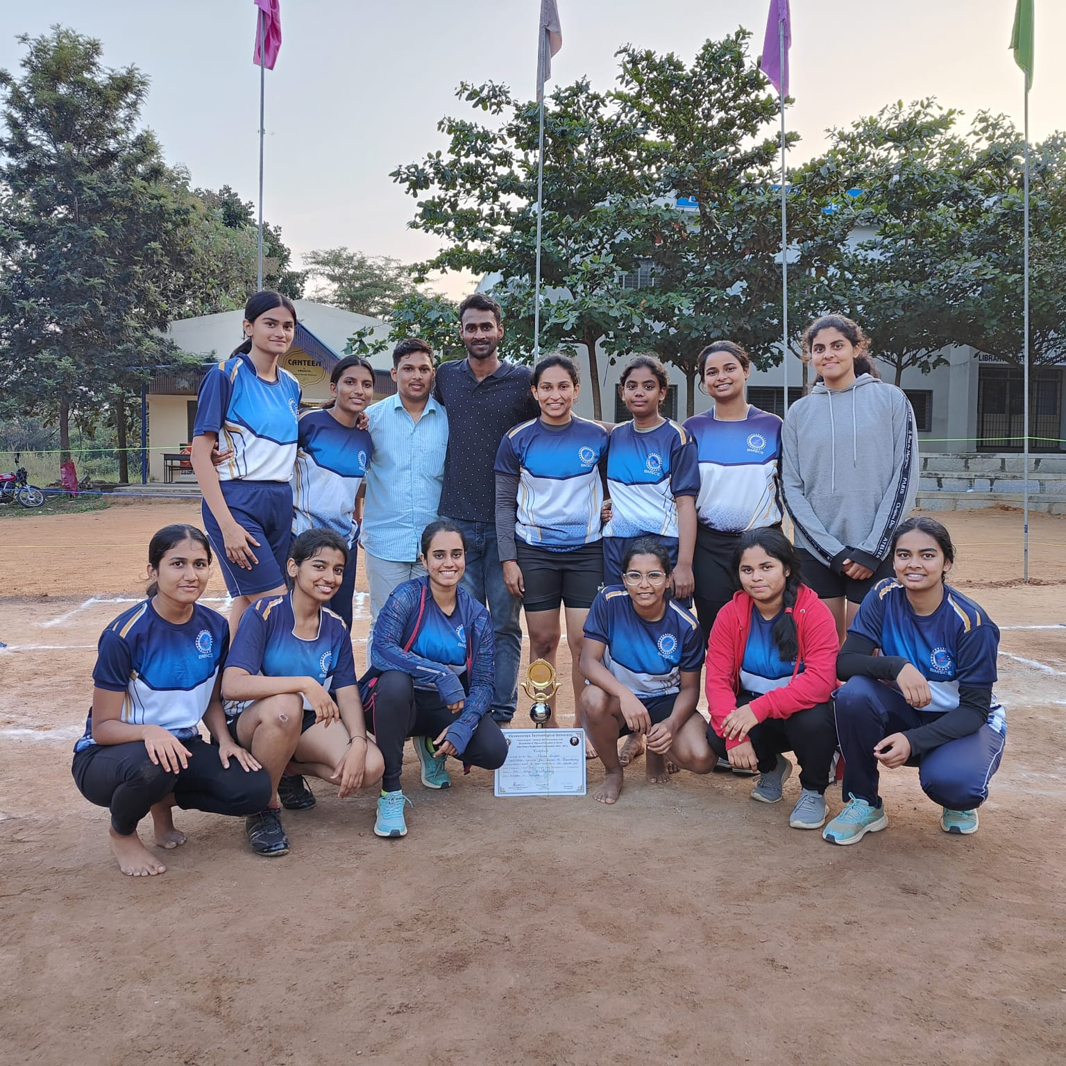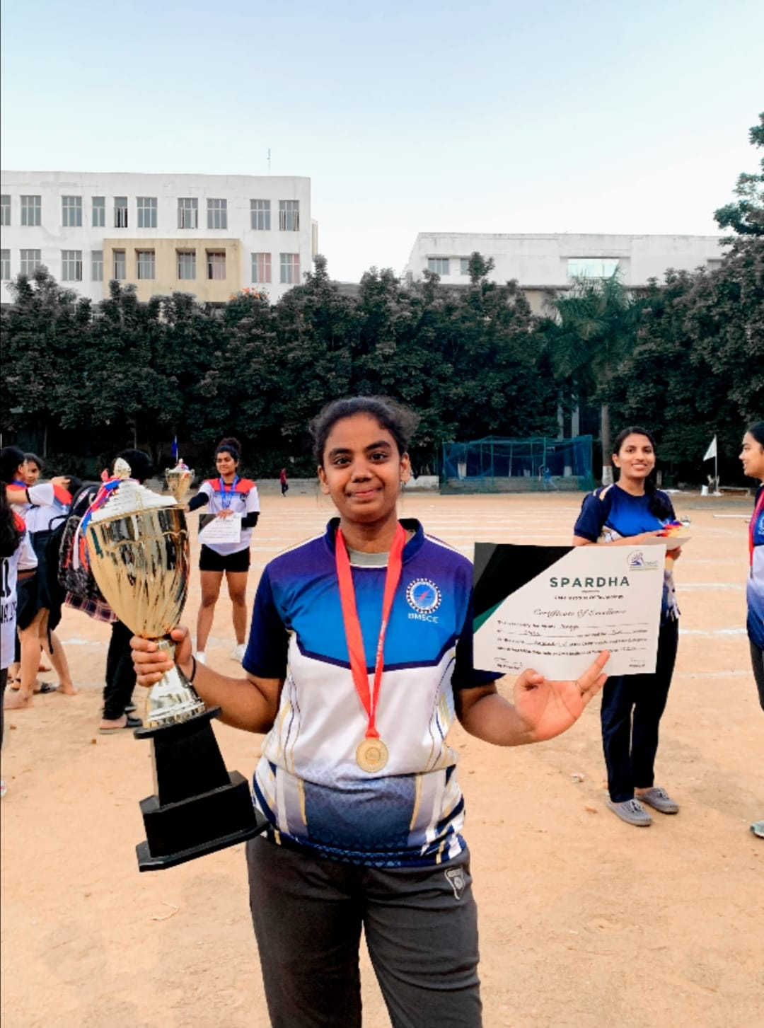

***Congratulations to Bhagyalakshmi for securing First position in Kabaddi(W) at CMRIT state level Inter-Collegiate sports fest SPARDHA 2022 and Winners in VTU Inter collegiate Bangalore division at APS College of Engineering***

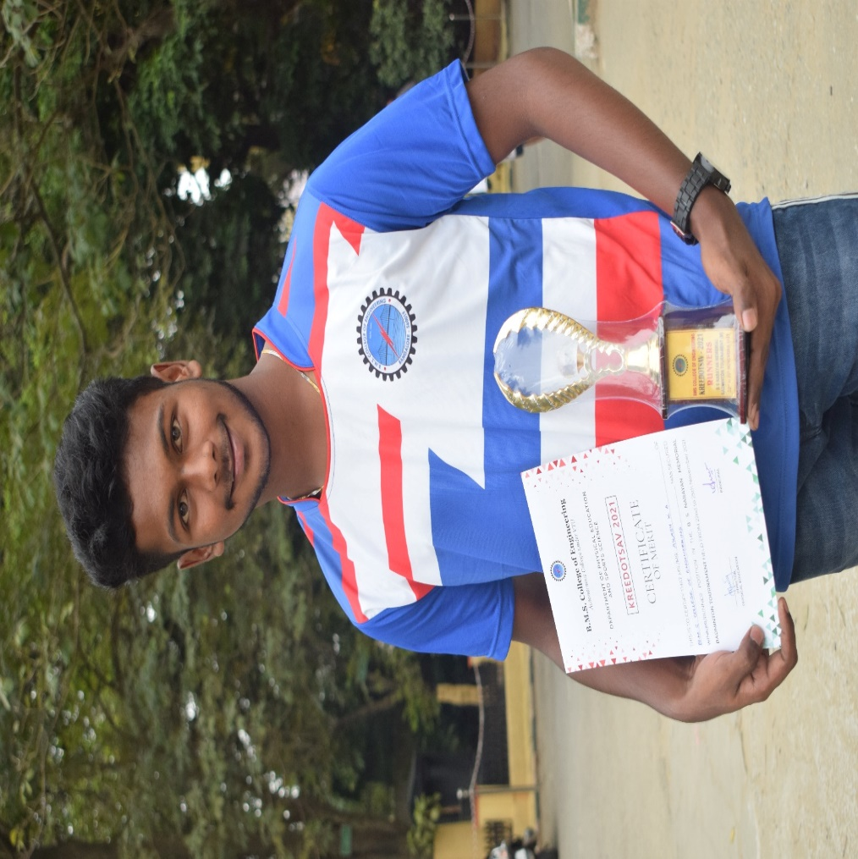

***Congratulations to Akash KA for securing Runner-up in the Inter-collegiate Bengaluru Central zone Badminton (M) Tournament 2021***

***Congratulations to Vamshi N for securing first place in Table Tennis (M) Bangalore Central division held at CMRIT 2023***

