

**UTSAV 2025**

May 9th – May 10 th 2025

**May 9th, 2025**

VarAInce hosted Treachery in Time during UTSAV 2025, a thrilling murder mystery treasure hunt on the 4th and 5th floors of PJ Block. 35 teams (70 participants) raced from 10:00 AM to 4:00 PM to solve clues and uncover a historical whodunit. The event had two rounds—riddle-solving and a final investigation where top teams identified the murderer, weapon, and motive using fictional evidence. Judged on logic and accuracy, the event had a ₹3,000 prize pool.

Winners

Etta Pranay & Chintan Upadhya(1st place)

Yash Kumar & Om G Gowdar(2nd place)

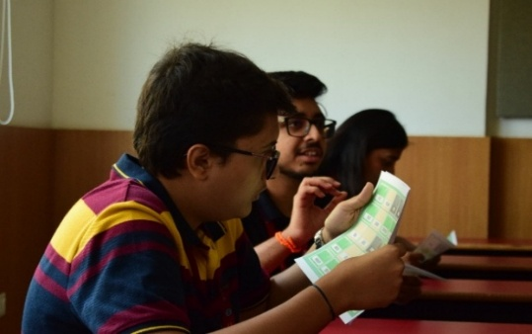 

**May 10th , 2025**

As part of UTSAV 2025, VarAInce presented The Diamond Affair, a heist-themed escape room on the 2nd floor of Mechanical Block. Over two days, 60 teams (120 participants) competed from 9:00 AM to 4:00 PM in three levels: solving a riddle, navigating a laser maze, and matching the weight of stolen diamonds. Time-based scoring and strict rules added intensity. Judges selected winners based on total points and successful heist completion. The event featured a ₹4,000 prize pool.

Winners

Abhishek Yadav and Ankit Gaur (1st place )

Shreya Sathyanarayana and Nitisha Shajee (2nd place)

