

B.M.S COLLEGE OF ENGINEERING
Autonomous Institute, Affiliated to VTU
DEPARTMENT OF CSE (IOT & CYBERSECURITY INCLUDING BLOCKCHAIN) &
DEPARTMENT OF MEDICAL ELECTRONICS ENGINEERING
INVITED TALK ON
CYBERSECURITY AWARENESS
TwiceIsWise Campaign “Check Twice, Stay Wise!”

Nationwide CSR initiative in partnership with the Indian Cyber Crime Coordination Centre (I4C)

DATE AND TIME:

Date of the Event: 9 December 2025, Tuesday

Time: 11:00 AM – 12:00 PM

VENUE: Auditorium 2

SPEAKER: Irene, Zonal Program Manager, Federal Bank,
RJ Pallavi, Radio City

FACULTY COORDINATOR:

Prof. Manjula M, Dept. of CSE(ICB),
Dr. Vijayalakshmi K, Dept. of Medical Electronics Engg.

PARTICIPANTS: Students of 1st and 2nd Semester, Dept. of CSE(ICB)

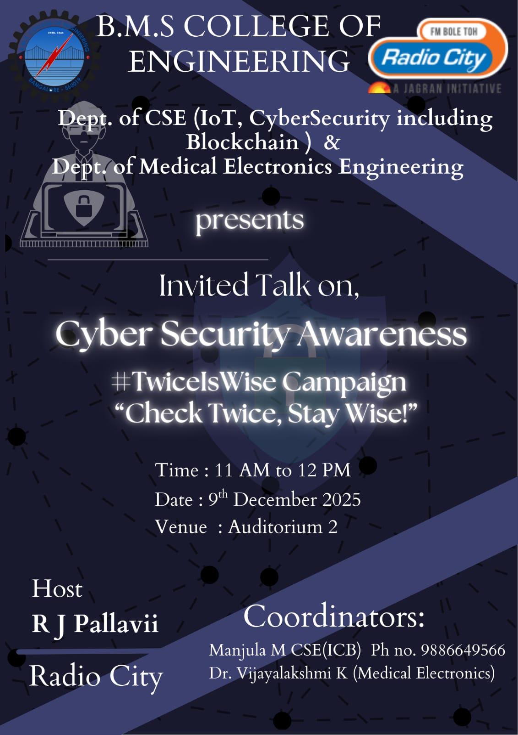

OBJECTIVE:
- To provide students with insights into how cyber-attacks can occur in everyday life.
- To create awareness about staying safe from multiple types of attacks and staying safe from them.
- To guide students in keeping their digital footprint private.

DESCRIPTION:
The Cyber Security Awareness session began with an engaging introductory speech by Radio Jockey Ms. Pallavi, who set the tone for the event by stressing the importance of being mindful in the digital world. She highlighted the core message “Think Twice,” encouraging everyone to pause and reflect before interacting with online content. Her introduction captured the audience’s attention and created a strong foundation for understanding why cyber awareness is essential in today’s technology-driven society.
Following this, Ms. Irene delivered an informative talk on cyber risks, common cyber-attacks, and the vulnerabilities that are often exploited by attackers. She explained how lack of awareness can lead to data breaches and financial losses, and stressed the need for safe online practices. The event concluded with a cyber safety pledge led by Ms. Pallavi, reinforcing the message of staying alert and making informed decisions online, leaving participants more aware and empowered to protect themselves in the digital space.

OUTCOMES:

Students gained awareness of various types of social engineering attacks.

Students understood the benefits of cyber security awareness.

The session broadened students’ perspectives on the vulnerabilities of their cyber space.

The pledge helped the students fully understand the duties as a student on the internet.

Photos:
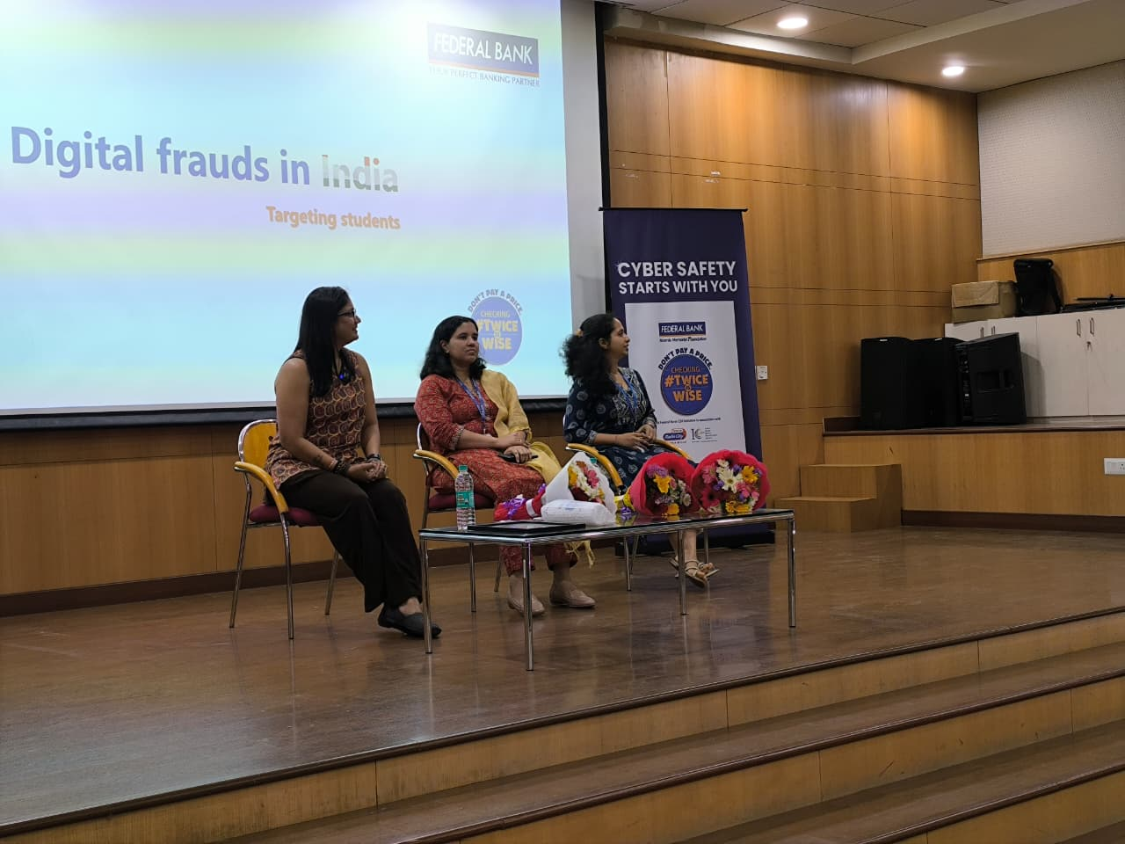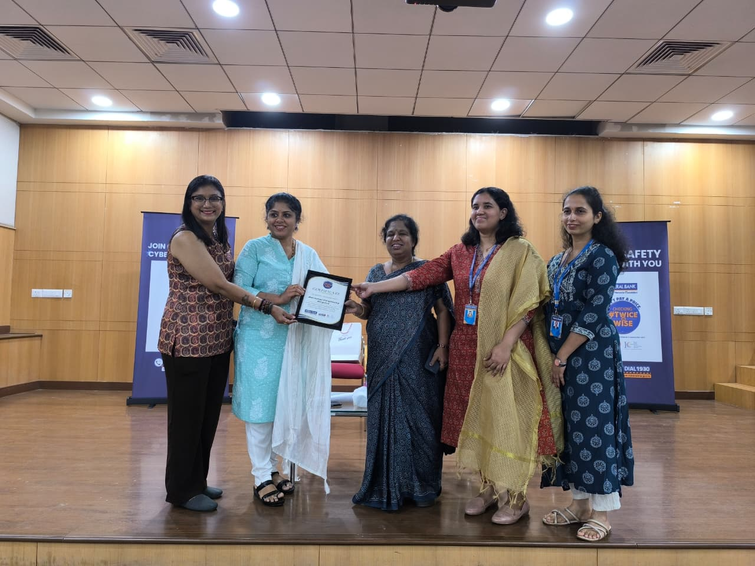

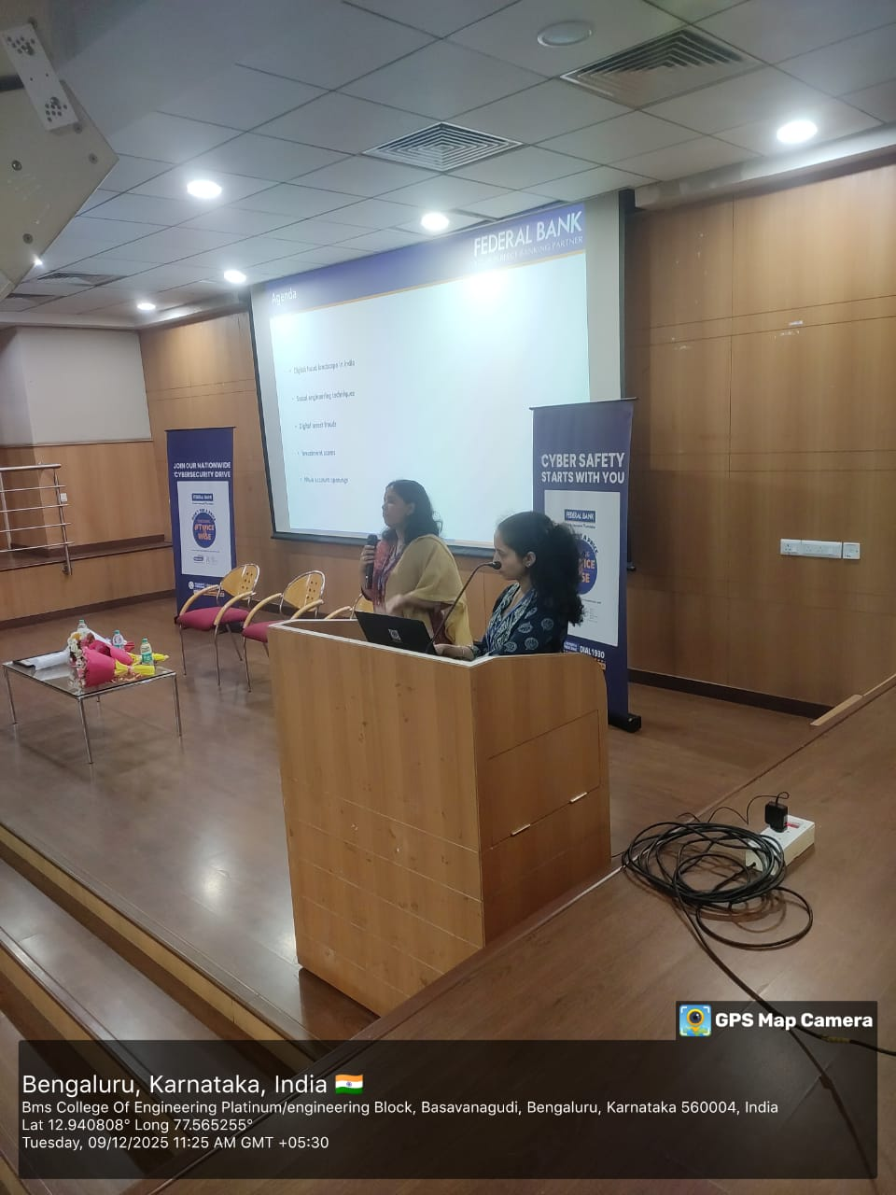
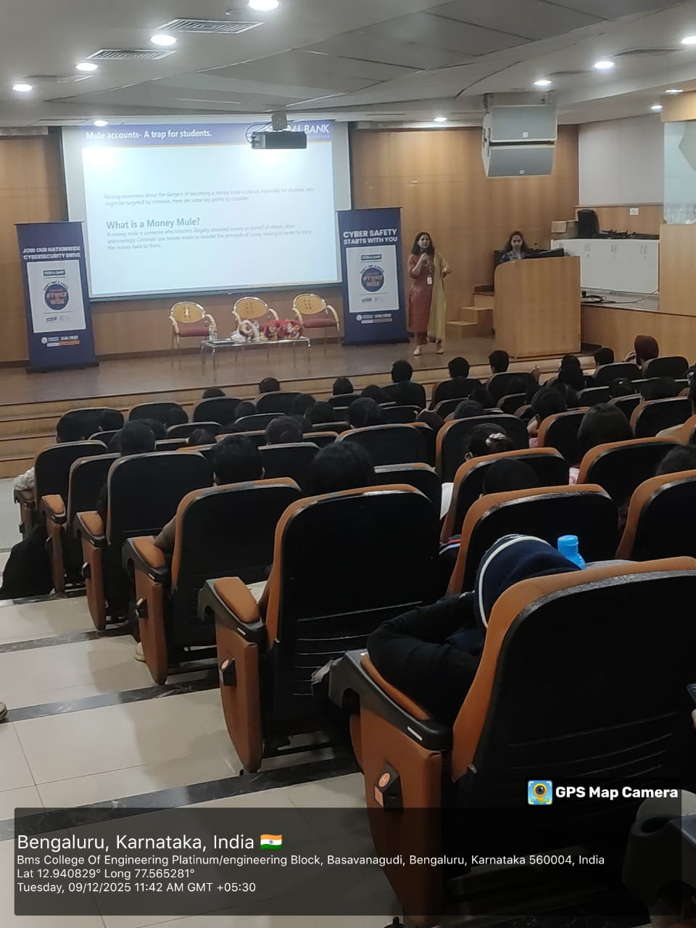

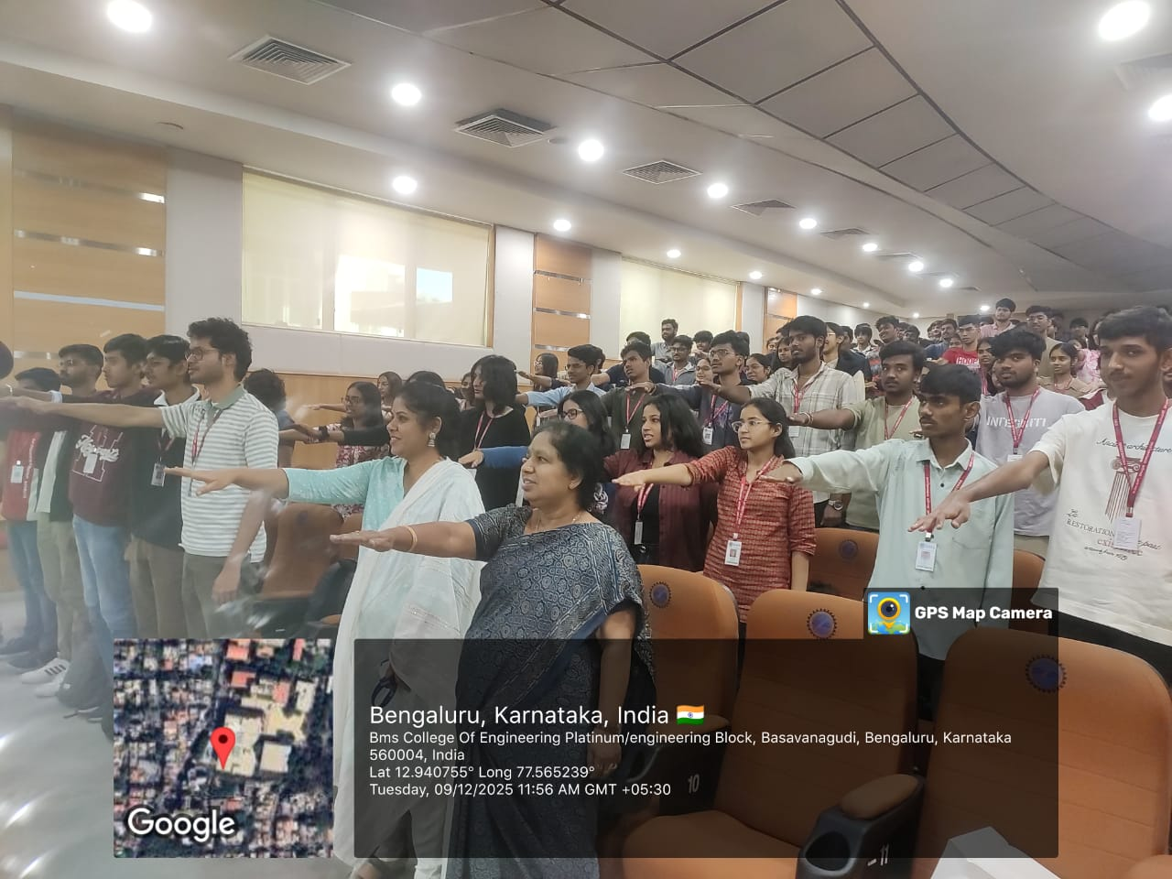

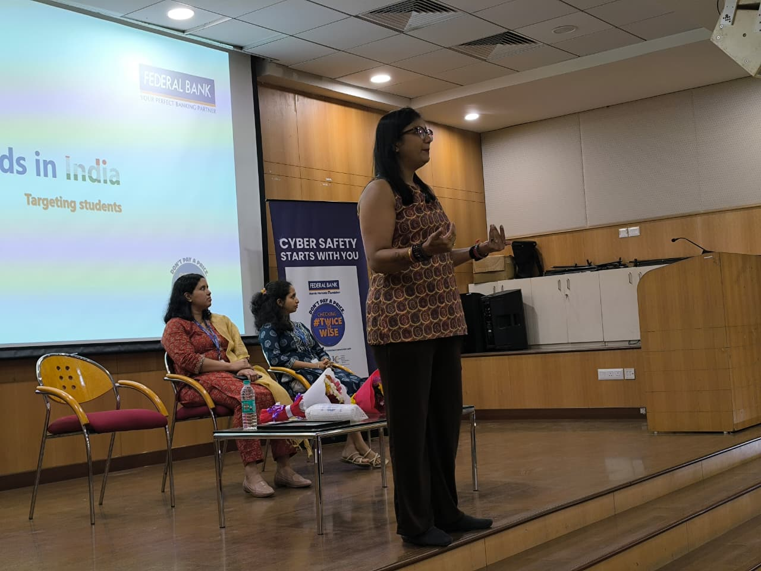
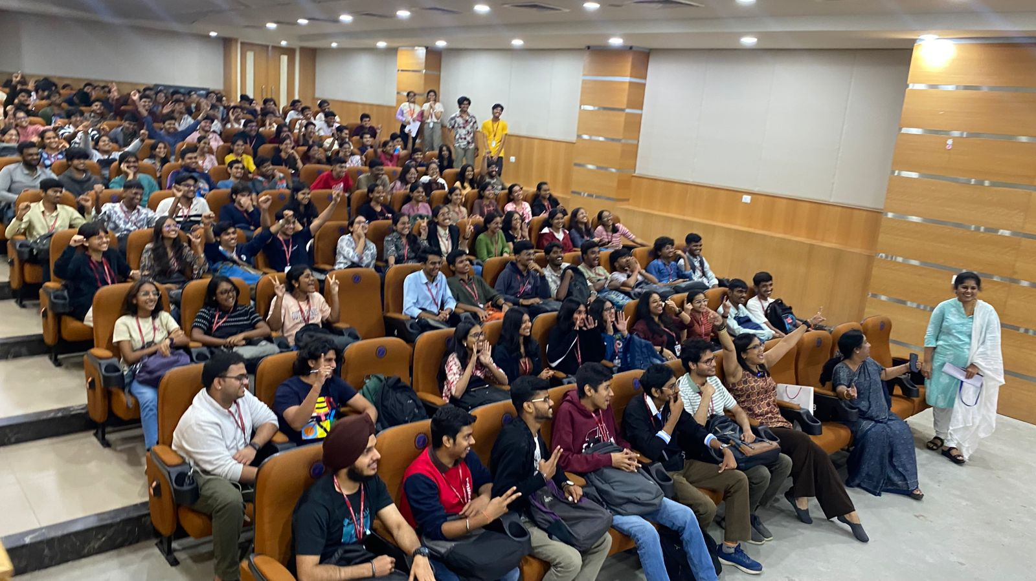
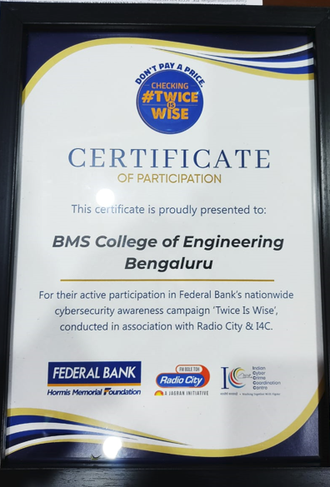

Attendance:
