**DEPARTMENT OF ARTIFICIAL INTELLIGENCE AND DATA SCIENCE**

**A Guest Lecture Report on**

***Data and Artificial Intelligence is way of life***

**Speaker Name :** Mekala Reddy

Kyndryl India Formerly IBM

**Session name :** Data and Artificial Intelligence is way of Life

**Date and Time:** 30.01.24 2:00 PM – 3:30 PM

The Department of Artificial Intelligence and Data Science organised a highly anticipated guest lecture on 30th January, 2024. The lecture, which was held at BMS College of Engineering, featured Mr. Mekala Reddy, an esteemed expert in Kyndryl India formerly IBM.

Working as Development Manager for Kyndryl Bridge product in Kyndryl India and also focussing on Talent acquisition, Skill university he has worked in IBM India as Business Development & Operations Leader. He has been in the Industry for 20 years and 15+ years at IBM India working on Product Supporting, Project Management, Business Partner Ecosystem areas.Prior to IBM, he worked on R&D software development in the areas of Finite Element Method, Green's Functions, Percolation Theory and Segmentation resulting into two International patents, two publications and presented these topics in 3 conferences. In 10+ years, he has partnered with many educational organisations to assess the education system and identify the areas where Industry can support & also enable faculty & students towards ‘smarter’ future.

Mr. Mekala Reddy provided invaluable insights drawn from his extensive experience, offering a comprehensive overview of the latest developments and trends shaping the field. Throughout the session, participants had the opportunity to engage in dynamic discussions, pose questions, and exchange ideas. The interactive nature of the lecture fostered a stimulating environment conducive to learning and knowledge sharing.

The lecture highlighted key case studies, methodologies, and real-world examples to illustrate the practical implications of artificial intelligence and data science across various industries. It also addressed pertinent ethical considerations and emphasised the importance of responsible AI deployment.

The lecture concluded with a lively Q&A session, during which attendees delved deeper into specific topics and sought clarification on complex concepts. Mr. Mekala Reddy offered valuable advice, encouraging aspiring professionals to continuously expand their skill sets and stay abreast of emerging technologies in the ever-evolving landscape of artificial intelligence and data science.

Overall, the guest lecture proved to be a resounding success, garnering positive feedback from attendees and reaffirming the Department of Artificial Intelligence and Data Science commitment to providing enriching educational experiences for students and faculty alike.

The guest lecture organised by the Department of Artificial Intelligence and Data Science served as a testament to the department's dedication to promoting interdisciplinary learning, fostering innovation, and advancing research in the field. The insightful discourse and engaging interactions underscored the pivotal role of such events in nurturing a vibrant intellectual community and shaping the future of artificial intelligence and data science.

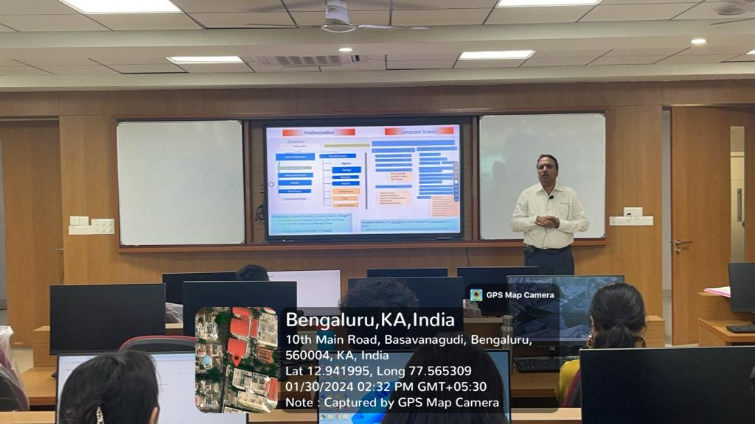

Session by Mekala Reddy

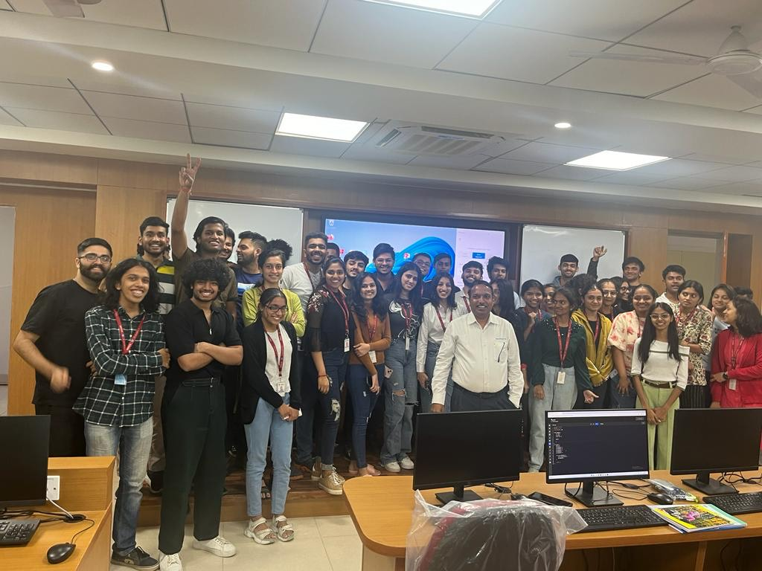

A group picture of students of 3rd AI and DS with the speaker