**DEPARTMENT OF ARTIFICIAL INTELLIGENCE AND DATA SCIENCE**

**A Guest Lecture**

**A TECHNICAL SEMINAR ON DATA SCIENCE FOR NEXTGEN**

A Technical Seminar on Data Science was organised by the Department of Artificial Intelligence and Data Science in collaboration with the Department of Computer Science (DS), as a flagship event of Phaseshift 2023: Techtopia Technical Symposium on 8th December,2023.

The seminar held for students was a comprehensive event aimed at providing participants with insights into the dynamic field of data science. The seminar was organised to bridge the gap between theoretical knowledge and practical applications, offering students a deeper understanding of the industry's current trends and challenges. It has provided a comprehensive exploration of the latest trends, methodologies, and applications in the field. Aimed at students, professionals, and enthusiasts, the event aimed to foster knowledge about the rapidly evolving domain of data science.

The seminar commenced with an inaugural session that included a welcome address, introduction to the agenda, and an overview of the significance of data science in today's technology-driven world. The event was graced with esteemed Dr. Shambhavi B R , HOD of CS(DS) , and other expertise faculty.

Mr.Nishanth Shetty is a PhD student in the [Department of Electrical Engineering](https://ee.iisc.ac.in/), [Indian Institute of Science, Bengaluru](https://iisc.ac.in/), under the supervision of [Prof. Chandra Sekhar Seelamantula](https://sites.google.com/site/chandrasekharseelamantula/). The focus of his PhD is deep generative modelling, in particular, score-based generative models, diffusion models and generative adversarial networks. He is currently exploring the links between optimization and sampling. On the applied side, he is interested in the potential of using generative models as priors to solve inverse problems in computational imaging. His PhD is graciously funded by the Prime Ministers’ Research Fellowship (PMRF) and Qualcomm Innovation Fellowship.

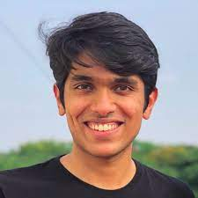

Previously, he completed his Bachelors in Electronics and Communication Engineering from [PES University](https://pes.edu/), Bangalore.

The core of the seminar comprised technical seminars where the following key topics were discussed:

* Introduction to Data Science and its Applications
* Data Cleaning and Preprocessing Techniques
* Machine Learning Algorithms and Models
* Big Data Analytics and Tools
* Data Visualization and Interpretation

The seminar covered the use of popular data science tools, programming languages, and case studies from diverse industries.

Students had the opportunity to ask questions and gain insights into potential career paths. The seminar facilitated networking among students and faculty. This allowed students to connect with potential mentors and employers, fostering collaboration and future opportunities. These interactive elements allowed attendees to clarify doubts, share experiences, and gain practical insights into the discussed topic. Students had the chance to demonstrate their problem-solving skills and creativity. This session provided a platform for peer learning and feedback.

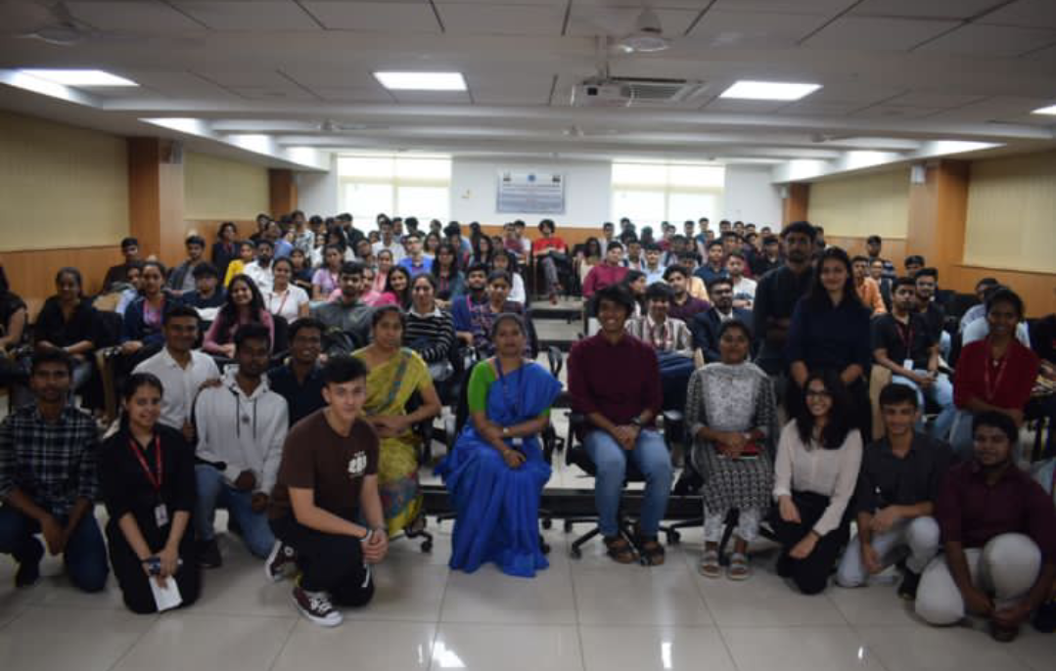

The seminar concluded with a closing ceremony, acknowledging the speaker, faculty and participants. E-certificates of participation were awarded, and attendees were encouraged to continue exploring and contributing to the field of data science.

Overall, the Technical Seminar on Data Science proved to be a valuable platform for students to gain practical insights, connect with industry experts, and explore the vast potential of data science in shaping the future. It proved to be a valuable platform for individuals keen on staying abreast of the latest developments in the field. Attendees left with enhanced knowledge, practical skills, and a renewed enthusiasm for leveraging data science in their respective domains. The event successfully contributed to the ongoing dialogue surrounding the future of data science and its pivotal role in shaping various industries.