Report on Industrial Visit to BEL- PDIC
Date of Visit: 12th May 2026
Organized by: Prof. K Poornima Kamath & Prof. Pooja A P
Participants: 29 Students and 2 Faculty Members
Venue: Bharat Electronics- Product development and Innovation center

Introduction
Product Development & Innovation Centre (PDIC) was established in December 2014 as a centralized facility to support the development activities and work as a self-sufficient design house. The innovation centre started its activities from the new facility since October 2018. The facility was formally inaugurated by Honourable Raksha Mantri, Sri Rajnath Singh on 19 Sept 2019.
PDIC is setup in a centralized air-conditioned five-storey building spread over 26 acre land and can house 700+ engineers. PDIC caters to new product and sub-system development requirements of SBU’s spread across all the Units of BEL. Major infrastructure for prototyping, testing and design validation, such as EMI/EMC test facility, ESS labs, Rate Tables, Clean Rooms, etc are part of the in-house facilities.

Objective of the Visit
The industrial visit aimed to expose students to cutting-edge defence electronics manufacturing, product innovation, and R&D practices at Bharat Electronics Limited (BEL), a leading public sector enterprise under the Ministry of Defence.

Visit Overview:
The students and faculties visited BEL's Product Development and Innovation Center, Bangalore, touring Display Hall 1 & 2 where defence models like radar systems and electronic warfare equipment were displayed. The different PDIC technology domains like antenna systems, automation systems, embedded systems, energy systems, sonar systems, 5G & wireless systems and so on were explained to the participants. They interacted with all the students, exploring product development and career opportunities in defence electronics. The students gained valuable knowledge about India's achievements in defence technology. The visit provided exposure to cutting-edge defence tech, strengthening industry-academia ties. Students gained insights into BEL's innovation ecosystem and potential career paths in defence electronics and R&D.

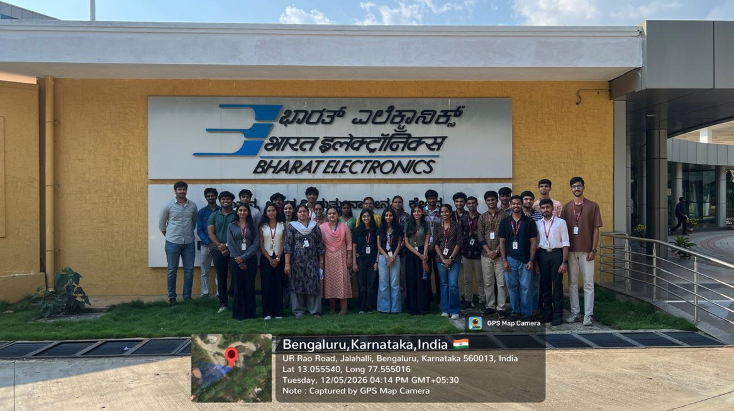

Conclusion:

The students gained insights into defence electronics manufacturing, product innovation, and R&D practices at BEL. The participants observed advanced facilities like spectrum analysers, antenna systems, automation systems, embedded systems and so on. BEL representatives highlighted internship and recruitment prospects in defence electronics. The students interacted with professionals, discussing emerging tech like 5G, quantum computing, and AI in defence.

Attendance Report:
