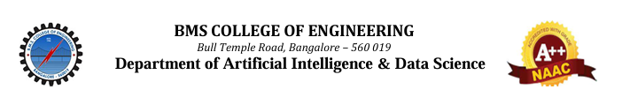

**12th May 2025:**

Dr. Indiramma M Professor and HoD of Department of AI & DS was a resource person at Nagarjuna College of Engineering and Technology. This one-day session is based on **Empowering the future with AI - How to make a machine learn case studies.**

