ENVIRONMENTAL MANAGEMENT SYSTEM OPERATIONAL CONTROL MANUAL – 01
Revision 0 | Dated 01.09.2023

BMS COLLEGE OF ENGINEERING
BANGALURU-560019, KARNATAKA


Compiled by | Reviewed by | Approved By
Dr.Ramakrishnaiah.C.R  Professor  Department of Civil Engineering  (PG-Environmental Engineering) | IQAC | < to be indicated >

VISION

Promoting Prosperity of mankind by augmenting Human Resource Capital through Quality Technical Education & Training.

MISSION

Accomplish Excellence in the field of Technical Education through Education, Research and Service needs of society

Contents
1. Chapter 1 - Introduction 7
1.1. PURPOSE OF THE MANUAL 7
1.2. INTRODUCTION 7
1.2.1. Purpose 7
1.2.2. General Information 8
1.2.3. Goals 8
1.3. Manual Compliances Mapping to various Processes 8
2. Chapter 2 - General 10
2.1. General and legal considerations 10
2.2. Emergency Numbers 11
2.3. Environmental management and Safety Responsibilities 11
2.3.1. Responsibilities of the Head of department 11
2.3.2. Responsibilities of the Staff and Students 12
2.3.3. Standard Safety Behaviour 12
2.4. Noise management 14
2.5. Reporting Environmental Incidents 14
3. Chapter 3 – Emergency management 15
3.1. Introduction 15
3.2. Fires 15
3.2.1. Building fires 15
3.2.2. Laboratory fires 16
3.2.3. Fire safety reminders 17
3.3. Chemical Exposures 17
3.3.1. Chemicals on skin or clothing 17
3.3.2. Chemicals in eyes 18
3.3.3. Chemical Inhalation 18
3.3.4. Accidental ingestion of chemicals 18
3.3.5. Accidental injection of chemicals 18
3.4. Chemical Spills 18
3.4.1. Emergency spills 19
3.4.2. Minor spills 20
3.4.3. Mercury handling and spill clean up 21
3.5. Medical Emergencies 23
3.6. General First Aid 24
3.7. Personal Protection during First Aid 25
3.8. Leaking Compressed Gas Cylinders 25
4. Chapter 4 – General safety rules 27
4.1. General Safety Policies 27
4.2. Elementary Safety Rules 27
5. Chapter 5 - Safety Rules – Labs 29
5.1. General 29
5.1.1. Personal safety practices 29
5.1.2. Record Keeping 29
5.1.3. Housekeeping 30
5.1.4. Labelling and signs 31
5.1.5. Storage 31
5.1.6. General considerations: 34
5.1.7. Chemicals Incompatibility 35
5.1.8. Compressed gas cylinder storage 37
5.1.9. Unattended Operation 38
5.1.10. Working alone 39
5.2. Handling and transporting chemicals. 39
5.3. Handling glassware 39
5.4. Safety Guidelines for Non-Regular Classes 39
5.4.1. Personal Protection 41
5.4.2. Hygiene 41
5.4.3. Eye protection 41
5.4.4. Ear protection 42
5.4.5. Foot protection 42
5.4.6. Skin protection 42
5.4.7. Hand protection 42
5.4.8. Respirators 42
5.4.9. Hoods 43
5.5. Safety Equipment 43
5.5.1. Fire extinguishers 44
5.5.2. First aid kits 44
5.5.3. Safety shields 44
6. Chapter 6 – Fire safety 45
6.1. Fire protection of buildings 45
6.2. National building code 2005- Part 4(fire & life safety) 45
6.3. Fire exit signs 46
6.4. Ventilation facility 46
6.5. Type of fire extinguishers 46
6.6. Fire extinguisher color codes 48
6.7. Fire Fighting Equipment’s 49
6.8. Fire emergency procedures 52
7. Chapter 7 – Chemical and Biohazards 53
7.1. Introduction 53
7.2. Flammable solvents 53
7.2.1. Use and storage. 54
7.2.2. First aid 56
7.2.3. Personal protective equipment 56
7.3. Oxidizers 56
7.3.1. Use and storage 57
7.3.2. Use and storage of perchloric acid 57
7.3.3. First aid 58
7.3.4. Personal protective equipment 58
7.4. Corrosives 58
7.4.1. General characteristics 58
7.4.2. Use and storage 59
7.4.3. Use and storage of hydrofluoric acid 59
7.4.4. First Aid 60
7.4.5. Personal protective equipment 60
7.5. Reactive 61
7.5.1. General characteristics 60
7.5.2. Use and storage 63
7.5.3. First aid 64
7.5.4. Personal protective equipment 64
7.6. Biohazard Safety 65
7.7. Laboratory safety 68
7.8. Personal and General laboratory safety 68
7.9. Electrical safety 69
7.10. Mechanical safety 69
7.11. Chemical safety 70
7.12. Compressed Gas Cylinders 71
7.12.1. Use and storage 70
8. Chapter 8 – Electrical Safety and Energy Management 72
8.1. Introduction 72
8.1.1. Electrical Hazards 72
8.1.2. Power loss 73
8.1.3. Electrical Fires harming Environment 73
8.2. Preventing Electrical Hazards 74
8.2.1. Insulation 74
8.2.2. Guarding 74
8.2.3. Grounding 74
8.2.4. Circuit protection devices 74
8.2.5. Motors 76
8.2.6. Static Electricity and Spark Hazards 76
8.2.7. High Voltage or Current 76
8.2.8. Safe Work Practices 76
8.2.9. Energy management considerations 80
9. Chapter 9 – Mechanical Safety 81
9.1. Introduction 81
9.2. General safe working procedure 82
9.3. Hand Tools 83
9.4. Machine Tools 84
9.5. Drill press 86
9.6. Electric drill (handheld) 87
9.7. Bench Grinder 87
9.8. Disc grinder – Portable 88
9.9. Engine lathe 88
9.10. Milling machine 90
9.11. Oxygen-Acetylene Welding 91
9.12. Electric Welding 93
9.13. Compressed Air 94
9.14. Sheet Metal Shear 94
9.15. Wood Tools 94
9.16. Abrasive Wheels 95
9.17. Metal-Cutting Guillotines 95
9.18. Power Hacksaws 96
10. Chapter 10 – Hazardous Waste management 97
10.1. Definitions 97
10.2. Types of Hazardous Waste 97
10.3. Containers, Tags, and Collection 98
10.4. Disposing of Empty Containers 99
10.5. Reduction of Waste Source 99
10.6. Purchasing and inventory control 99
10.7. Chemical usage 100
10.8. Waste Minimization Techniques 100
10.9. Waste Segregation 101
10.10. Incompatible Waste 101
10.11. Segregation Classification 103
10.12. Special Concerns 103
11. Chapter 11 – Solid waste and water management 105
11.1. Solid Waste Management: 105
11.1.1. Segregation And Primary Storage 105
11.2. E-waste management: 105
11.3. Effluent Disposal 106
11.4. Bio medical waste disposal 106
11.5. Battery waste disposal 106
11.6. Oil Disposal 106
11.7. Construction and Demolition Waste 106
11.8. Sewage disposal: 106
11.9. Chemical waste: 107
11.10. Bore Well Water Consumption, Rainwater harvesting structures and utilization: 107
12. Chapter 12 - Miscellaneous activities - Environmental management systems 109
12.1. General 109
12.2. Sports Room 114
12.3. Garden 114
12.4. Pest Control 115
12.5. Utilities HVAC 115
12.6. Utilities DG 119
12.7. Utilities Sewage / Water treatment Plant 119
12.8. Buildings Electrical and Energy management 120
12.9. Utilities Mess / Kitchen / Pantry 125
12.10. OH&C center. 126
13. Chapter 13 – Green Practices 127
13.1. CARBON NEUTRALITY 127
13.2. BIODIVERSITY PROTECTION 127
13.2.1. ORNAMENTAL PLANTS 127
13.2.2. WELL GROWN TREES 128
13.3. PLASTIC FREE AND PAPERLESS OFFICE 128
13.4. Public transport 129
13.5. Pedestrian friendly roads 129
14. Chapter 14 – Records in EMS 130
14.1. Formats and Templates for EMS 130
15. Chapter 15 - Appendix 131
15.1. APPENDIX I 131
15.2. APPENDIX II 131
15.3. APPENDIX III 134
15.3.1. Definition of Hazardous Waste 134
15.3.2. Definitions of Biohazard waste 137
16. Chapter 16 - References 138
16.1. References 138

Chapter 1 - Introduction

PURPOSE OF THE MANUAL
This Environmental management system (EMS)Manual outlines procedures, rules and regulations governing Environmental protection in which to follow while working at BMS College of Engineering. The ENVIRONMENTAL Manual will be revised as necessary to add requirements and procedures involving newly identified exposures. Periodically, material in this manual will be updated, revised, or supplemented in order to keep the manual current and relevant.
It is impossible to effectively deal with all safety concerns or procedures in a single manual. Many safety related matters involve situation-specific factors, which are difficult to anticipate. Accordingly, this manual is not the definitive statement, or the only statement, on college safety concerns or procedures. This manual is a starting point and a good-faith attempt to create a viable, college-wide, safety program and philosophy.

INTRODUCTION

Purpose
This procedure is established to provide College with a manual on Environmental management system (EMS) in accordance with the Indian standards.
BMS College of Engineering shall provide a safe educational and pollution free working environment in compliance with appropriate Environmental standards. BMS College of Engineering students, employees and visitors are entitled to:
- Pollution free environment
- Have basic, and when necessary, specific Environmental training.
The College shall develop, implement, and administer a comprehensive environmental management program to address prevention of pollution, protection of environment, promote sustainability and preservation of resources.
To ensure such an environment, specific procedures, rules, and regulations are published in the Environmental Management Operational Control Procedure Manual.

General Information
The manual contains programs and requirements for Environmental control program within the College and also outside the College to the extent the program involves communication and/or interaction with BMSCE employees, students, outside contractors, government agencies, and the public.

Goals
- Minimize Environmental risks by providing pollution free environments and controlling exposures to Environmental impacts in the workplace.
- Provide and assure appropriate Environmental programs exist and are in place.
- Assure that employees are informed of safety data sheets of materials and how to protect themselves from overexposure.
- Assure all administrators, managers, employees, and students have received orientation, instruction and training in Environmental protection matters.
- Require that all environmental protection and loss control practices, standards, laws, and regulations be observed relating to people, facilities, materials, processes, wastes and the environment.

Manual Compliances Mapping to various Processes
Applicable to -> | Building Section Team including utilities, OHC, Sports, Cafeteria - Pantry / mess | IT and Data centre | Procurement, Stores | Classroom + Physical equipment / chemical / bio lab | Classroom
Chapter Compliances
Chapter 1 - Introduction page no. 7 | Yes | Yes | Yes | Yes | Yes
Chapter 2 - General page no. 9 | Yes | Yes | Yes | Yes | Yes
Chapter 3 – Emergency management page no. 14 | Yes | Yes | Yes | Yes | Yes
Chapter 4 – General safety rules page no. 25 | Yes | Yes | Yes | Yes | Yes
Chapter 5 - Safety Rules – Lab’s page no. 27 | Yes | Yes | Yes | Yes | Yes
Chapter 6 – Fire safety page no. 42 | Yes | Yes | Yes | Yes | Yes
Chapter 7 – Chemical and Biohazards page no. 50 | Yes | NA | NA | Yes | NA
Chapter 8 – Electrical Safety and Energy Management page no. 65 | Yes | Yes | Yes | Yes | Yes
Chapter 9 – Mechanical Safety page no. 72 | Yes | NA | NA | Yes | NA
Chapter 10 – Waste management page no. 87 | Yes | Yes | Yes | Yes | Yes
Chapter 11 – Solid waste and water management page no. 94 | Yes | Yes | Yes | Yes | Yes
Chapter 12 - Misc. Activities | Yes | No | No | Yes | No
Chapter 13– Green Practices page no. 98 | Yes | Yes | Yes | Yes | Yes
Chapter 14 – Records in EMS page no. 101 | Yes | Yes | Yes | Yes | Yes
Chapter 15 - Appendix page no. 102 | Yes | Yes | Yes | Yes | Yes
Chapter 16 - References page no. 108 | Yes | Yes | Yes | Yes | Yes
Format Compliances
List of emergency team – EMS OCP / F 01 | Yes | Yes | Yes | Yes | Yes
List of fire extinguishers – EMS OCP / F 02 | Yes | Yes | Yes | Yes | Yes
List of First Aid Boxes and inventory – EMS OCP / F 03 | Yes | Yes | Yes | Yes | Yes
Environmental Incident Tracker – EMS OCP / F 04 | Yes | Yes | Yes | Yes | Yes
EMS Statistics – EMS OCP / F 05 | Yes | Yes | Yes | Yes | Yes
Waste generation record – EMS OCP / F 06 | Yes | Yes | Yes | Yes | Yes
Competence Skill Matrix – EMS OCP / F 07 | Yes | Yes | Yes | Yes | Yes
Training Plan – EMS OCP / F 08 | Yes | Yes | Yes | Yes | Yes
Training Record – EMS OCP / F 09 | Yes | Yes | Yes | Yes | Yes
EMS communication Log – EMS OCP / F 10 | Yes | NA | NA | Yes | NA
MSDS Binder – EMS OCP / F 11 | Yes | NA | NA | Yes | NA
List of chemical spill kits – EMS OCP / F 12 | Yes | NA | NA | Yes | NA
Mockdrill Format – EMS OCP / F 13 | Yes | NA | NA | Yes | NA
Master list of Equipment Maintenance Checklists – EMS OCP /F 14 | Yes | NA | NA | Yes | NA
Calibration Record – EMS OCP /F 15 | Yes | NA | NA | Yes | NA
External testing Schedule – EMS OCP /F 16 | Yes | NA | NA | Yes | NA
Legal Compliance Responsibility – EMS OCP /F 17 | Yes | NA | NA | Yes | NA

Chapter 2 - General

General and legal considerations
Environmental Impacts that need to be addressed at BMSCE are.
- Preservation / Conservation of Natural resources
  - Achieved through monitoring the consumption quantities and taking effort to retain optimised consumption / reducing consumption.
- Land Pollution and Water pollution
  - Achieved through good waste management practices, Sewage Treatment plant, Disposal of chemical effluent to authorised agencies, segregation, collection storage and disposal of waste to authorised agencies as recommended in Hazardous waste management rules, E waste Management rules, Bio-medical Waste (Management & Handling) Rules, Plastic Waste Management Rules, Construction and Demolition Waste Management Rules, Battery Waste Management Rules, The Water (Prevention and Control of Pollution) Act, canteen waste management as per FSSAI guidelines
- Air pollution and Noise pollution
  - Achieved through acoustics for high noise emitting equipment and areas, stack emission system, fume hoods to all activities having air emissions, ensuring automobile where used air emissions are compliant with emission norms as per The Air (Prevention and Control of Pollution) Act, The Air (Prevention and Control of Pollution) Rules, The Noise Pollution (Regulation and Control) Rules, 2000, National Ambient Air Quality Standards, Notification, prevention of substance use listed under The Ozone Depleting substances (Regulation and Control) Rules
Emergency situations in BMSCE which affect environment can include:
- Fire
- Chemical Spillage
- Harmful Gas release

Emergency Numbers
Table 2.1 Emergency Numbers
Campus Security | 9591812616
Ambulance | 9900013237
BMSCE Primary Health Centre | Extension No.: 6070
Police Station | 9480801524
Water Emergency | 080-26679736
Electrical Emergency | 080-26679736
Anti-Ragging Helpline | 9845942068
Women Helpline | 9449036862
BMS Hospital | 080-26613888
Hostel Warden | 9972233858

Environmental management and Safety Responsibilities
- In order to keep the work inside workshop and laboratories in safe side, all parties’ responsibilities should be clearly defined and well known by each party

Responsibilities of the Head of department
- Head of department should make sure to do some precautions:
  - Ensure that this manual is available to each one by department website link and make sure that staff and students concerning to work inside workshop or labs has received a hard copy of this manual and has signed the form at its end.
  - Ensure that general workshop and labs rules and emergency steps are listed clearly at the gate of working area.
  - Ensure to review all Environmental precautions to guarantee that it is adequate to work atmosphere.
  - Ensure that all machines and equipment are safe according to types of activities inside workshop and labs.
  - Ensure that an appropriate risk control is implemented.
  - Trains employees and students in environmental safety procedures.
  - Corrects improper work practices.
  - Identifies defective environmental conditions which could result in environmental incidents.
  - Develops a positive attitude among employees toward environmental incidents prevention.
  - Reviews and evaluates the effectiveness of the environmental practices at least annually, and updates as necessary.

Responsibilities of the Staff and Students
- The responsibilities of all staff and students inside workshop and labs are not only taking their own Environmental care reasonability but also the Environmental of all others having access to workshop or labs areas: -
  - Avoiding any hazards when dealing with machines or equipment.
  - Complying with all Environmental precautions in this manual.
  - Complying with all emergency instructions stated in this manual.
  - Making sure that devices and personal protective equipment are used properly and safely.
  - Avoiding any action that may cause risk of other persons inside workshops or labs.
  - Asking workshop and labs supervisors before performing any unknown activity or operating any new machine or equipment that you are not familiar with.
  - Wearing a suitable protective clothing and safety shoes at all times.
  - Eating and drinking is not allowed inside the workshop or laboratory.
  - Reporting all incidents, risk behave or near miss Environmental Incidents, and make sure to inform chairman or supervisors.

Standard Safety Behaviour
- Working inside workshop or laboratories should be carried out according to standard safe behaviour as follows: -
  - Always keep in your mind the safety first, avoid any risky situations and always keep attention about any possible risky behave or activity.
  - Wearing cloths should be compatible to all workshop or laboratory nature and activities.
  - Eye protection is important in case of hand operating or dealing with machine tools. Special eye protection should be worn when dealing with some equipment like welding machines.
  - Always wear hearing protection when subjected to noisy operations.
  - Never perform any irresponsible or reckless behaviour action like running or pushing or fighting with your colleagues inside the workshop or any laboratory.
  - Avoid any work requires you to stay alone in the workshop or laboratory; at least a second party should stay with you.
  - Do not eat or drink inside workshop or labs.
  - Storing food or drink inside any refrigerator that used for workshop or labs materials.
  - Do not smoke inside workshop or any laboratory.
  - Waste cotton or rags with oil have to be collected in suitable steel containers and should be isolated from other normal west; this will lead to reduce chances for fire Environmental Incidents.
  - When dealing with any unfamiliar substance consider it as hazardous till the opposite is proven.
  - Clear permission should be signed by the workshop and Lab’s supervisor, before any work done inside workshop or any laboratory.
  - Before performing any operation, the potential hazards of this operation should be precisely known, and appropriate safety precautions should be adopted.
  - Do not commence any flame producing activity until making sure that any volatile materials or flammable dusts are completely eliminated.
  - Carrying or moving any potentially hazardous material should be carried out with more additional care.
  - All fire-escape paths should be completely clear all the time.
  - All safety equipment should be periodically checked and repaired and make sure that it remains accessible for all persons and all the time.
  - Safety information and emergency precautions should be prominently displayed.
- First aid box locations
  - There are two portable first aid boxes inside the workshop on the two walls at the two ends of workshop main corridor.
  - Before using of the first aid box, you should have some training to know the components inside and the right way of using each one. Most of first aid box components are very easy to use. Take care and make sure to get professional medical care after using the first aid box “it is just fast action to minimize the risk and to avoid complications and sometimes safe lives”. All workshop users should get some first aid training. This will give them the ability to engage to any situation of colleague’s emergency needs.
- Physical Precautions
  - Workshop and Labs supervisor have to make sure that all machines, equipment, hand-held tools, are working properly and any malfunction equipment or tool is replaced with proper one. Other equipment or tools that need maintenance should be recorded for maintenance and separated until repaired. Securing a proper earthed pole and connecting it to all machines and equipment to avoid any user electric shock. Tools must be checked to keep it ready for work. Sharp tool edges of all cutting tools should be kept sharp, and its sharp edges should be inverted when stored to avoid injury for users. Any defects in tools or machines should be immediately detected and assigned for repair after reporting it and informing the workshop and labs supervisor. Hand tools having sharp edges which may causes injury must be returned to its toolbox after use and should not be carried in personnel pockets. Warning notices must be displayed during all the entire period of maintenance or repairs to any machine. Whenever possible, all fuses should be removed, and all switches should be locked off using suitable temporary locks.
  - Overcrowding is always not recommended. Mats of slip preventive materials like rubber should be placed in front of machines whenever it possible. All machines should be anchored to the ground using suitable anchoring facility according to the nature of machine operating properties. Machines and equipment should be placed and wisely distributed inside the workplace. Proper light system has to be carefully designed according to the nature of the workplace and machinery used inside taking into consideration to include natural sun light whenever it possible. Ventilation system including natural and forced ventilations should be well designed according to the work field nature. Hazards Warning labels must be fixed on machines explaining any risk and setting all necessary safety precautions.
  - Extremely hazardous portable powered tools like grinders or circular saws as examples should be operated by well qualified and trained persons only. Electrical connections and cables of electrical equipment and portable powered tools should be periodically checked and repaired immediately when any malfunction detected and should not be returned to duty before approved after repair completion.

Noise management
Activities and equipment’s have to be well maintained to ensure that there is no noise generated from the processes, if required acoustic measures have to be implemented, it should be ensured that Ambient noise levels do not exceed 75Db

Reporting Environmental Incidents
All Environmental Incidents should be reported to your Head of the Department/ laboratory superintendent and then to the ENVIRONMENTAL Committee without any delay. If the incident occurred in the lab, superintendent is required to submit a Report of Environmental incident and send it to the Head of the Department and ENVIRONMENTAL Committee. Students and lab superintendent should understand that the purpose of reporting and documenting Environmental Incidents is not to affix blame, but instead to determine the cause of the accident so that similar incidents may be prevented in the future.
Minor incident many times are not reported because they are perceived to be embarrassing or that "careless actions" lead to the incident. However, minor incident can sometimes lead to more serious complications that only become evident at a later time. Taking corrective action as a result of a minor accident may keep a major incident from happening. Without knowledge of all minor Environmental Incidents, the desirable investigation and resulting corrective actions are circumvented.
In the case of occurrence of any accident/ injury, take necessary emergency action and then report the incident to Environmental Committee (ENVIRONMENTAL) without any delay.

Chapter 3 – Emergency management
EMERGENCY SITUATIONS

Introduction
During the course of normal operations there is always a chance for an emergency situation to arise. These emergencies can be the result of a fire, chemical exposure, chemical spill, or the need for medical assistance. In the event of an emergency, an emergency response plan should be implemented. This plan would include evacuation of the facility if deemed appropriate.
Internal communication is very important during any emergency situation. It is essential that all employees and students know how to act and react during the emergency. To accomplish this, it is necessary that a written Emergency Response Plan be developed and that all employees are trained on how to act accordingly. All Environmental Incidents, regardless of severity, should be reported and investigated.
Pre-plan your escape
- Know the location of fire alarm pull box locations.
- Make sure your floor has at least two unobstructed ways out.
- Check the fire exits to make sure they are usable.
- Do not use the elevators. They could become disabled, trapping you on the fire floor.
- Know the location of fire rated stairwells that will provide a protected path all the way to the outside.
- Learn the sound of your buildings fire alarm. They could be bells, chimes, horns, or a coded gong.
- Post emergency numbers near all telephones.
- If you have fire blankets in your area, know how to use them.

Fires

Building fires
The following steps are recommended if a fire occurs in a building:
- Initiate a building evacuation using the emergency alarm.
- Keep yourself and others calm.
- Dial 101 to notify Public Safety and request fire department assistance.
- If the fire is small and you have been trained in the use of portable fire extinguishers, you may attempt to extinguish the fire. Fight the fire from a position where you can escape.
- If your clothing catches fire, drop to the floor and roll to smother the fire. If a co-worker’s clothing catches fire, lower the person to the floor and roll him or her to smother the flames. Use a safety shower immediately thereafter.
- Use the nearest safe exit route to exit the building. Close all doors on the way out to prevent the spread of smoke and fire.
- Quickly proceed outside the building to your department/areas designated meeting location using the planned evacuation route.
- After exiting, immediately proceed to a safe location at least 30 meters away from the building.
- Do not re-enter the building until all clear is given by the fire department.

Laboratory fires
Fires are a common emergency in any laboratory and specifically in a laboratory with flammable materials. In the event of a fire, do the following things:
- Assist any person in immediate danger to safety if it can be accomplished without risk to you.
- Immediately activate the building fire alarm system.
- If the fire is small and you have been trained in the use of portable fire extinguishers, you may attempt to extinguish the fire. Fight the fire from a position where you can escape.
- DON’T fight the fire if either of these conditions exists: The fire is too large or out of control. The atmosphere is toxic.
- If first attempts to put out the fire do not succeed, evacuate the building immediately.
- Doors, and if possible, windows, should be closed as the last person leaves a room or area of a laboratory.
- When they hear the fire alarm sound, all personnel in the affected areas shall evacuate the building immediately.
- Upon evacuating the building, personnel shall proceed to a designated area at least 50 meters away from the affected building.
- No personnel will be allowed to re-enter the building without permission.
- You must report all fires to your supervisor.

Fire safety reminders
• Never use an elevator if the building fire alarm is activated.
• Use stairwells to evacuate the building. Be aware of your egress routes.
• Never block open corridor/hallway doors in a building. • Check all appliances in your office before leaving. Turn them off.
• Use electrical extension cords properly. Examine the cords periodically for safe service.

Chemical Exposures
The following procedures should be followed in the event of a chemical exposure. In all cases the incident should be reported to your laboratory chief, technician, or principal investigator, regardless of severity.

Chemicals on skin or clothing
1. Immediately flush with water for no less than 15 minutes (except for hydrofluoric acid).
2. While rinsing, quickly remove all contaminated clothing or jewellery.
3. Use caution when removing pullover shirts or sweaters to prevent contamination of the eyes.
4. Check the MSDS (Material Safety Data Sheet) to determine if any delayed effects should be expected.
5. Discard contaminated clothing or launder them separately from other clothing. Leather garments or accessories cannot be decontaminated and should be discarded.
Do not use solvents to wash skin. They remove the natural protective oils from the skin and can cause irritation and inflammation. In some cases, washing with a solvent may facilitate absorption of a toxic chemical.
For flammable solids on skin, first brush off as much of the solid as possible, then proceed as described above.
For hydrofluoric acid, rinse with water for 5 minutes and apply calcium gluconate gel, then get immediate medical attention. If no gel is available, rinse for 15 minutes and consult a doctor immediately.

Chemicals in eyes
- Immediately flush eye(s) with water for at least fifteen minutes. The eyes must be forcibly held open to wash, and the eyeballs must be rotated so all surface area is rinsed.
- Remove contact lenses while rinsing. Do not lose time removing contact lenses before rinsing. Do not attempt to reinsert contact lenses.
- Seek medical attention regardless of the severity or apparent lack of severity. Contact for an ambulance or transportation to a health centre if it is needed. Explain carefully what chemicals were involved.

Chemical Inhalation
- Close containers, open windows or otherwise increase ventilation, and circulate fresh air.
- If symptoms, such as headaches, nose or throat irritation, dizziness, or drowsiness persist, seek medical attention by calling emergency or going to a health centre. Explain carefully what chemicals were involved.
- Review the MSDS to determine what health effects are expected, including delayed effects.

Accidental ingestion of chemicals
- Immediately go to a health centre or contact Ambulance at 108 for instructions.
- Do not induce vomiting unless directed to do so by a health care provider.

Accidental injection of chemicals
Wash the area with soap and water and seek medical attention, if necessary, immediately go to a health centre or contact Ambulance at 108. Explain carefully what chemicals were involved.

Chemical Spills
All chemical spills, regardless of size, shall be reported in writing to your supervisor. The report shall include the date, time, location, chemical(s) and their volume, and names of all persons involved, including any visitors who were exposed, and personnel involved in the clean-up.

Emergency spills
Chemical spill is classified as an Emergency Spill whenever it:
- Causes personal injury or chemical exposure that requires medical attention.
- Causes a fire hazard or uncontrollable volatility.
- Requires a need for breathing apparatus of the supplied air or self-contained type to
- handle the material involved.
- Involves or contaminates a public area.
- Causes airborne contamination that requires local or building evacuation.
- Causes a spill that cannot be controlled or isolated by laboratory personnel.
- Causes damage to college property that will require repairs.
- Involves any quantity of metallic mercury.
- Cannot be properly handled due to lack of local trained personnel and/or equipment to
- perform a safe, effective clean-up.
- Requires prolonged or overnight clean-up.
- Involves an unknown substance.
The following tactics are prioritized in terms of usual preferred action sequences. However, each spill incident is unique and involves persons with varying levels of spill expertise and experience. Thus, for any individual incident, isolation of the spill and/or securing the area might best occur prior to or simultaneously with contacting Police/Fire by dialling 100 /101. The following general procedures should be used for all emergency spills:
- 1. Contact the Campus Security for Assistance. Notify the police dispatcher of location of the spill and, if known, the chemical spilled.
- If the spill presents an immediate danger, leave the spill site, and warn others, control entry to the spill site.
- Remove contaminated clothing. Flush skin/eyes with water at least 15 to 30 minutes; use soap for intermediate and final cleaning of skin areas.
- Protect yourself, and then remove injured person(s) to fresh air, if safe to do so.
- Notify nearby persons and evacuate as necessary. Prevent entry, as necessary, by posting a guard in a safe area and/or shutting doors.
- If flammable vapours are involved, do not operate electrical switches unless to turn off motorized equipment. Try to turn off or remove heat sources, where safe to do so.
- If the substance involved is an unknown, then emergency spill response procedures are limited to self-protection, notification of Campus Security for response, isolation of the chemical, evacuating and securing the area involved.
- Do not touch the spill without protective clothing.
- Where the spill does not present immediate personal danger, try to control the spread or volume of the spill. This could mean shutting a door, moving nearby equipment to prevent further contamination, repositioning an overturned container or one that has a hole in the bottom or side, creating a dike by putting an absorbent around a spill or opening the sashes on the fume hoods to facilitate removal of vapours.
- Never assume gases or vapours do not exist or are harmless because of lack of smell.
- Increase ventilation by opening closed fume hood sashes to the 12 inch or fully open position. Exterior doors may be opened to ventilate non-toxic vapours.
- Use absorbents to collect substances. Reduce vapour concentrations by covering the surface of a liquid spill with absorbent. Control enlargement of the spill area by confining with absorbent.

Minor spills
Minor spills are those spills that do not fit the requirements for Emergency Spills. The following general procedures should be used for all minor spills:
- Attend to any persons who may have been contaminated. If these persons require medical attention this is an Emergency Spill (see above).
- Notify persons in the immediate area about the spill.
- Evacuate all nonessential personnel from the spill area.
- If the spilled material is flammable, turn off ignition and heat sources.
- Avoid breathing vapours of the spilled material. If respiratory protection is necessary, this is an Emergency Spill (see above).
- Leave on or establish exhaust ventilation if it is safe to do so.
- Secure supplies to effect cleanup.
- Put on appropriate personnel protective equipment.
- Spilled Liquids:
- Confine or contain the spill to a small area. Do not let it spread.
- For small quantities of inorganic acids or bases, use a neutralizing agent or an absorbent mixture (e.g., soda ash or diatomaceous earth). For small quantities of other materials absorb the spill with a nonreactive material (such as vermiculite, clay, dry sand, or towels).
- For larger amounts of inorganic acids and bases, flush with large amounts of water (providing the water will not cause additional damage). Flooding is not recommended in storerooms where violent spattering may cause additional hazards or in areas where water reactive chemicals may be present.
- Carefully pick up and clean any cartons or bottles that have been splashed or immersed.
- If the spilled material is extremely volatile, let it evaporate and be exhausted by the laboratory hood (provided that the hood is authorized for use with the spilled chemical).
- Spilled Solids:
- Generally, sweep spilled solids into a dustpan and places them into a container suitable for that chemical.
- Dispose of residues according to safe disposal procedures. Remembering that personal protective equipment, brooms, dustpans, and other items may require special disposal procedures.
- Report the chemical spill in writing as required above.

Mercury handling and spill clean up
- Storage and handling
- Always store mercury in unbreakable containers and stored in a well-ventilated area.
- When breakage of instruments or apparatus containing mercury is a possibility, the equipment should be placed in an enamelled or plastic tray or pan that can be cleaned easily and is large enough to contain the mercury.
- Transfers of mercury from one container to another should be carried out in a hood, over a tray or pan to confine any spills.
- If at all possible, the use of mercury thermometers should be avoided. If a mercury thermometer is required, many are now available with a Teflon coating that will prevent shattering.
- Always wash hands after handling mercury.
- Protective Clothing
For small spills, a laboratory coat, safety glasses, and gloves should be used. Gloves made of the following have been rated as excellent for protection against elemental mercury:
- Chlorinated polyethylene (CPE)
- Polyvinyl Chloride (PVC)
- Polyurethane
- Nitrile Rubber (also known by several brand names)
- Butyl Rubber
- Neoprene
If mercury has been spilled on the floor, the workers involved in cleanup and decontamination should wear plastic shoe covers. Laboratory Superintendent or Tradesman should be called immediately if a spill is extensive enough to require workers to kneel or sit where mercury has been spilled since impermeable clothing will be required.
- Spill Kits
Special spill kits are available from a variety of sources. If a spill kit is purchased, follow the manufacturer's directions. Alternatively, a kit can be assembled with the following components:
- Protective gloves.
- Mercury suction pump or disposable pipettes to recover small droplets.
- Elemental zinc powder.
- Dilute sulphuric acid (5-10%) in spray bottle.
- Sponge.
- Plastic trash bag.
- Plastic container.
- Plastic sealed vial for recovered mercury.
- Clean Up Procedures
- Wearing protective clothing, pools and droplets of metallic mercury can be pushed together and then collected by a suction pump.
- After the gross contamination has been removed, sprinkler the entire area with zinc powder. Spray the zinc with the dilute sulphuric acid.
- Using the sponge, work the zinc powder/sulphuric acid into a paste consistency while scrubbing the contaminated surface and cracks or crevices.
- After the paste has dried, it can be swept up and placed into the plastic container for disposal.
- Rags, shoe covers, sponges, and anything used for the cleanup should be placed in the trash bag to be disposed of as contaminated material.

Medical Emergencies
Personal injury is not uncommon in laboratories. These incidents are usually minor cuts or burns but can be as severe as acute effects of chemical exposure or incidents such as heart attacks or strokes. Prevention of incident should be a major emphasis of any laboratory safety program. Proper training will help prevent incident from glassware, toxic chemicals burns and electrical shock.
In the event of any personal injury, the initial responsibility for first aid rests with the first persons at the scene, who should react quickly but in a calm and reassuring manner. The person assuming responsibility should:
- Immediately call for medical help (refer emergency numbers in chapter 2-page number 5). Call 108 for medical emergencies.
- Be explicit in reporting suspected types of injury or illness, location of victim, and type of assistance required.
- Send someone to meet the ambulance crew at likely entrances of the building.
- Not move the injured person except where necessary to prevent further injury.

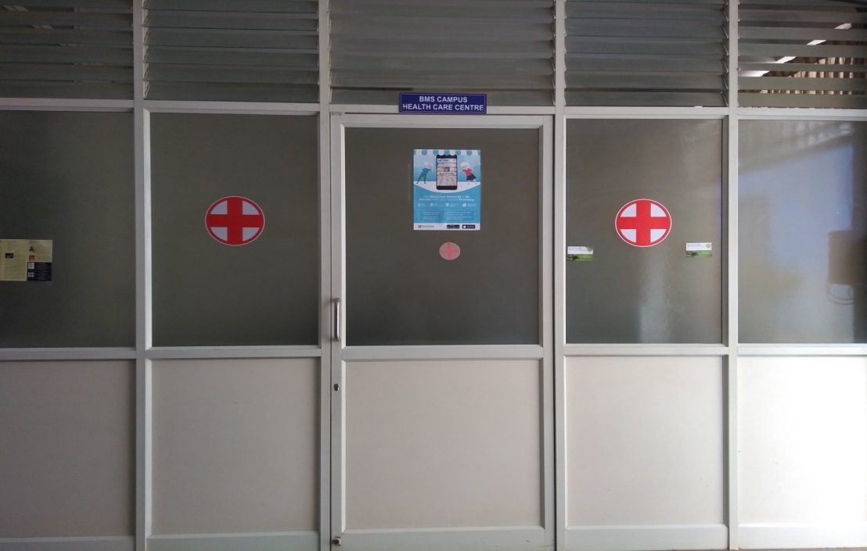
The following details should be posted at each laboratory:
- The names of person(s) with telephone number in the area trained in CPR (cardiopulmonary resuscitation) and First Aid.
- Telephone number for medical emergency (refer chapter 2-page no. 5).

General First Aid
- First aid equipment should be readily available in each laboratory. See Section, 5.5.2 of this document for additional information.
- Following any First Aid, a nurse or physician qualified to handle chemical emergencies should provide further examination and treatment. The location and phone number of emergency services should be clearly posted.
- It is recommended that each Department have at least one person trained in basic First Aid and Cardiopulmonary Resuscitation (CPR).
- Someone knowledgeable about the accident should always accompany the injured person to the medical facility and provide a copy of any appropriate MSDS if the accident resulted from chemical exposure.
- Minor incident requiring first aid should always be reported to a supervisor and recorded reasons for this are as follows.
- A minor injury may indicate a hazardous situation that should be corrected to prevent a serious future injury.
- It is important to document a minor injury as having been "work related" if the injury later leads to serious complications, such as from an infected cut.

Personal Protection during First Aid
- Persons responding to a medical emergency should be protected from exposure to blood and other potentially infectious materials. Protection can be achieved through adherence to work practices designed to minimize or eliminate exposure and through the use of personal protective equipment (i.e., gloves, masks, and protective clothing), which provide a barrier between the worker and the exposure source. For most situations in which first aid is given, the following guidelines should be adequate.
- For bleeding control with minimal bleeding and for handling and cleaning instruments with microbial contamination, disposable gloves alone should be sufficient.
- For bleeding control with excessive blood, disposable gloves, a coat, a mask, and protective eyewear are recommended.
- For measuring temperature or measuring blood pressure, no protection is required.
- After emergency care has been administered, hands and other skin surfaces should be washed immediately and thoroughly with warm water and soap if contaminated with blood, other body fluids to which universal precautions apply, or potentially contaminated articles. Hands should always be washed after gloves are removed, even if the gloves appear to be intact.

Leaking Compressed Gas Cylinders
Occasionally, a cylinder or one of its component parts develops a leak. Most such leaks occur at the top of the cylinder in areas such as the valve threads, safety device, valve stem, and valve outlet.
If a leak is suspected, do not use a flame for detection; rather, a flammable-gas leak detector or soapy water or other suitable "snoop" solution should be used. If the leak cannot be remedied by tightening a valve gland or a packing nut, emergency action procedures should be affected. Laboratory workers should never attempt to repair a leak at the valve threads or safety device; rather, they should consult with the supplier for instructions.
In the case of occurrence of any accident/ injury, take necessary emergency action (refer page no. 5 for emergency contact numbers) and then report the incident to Environmental Health

Chapter 4 – General safety rules
SAFETY RULES

General Safety Policies
- The safety and well-being of its students, faculty, and staff come above all other considerations at BMSCE Bengaluru.
- It is the first duty of research directors, instructors, supervisors, and all persons in authority to provide for safety in the environment and operations under their control.
- It is the BMSCE policy to comply not only with legal safety standards, but to act positively, where it can, to prevent injury, ill-health, damage, and loss arising from work carried out within its buildings.
- The BMSCE seeks to encourage all its members to participate in and contribute to the establishment and observance of safe working practices.

Elementary Safety Rules
- Keep this manual within easy access in your laboratory and be familiar with its contents.
- The safe way is the right way to do your job.
- Plan your work.
- Follow instructions.
- If you do not know how to do the job, ask your instructor, or research director. Report to the Safety Coordinator all unsafe conditions, unsafe acts and "near misses" which might cause future Environmental Incidents.
- Be able to use all safety devices and protective equipment provided for your use.
- Know the location and contents of the nearest safety station. Maintain good housekeeping by keeping your work area clean and orderly.
- Storage unused equipment in the storage room.
- Wear proper clothing.
- Avoid bringing long hair, loose sleeves, cuffs, rings, bracelets, etc. in proximity to moving machinery.
- Proper shoes are required in the laboratory.
- Horseplay in any form is dangerous and prohibited.
- Do not run in laboratory areas or halls.
- Do not oil, grease, or work on unprotected machinery in motion.
- All machinery and equipment under repair and adjustment shall be properly "locked out" and tagged.
- Know the evacuation procedure for your area, the location of fire exits, the location and use of fire extinguishers, and the proper method of reporting fires.
- Compressed gas cylinders should be secured firmly.
- Never move a cylinder unless the protective cap is screwed over the valve.
- DON‟T try completely new and untried experiments involving potentially dangerous chemicals without help.
- Changes to common procedures, including: "scaling-up" a reaction; a change in heat source or reaction temperature or pressure; change in solvent; etc., turn a known procedure into a high-risk procedure.
- Be sure to discuss all changes to know procedures with class instructor or laboratory engineer.
- It is your responsibility to see that adequate information is supplied to protect safety personnel or firemen who may have to deal with an emergency situation in your laboratory.
- Never leave a reaction or experiment running unattended.
- NEVER carry out hazardous work alone, especially at night or over the weekends. Make sure someone is in visible or audible range to help you if something goes wrong.
- Regardless of the work function, there should be a check procedure established at some regular interval to determine the physical state of the person working alone.
- Keep aware of where your neighbours are.
- Report every accident or fire, no matter how trivial, at once to the Campus Security.
- Smoking is prohibited in the campus.

Chapter 5 - Safety Rules – Labs

General

Personal safety practices
- Lab coats and safety glasses are required in laboratories employing chemicals, or biohazards. Never wear shorts, sandals, or open-toed shoes in a lab.
- Do not allow children or pets in laboratories.
- Never pipette anything by mouth.
- Be aware of dangling jewellery, loose clothing, or long hair that might get caught in equipment. • Store food and drinks in refrigerators that are designated for that use only.
- Never work alone in a lab if it is avoidable. If you must work alone, make someone aware of your location and have them call or check on you periodically.
- Wash your hands frequently throughout the day and before leaving the lab.
- Do not wear lab coats, gloves, or other personal protective clothing out of the lab and into non-lab areas. This clothing may have become contaminated, and you could spread the contamination. • Contact lenses should not be worn in a lab because chemicals or particulates can get caught behind them and cause severe damage to the eye.

Record Keeping
- It is the Lab Superintendent’s responsibility to keep an updated hazardous chemical inventory poster on file and to post a current inventory summary sign on each lab storage cabinet. Lab personnel should also keep usage records of high-risk substances (Hazardous Chemical Inventory Instruction Sheet).
- Each Lab Superintendent must document and report any lab accident that results in an injury, to the head of the department and then to the ENVIRONMENTAL Committee without any delay. A student injured in a laboratory should complete a First Report of Injury or Illness (with the assistance of his or her lab Superintendent).
- Laboratory Environmental training records are maintained in the department. Any laboratory Environmental training conducted by department or college must be documented and must contain the following information: date, training outline, length of training, persons conducting the training, and employee’s printed name and signature.
- Understand the chemical hazards and precautions specified in the pertinent Material Safety Data Sheets (MSDSs). Material Safety Data Sheets must be maintained for hazardous products in use. Departments are encouraged to maintain accessible copies of MSDSs for immediate reference by any concerned worker.

Housekeeping
The following recommendations are designed for accident prevention:
- Each laboratory Superintendent shall be responsible for maintaining the cleanliness of his/her area
- Clean your work area throughout the day and before you leave the lab
- If necessary, clean equipment after use to avoid the possibility of contaminating the next person who needs to use it.
- Equipment must be maintained in safe operating condition, including electrical wires in good condition, and not overloaded to any one outlet, pumps, mercury bubblers vented to fume hoods, belt guards on pumps, all equipment electrically grounded, and refrigerators properly designated and used (food or chemicals/flammables, but not both)
- Reasonably neat and clean counter tops and shelves
- Maintenance: Malfunctioning safety equipment detected by laboratory personnel during attempted use or visual surveys and used Fire Extinguishers should be reported immediately to the head of the department to coordinate prompt repair or replacement.
- Keep all aisles and walkways in the lab clear to provide a safe walking surface and an unobstructed exit.
- Do not block access to emergency equipment and utility controls.

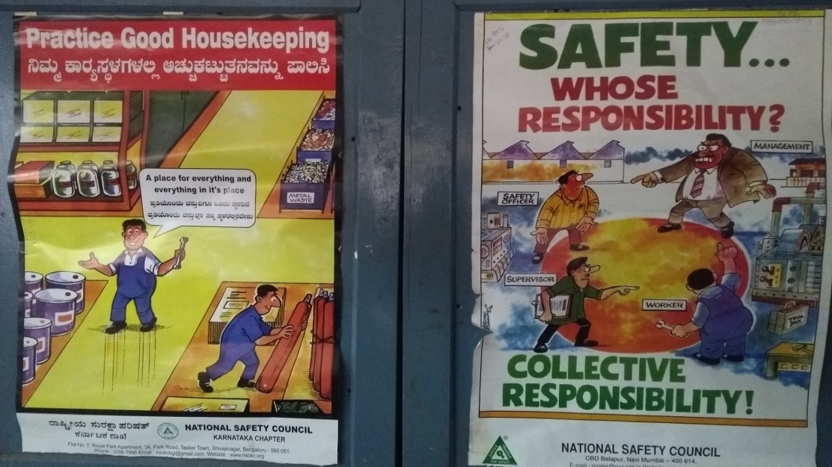

Labelling and signs
Prominent signs and labels of the following types should be used:
- Location signs shall be prominently posted to indicate safety showers, eye wash stations, and other safety and first aid equipment.
- Warning signs at areas or equipment where special or unusual hazards exist.
- The manufacturer’s label should be kept intact. Do not intentionally deface or obscure the label or the hazard warnings.
- When a chemical is transferred from the original container into a secondary container for storage, the new container should be labelled with the name of the product, the chemical constituents, and the primary hazard warnings.
- A plan showing evacuation route(s) should be posted prominently in each laboratory.
- Telephone numbers to be called in case of fire, accident, hazardous chemical spill, or another emergency.

Storage
Major chemical hazard classes should physically segregate chemicals. Incompatibles within these classes should also be segregated.
All Chemicals wherever possible should be stored in accordance with NON-REACTIVE SECONDARY CONTAINMENT Measures.
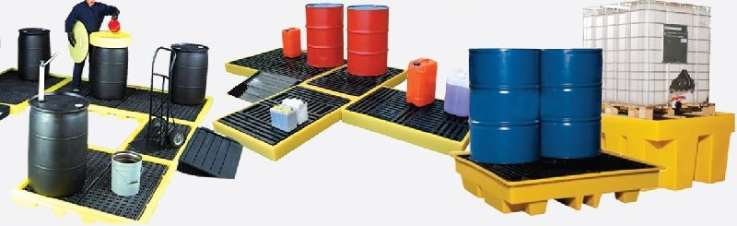

Table 4.1 lists segregation categories of chemicals usage.
Table 4.1. Segregation categories of chemicals
Acids | - Segregate acids from active metals such as sodium, potassium, magnesium, etc.  - Segregate oxidizing acids from organic acids such as glacial acetic acid and from flammable and Acids combustible materials, such as cardboard boxes.  - Segregate acids from chemicals which could generate toxic or flammable gases upon contact, such as sodium cyanide, iron sulphide, calcium carbide, etc.  - Segregate acids from bases.
Bases | - Segregate bases from acids, metals, explosives, organic peroxides, and easily ignitable materials.
Flammables | - Store in approved safety cans or cabinets. Segregate from oxidizing acids and oxidizers. Keep away from any source of ignition: heat, sparks, or open flames.
Oxidizers | - Store in a cool dry place. Keep away from combustible and flammable materials. Keep away from reducing agents such as zinc, alkali metals, and formic acid
Water Reactive Chemicals | - Store in a cool dry place away from any water source. Reactive  - Have a Class D fire Chemicals extinguisher available in case of fire
Pyrophoric Substances | - Materials that will react with the air to ignite when exposed (e.g., white phosphorus)  - Store the contained material in a cool dry place, making provisions for an airtight seal.
Light Sensitive Chemicals | - Store in amber bottles in a cool, dry, dark place.
Peroxidizable Chemicals | - Store in airtight containers in a dark and cool place. Most peroxidizable compounds are flammable and should be stored in a flammable liquid storage cabinet or room.  - Label the containers with receiving, and opening dates.  - Periodically test for the presence of peroxides.  - Discard before exceeding expiration date.
Toxic  Chemicals | - Store according to the nature of the chemical, using appropriate security where necessary
Nitrated  Compounds | - Nitrated compounds can be considered explosive; special care may be taken to handle them.

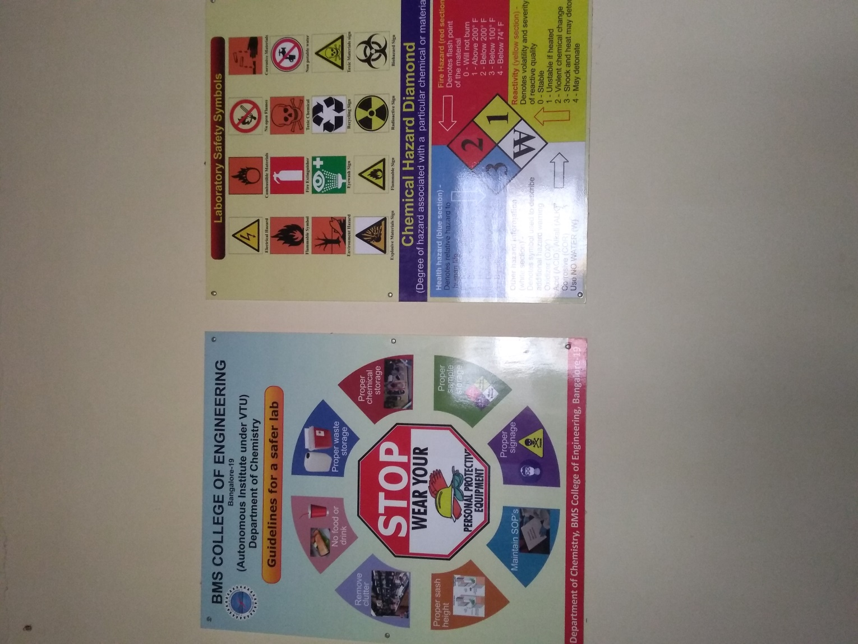

General considerations:
The following are the general storing rules for storing materials and equipment in cabinets and on shelves:
- Do not store flammable liquids in a refrigerator unless it is approved for such storage. Such refrigerators are designed with non-sparking components to avoid an explosion.
- Storing materials and equipment on top of cabinets should be avoided.
- Make sure that the weight of the chemicals does not exceed the load capacity of the shelf or cabinet.
- Heavy-duty brackets and standards should be used for wall-mounted shelving must have.
- Cabinets for chemical storage must be of solid, sturdy construction, preferably hardwood or metal.
- Do not store materials on top of high cabinets where they will be hard to see or reach.
- Do not store corrosive liquids above eye level.
- Return the chemicals to their proper locations after each use.
- Store chemicals do not require a ventilated cabinet inside a closable cabinet.
- Do not expose chemicals to heat or direct sunlight.
- Do not storage of incompatible chemicals in one cabinet.
- If the primary container breaks or leaks collect and store the material in corrosion resistant storage trays or secondary containers. 4.3.6 Storage of flammable liquid
- A maximum of 10 gallons of flammable liquids, in approved containers, maybe stored outside of a flammable liquid cabinet. See the table 4.2 for container types and limits.
Table 4.2 Approved Flammable Liquid Storage Containers **
Container Type | Flammable Liquids |  |  | Combustible Liquids
 | Class l-A | Class l-B | Class l-C | Class II | Class III
 | Flash point < 73°F  Boiling point <100°F  (Ethyl ether) | Flash point < 73°F  Boiling point <100°F  (Ethyl ether) | Flash point < 73°F  Boiling point <100°F  (Ethyl ether) | Flash point < 73°F  Boiling point <100°F  (Ethyl ether) | Flash point < 73°F  Boiling point <100°F  (Ethyl ether)
Glass | 1 pint* | 1 quart* | 1 gallon | 1 gallon | 5 gallons
Metal | 1 Gallon | 5 gallons | 5 gallons | 5 gallons | 5 gallons
Approved plastic | 0 | 0 | 0 | 0 | 5 gallons
Safety can | 2 gallons | 5 gallons | 5 gallons | 5 gallons | 5 gallons
* Containers may be up to 1 gallon for reagents of Analytical Purity Grade or High Grade. ** Source UW safety manual.

Chemicals Incompatibility
Mixing these chemicals purposely or as a result of a spill can result in heat, fire, explosion, and/or toxic gases. Details are given below.
Chemical | Keep out of contact with
Acetic Acid | Chromic Acid, nitric acid, hydroxyl-containing compounds, ethylene glycol, perchloric acid, peroxides, and permanganates
Acetone | Bromine, chlorine, nitric acid, sulphuric acid, and hydrogen peroxide
Acetylene | Bromine, chlorine, copper, mercury, fluorine, iodine, and silver
Metals such as calcium, lithium, magnesium, sodium, potassium, powdered aluminium | Carbon dioxide, carbon tetrachloride and other chlorinated hydrocarbons, water, Bromine, chlorine, fluorine, and iodine. Do not use C02, water or dry chemical, extinguishers. Use Class D fire extinguisher (e.g., Met-L X) or dry sand.
Aluminium and its (Alloys especially powders) | Acid or alkaline solutions, ammonium persulphate and water, chlorates, chlorinated compounds, nitrates, and organic compounds in nitrate/nitrate salt baths
Ammonia (anhydrous) | Bromine, chlorine, calcium hypochlorite, hydrofluoric acid, iodine, mercury, and silver
Ammonium Nitrate | Acids, metal powders, flammable liquids, chlorates, nitrates, sulphur and finely divided organics or other combustibles
Aniline | Hydrogen peroxide or nitric acid
Bromine | Acetone, acetylene, ammonia, benzene, butadiene, butane and other petroleum gases, hydrogen, finely divided metals, sodium carbide, and turpentine
Calcium Oxide | Water
Carbon (activated) | Calcium hypochlorite, all oxidizing agents
Caustic (soda) | Acids (organic and inorganic)
Chlorates or Perchlorates | Acids, aluminium, ammonium salts, cyanides, phosphorous, metal powders, oxidizable organics or other combustibles, sugar, sulphides, and sulphur
Chlorine | Acetone, acetylene, ammonia, benzene, butadiene, butane and other petroleum gases, hydrogen, finely divided metals, sodium carbide, and turpentine.
Chlorine Dioxide | Ammonia, methane, phosphine, hydrogen sulphide
Chromic Acid | Acetic acid, naphthalene, camphor, alcohol, glycerine, turpentine, and other flammable liquids
Copper | Acetylene, hydrogen peroxide
Cumene Hydroperoxide | Acids
Cyanides | Acids
Flammable Liquids | Ammonium nitrate, chromic acid, hydrogen peroxide, nitric acid, sodium peroxide, bromine, chlorine, fluorine, iodine
Hydrofluoric Acid | Ammonia, aqueous or anhydrous.
Hydrogen Peroxide (anhydrous) | Chromium, copper, iron, most metals or their salts, aniline, any flammable liquids, combustible materials, nitromethane, and all other organic material
Hydrogen Sulphide | Fuming nitric acid, oxidizing gases.
Iodine | Acetylene, ammonia (aqueous or anhydrous), hydrogen
Mercury | Acetylene, alkali metals, ammonia, fulminic acid, nitric acid with ethanol, hydrogen, oxalic acid.
Nitric acid (concentrated) | Acetic acid, acetone, alcohol, aniline, chromic acid, flammable gases and liquids, hydrocyanic acid, hydrogen sulphide and nitratable substances
nitrates | Potassium or sodium cyanide.
nitroparaffins | Inorganic bases, amines.
Oxalic acid | Silver, mercury, and their salts
Oxygen (liquid or enriched air) | Flammable gases, liquids, or solids such as acetone, acetylene, grease, hydrogen, oils, phosphorous
perchloric Acid | Acetic anhydride, alcohols, bismuth and its alloys, paper, wood, Acid grease, oils or any organic materials and reducing agents
peroxides (organic) | Acid (inorganic or organic). Also avoid friction and store cold.
phosphorus pentoxide | Alcohols, strong bases, water
potassium | Air (moisture and/or oxygen) or water, carbon tetrachloride, carbon dioxide
potassium Chlorate | Sulphuric and other acids.
Potassium Perchlorate | Acids
Potassium Permanganate | Benzaldehyde, ethylene glycol, glycerol, sulphuric acid.
silver and silver salts | Acetylene, oxalic acid, tartaric acid, fulminic acid, ammonium compounds
Sodium | See Alkali Metals
Sodium Chlorate | Acids, ammonium salts, oxidizable materials and sulphur
Sodium Nitrite | Ammonia compounds, ammonium nitrate, or other ammonium salts
Sodium Peroxide | Any oxidizable substances, such as ethanol, methanol, glacialacetic acid, acetic anhydride, benzaldehyde, carbon disulphide, glycerol, ethylene glycol, ethyl acetate, methyl  acetate, furfural, etc.
Sulphides | Acids.
Sulphur | Any oxidizing materials
Sulphuric Acid | Chlorates, perchlorates, permanganates, compounds with light metals such as sodium, lithium, and potassium
water | Acetyl chloride, alkaline and alkaline earth metals, their hydrides and oxides, barium peroxide, carbides, chromic acid, phosphorous oxychloride, phosphorous pentachloride, phosphorous pentoxide, sulphuric acid, sulphur trioxide

Compressed gas cylinder storage
Cylinders containing the compressed gases listed below must be stored in a ventilated enclosure (cage) outside the labs. Cylinders must be positioned and secured at all times so that they will not fall down.
Acetylene | Fluorine
Ammonia | Formaldehyde
Arsenic Penta fluoride | Germane
Arsine | Hydrogen Chloride, anhydrous
Boron Trifluoride | Hydrogen Cyanide
1,3 – Butadiene | Hydrogen Fluoride
Carbon Monoxide | Hydrogen Selenide
Carbon Oxysulphide | Hydrogen Sulphide
Chlorine | Methylamine
Chlorine Monoxide | Methyl Bromide
Chlorine Trifluoride | Methyl Chloride
Chloroethane | Methyl Mercaptan
Cyanogen | Nitrogen Oxides
Diborane | Phosgene
Dichloroborane | Phosphine
Dichlorosilane | Silane
Dimethylamine | Silicon Tetrafluoride
Ethane | Stibine
Ethylamine | Trimethylamine
Ethylene
Ethylene Oxide

Unattended Operation
- Unattended operations or experiments should be avoided whenever possible.
- It is the responsibility of the worker to design all experiments so as to prevent the release of hazardous substances in the event of interruptions in utility services such as electricity, cooling water, and inert gas.
- If an operation needs to run longer than working hours, the door to the room must be labelled with the name and phone number where the person responsible for the reaction can be reached.
- Clear directions for an untrained person to shut down the operation during an emergency should be posted.
- Arrangements should be made for other workers to periodically inspect the operation.
- Laboratory lights should be left on, and signs should be posted identifying the nature of the experiment and the hazardous substances in use.

Working alone
Working alone in the labs is not allowed under any conditions if hazards exist. An individual is advised to work only under conditions in which appropriate emergency aid is available when needed.

Handling and transporting chemicals.
To avoid spills and chemical exposure due to incorrect transportation of chemicals consider the following:
- Keep chemicals in their original packing when transporting, if possible.
- When transporting compressed gas cylinders do not carry or roll cylinders from one area to another. The cylinder should always be strapped in a cylinder cart and the valve protected with a cover cap.
- Use a bottle carrier, cart or other secondary container when transporting chemicals in breakable containers (especially 250 ml or more) through hallways or between buildings. Secondary containers are made of rubber, metal, or plastic, with carrying handle(s).
- All chemical contaminated waste shall be treated as hazardous waste and disposed in accordance with hazardous waste management rules

Handling glassware
- Only glass in good condition should be used and discard or send for repair all broken, chipped, starred or badly scratched glassware.
- Do not store glassware near the edge of shelves. Store large or heavier glassware on lower shelves.
- Avoid catching the glassware if it is dropped or knocked over.
- A proper size of the glassware should be used; allow at least 20% free space.
- All chemical contaminated waste shall be treated as hazardous waste and disposed in accordance with hazardous waste management rules

Safety Guidelines for Non-Regular Classes
- Students should be assigned to work in laboratories in which graduate students and/or postgraduates also are working.
- Students should receive instruction and close supervision directly from their faculty mentor, although a senior graduate/postgraduate student working with the faculty member may also be involved.
- Students should not work alone, particularly at night or on weekends, on operations involving chemicals or other hazards of the type covered in the Safety Manual. If work at night or on weekends is required, it should only be done with the express permission of the faculty mentor and with specific arrangements to avoid working alone.
- An outline of the independent study project, including the goal(s) and as far as practical, the kinds of experiments to be carried out, methods to be used and data to be collected, as well as a proposed schedule of accomplishments, should be completed (by the student and faculty member together) before the beginning of the first semester or as soon as possible thereafter. This will serve as a guide so that it is clear to student and mentor what each expects at each stage of the project and for the Overall project. It would be appropriate for each to sign and keep a copy. This document should also state where the lab space for the project is and who else is to be involved in the supervision (if anyone).
- Supervising faculty and, if appropriate, associate supervisors, should discuss with the student the potential hazards of all experiments to be carried out, and closely supervise preparations for all new potentially hazardous operations.
- Students should agree with their supervising professors on a weekly work schedule and should make every effort to maintain this schedule.
- Students must read the concerned part(s) in the safety manual as specified by the instructor and sign a statement that they have done so before they are allowed to begin laboratory work.
- In order to comply with first four guidelines above, that faculty without graduate students or postdoctoral associates or without lab space should enter into collaborations with other faculty who have students and facilities, or at least make arrangements to "borrow" appropriate lab space. If at all possible, these arrangements should be made (at least tentatively) before students are accepted for supervision. If necessary, the Coordinator of Independent Study can be called on to facilitate arrangements.

Personal Protection
- The laboratory should be kept clean and free from clutter, by regular maintenance. At the completion of each experiment, equipment should be cleaned and properly stored. Do not let unused equipment or chemicals accumulate in the lab. Do not use the aisles of the lab or the space in front of the emergency escape panels for storage. Dispose of all hazardous wastes in accord with the procedures indicated in this manual. Reagent bottles must be properly labelled - when pouring hold the bottle with its label to your palm to protect the label. Notify your Head of the Department of bottles whose contents are in doubt.

Hygiene
- Wash hands often-always before eating and before leaving the laboratory. Washing should be an instinctive reaction to spillage of any chemical on the skin.
- Never eat or drink in the lab - never use lab equipment as a food or drink container.
- No food items should ever be stored or even cooled in a laboratory refrigerator. Food and beverages can become contaminated within a very short period of time to a life-threatening level by absorption of chemical vapours. Any food/beverage found in inappropriate areas will be removed without notice.

Eye protection
In all laboratories where chemicals are used there is the hazard of splashes or dust particles entering into the eyes. Pressurized or vacuum vessels may explode or implode sending shrapnel through the lab. While working with electrical wiring there are hazards from molten solder and debris. Therefore, it requires the use of various types of eye protection listed in order of increasing effectiveness include:
1. Ordinary spectacles
2. Safety glasses with side shields
3. Protective goggles, which can be worn over spectacles, if necessary
4. Face shields
5. Head shields, which protect all of the head and throat
Most lab operations simply require the use of safety glasses. However, when any chemicals are being used at least chemical goggles should be used or in some cases a face shield is required.

Ear protection
The healthy ear can detect sounds ranging from 15 to 20,000 Hertz. Temporary exposure to high noise levels will produce a temporary hearing loss. Long-term exposure to high noise levels produces permanent hearing loss. There appears to be no hearing hazard (although possible psychological effects) to noise exposure below 80 db. Exposure above 130 dB is hazardous and should be avoided. Earmuffs offer the highest noise attenuation and are preferred for levels above 95 db. Earplugs are more comfortable and are preferred in the 80-95 dB range. If you suspect a hearing hazard exists, then notify the instructor or Superintendent to check the sound level.
Where possible acoustics have to be ensured if ambient noise from the activities are more than 75 Db

Foot protection
All persons in labs must wear shoes (bare feet are not allowed) and adequate clothing to protect the skin from spilled chemicals, if any.

Skin protection
1. A lab coat or apron should be worn when working with hazardous materials.
2. Never wear shorts in the lab.
3. Always wear clothing that minimizes the amount of skin that can be exposed to potentially harmful chemicals.

Hand protection
Use gloves made of a material suitable for the operation for any laboratory procedure. Gloves are made of a variety of materials and have specific uses, if used improperly they may not provide the necessary protection.

Respirators
Respirator use should be avoided if at all possible (and is usually not required if adequate precautions are taken). Fume hoods provide constant respiratory protection in all laboratories in the building. Such protection is adequate for most controlled experiments in using the hoods in the building.

Hoods
The most important laboratory equipment is the chemical fume hood because it is considered the first line of defence against exposure to hazardous chemicals. A Superintendent should check fume hoods at least once annually. However, lab personnel may request more frequent performance checks, particularly when the fan/motor is serviced. Where present, face velocity monitors are recalibrated at the same time. When a fume hood is suspected of breaking down, inform the Superintendent.
The following guidelines should be followed whenever a chemical fume hood is being used:
Vertical sash hoods
Use the chemical fume hood with the vertical sash lowered to 18" or the indicated operating height. The operating height should be clearly marked by arrows on yellow tags located on either side of the sash track. Do not work in the hood with the hood sash fully open. To be effective, the fume hood must be operated with the sash at the designated operating height. This will allow the sash to serve as a physical barrier between your face and the contents of the fume hood in case of explosion or fire.
Horizontal sash hoods
Use the chemical fume hood with the horizontal sash(es) in place to serve as a physical barrier between your face and the hood contents.
Proper hood operation
- Keep the sash(es) clean. Never obstruct your view with paper, notices, decals, or other items on the sash(es).
- Do not place equipment or chemicals close to slot openings in the baffles at the rear of the hood or close to the front edge of the hood.
- Avoid sudden movements while working in the hood.
- Perchloric acid can leave explosive residues in a fume hood, duct system, or on a hood fan. Perchloric acid can also form explosive mixtures with organic compounds. for this reason, the use of Perchloric acid in fume hoods must be carefully evaluated prior to use.

Safety Equipment
The following safety equipment should be in available in each lab:
- Fire extinguishers
- A first aid kit.
- A flashlight for use in case of a power failure

Fire extinguishers
Minimum of two sets of fire protection equipment must be available in each lab at two different locations. The extinguishers should be tested and maintained in accordance with the applicable standards.

First aid kits
- First aid kits are to be used for the immediate response to minor incident, such as cuts or minor burns and should be located in accessible places (with location clearly marked) in the laboratory.
- A lab superintendent should be responsible for monitoring and maintaining the first aid kit(s).
- First aid kit contents should include items such as Band-aids, sterile gauze pads, bandages, scissors, antiseptic wipes, or ointments. All kits should also contain examination gloves for response to emergencies in which blood is present.
- An emergency electrical response board should be available in Laboratories where high-voltage equipment is in use. This will contain an instruction card and a non-conductive stick to turn off the equipment and remove the shock victim from contact with the source.

Safety shields
Equipment that might cause high explosions, implosions or splash hazards should be protected using safety shields. Laboratory equipment should be shielded on all sides so that there is no line-of-sight exposure of personnel. Portable shields can be used to protect against hazards of limited severity, e.g., small splashes, heat, and fires.

Chapter 6 – Fire safety
FIRE SAFETY

Fire protection of buildings
This Part covers the requirements for fire prevention, life safety in relation to fire and fire protection of buildings. The Code specifies construction, occupancy and protection features that are necessary to minimize danger to life and property from fire.
Group B Educational Buildings
These shall include any building used for school, college, other training institutions for day-care purposes involving assembly for instruction, education, or recreation for not less than 20 students.
Buildings and structures under Group B shall be further sub-divided as follows:
Sub-division B-1 Schools up to senior secondary level
Sub-division B-2 All others/training institutions
a) Sub-division B-1 Schools up to senior secondary level — This sub-division shall include any building or a group of buildings under single management which is used for students not less than 20 in number.
b) Sub-division B-2 All others/training institutions — This sub-division shall include any building or a group of buildings under single management which is used for students
not less than 100 in number. In the case of temporary buildings/structures which are utilized for educational purposes, the provisions of 3.2.5.3 shall apply.
If residential accommodation is provided in the schools/institutions that portion of occupancy shall be classified as a building in sub-division A-3.

National building code 2005- Part 4(fire & life safety)
- For fire prevention
- Group B to be referred for schools and colleges.
- Subdivision B-2 for institutions under single management not greater than 100 students
- Subdivision A-3 referred for building with sleeping accommodation.

Fire exit signs
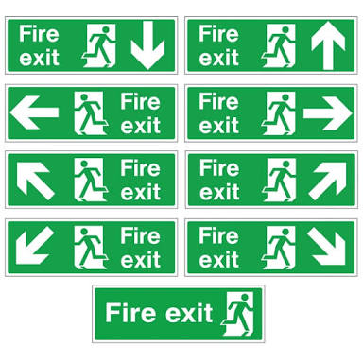

Ventilation facility
According to NBC Part 4 Proper ventilation should be provided for lifts, corridors, passages, and internal staircase
- Ventilation is provided for lifts
- Corridors, passages, and internal staircases have ventilation

Type of fire extinguishers
Based on the various class of fire they are classified
Different Classes of fire are listed below
- Class A Fire: it includes combustible materials such as woo, plastic, paper, cloth
- Class B fire: it includes flammable liquids or gases, or paints
- Class C Fire: it includes electrical equipment
- Class D Fire: it includes combustible metal fires
- Class K Fire: it includes cooking media such as cooking oil etc
Class A Fires; Caused by Ordinary Combustibles
Class A fires are the most common type of fire, and are caused when solid, organic materials such as wood, cloth, rubber, or some plastic become heated, ignite, and undergo combustion. This class of fire is comparatively easy to remove and contain the easiest way to remove the heat is to spray the burning material with water.
Class B Fires; Caused by Flammable Liquids and Gases
Class B fires are caused by flammable, combustible liquid, and gases.
To extinguish this type a solid stream of water should never be used because this will scatter the fuel causing it to spread rather than fade.
These fires are extinguished by dry chemical and Halon extinguishing agents, although smothering with CO₂ or, for liquids, foam is also effective. They inhibit the chemical reaction of the fire which eventually finishes it.

Class C Fires; Caused by Electrical Equipment’s
Class C fires are electrical fires involving potentially energized electrical equipment. They are usually caused by short-circuiting of machinery or overloaded electrical cables.
These fires are extremely dangerous and cannot be removed using water as water itself catches electricity which can spread the fire further.
Therefore, to fight the class C fires special extinguishing agents such as Carbon dioxide CO₂, FM-200, and dry chemical powder extinguishers such as PKP and even baking soda are used.
Class D Fires Caused by The Metals
Class D fires are caused when flammable metals such as sodium, potassium, and lithium etc. get ignited and produce a fire. Metal fires can be very dangerous if not controlled in time. They too like electrical fires cannot be extinguished using water as it can make the fire worse; therefore, special extinguishing agents are used.
Class K Fires Caused By cooking media
- Fuel: Combustible cooking media
  - Cooking oils
  - Grease
- Extinguishing agents:
  - The designation is new and coincides with a new classification of Class K extinguishing agents.
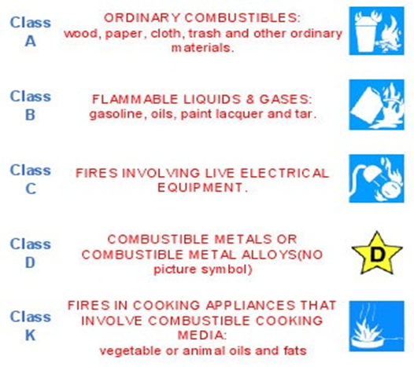

Fire extinguisher color codes
Each extinguishing medium is assigned its own color code: red for water, cream for foam, blue for dry power, and black for carbon dioxide. A fifth color, yellow, has been added for the new Wet Chemical type of fire extinguisher.

This unique colour coding helps:
- Easy identification of contents
- Identify extinguishers from any angle
- Identify extinguishers from a distance
- Make the extinguisher more visible
- Avoid confusion between different types of extinguishers
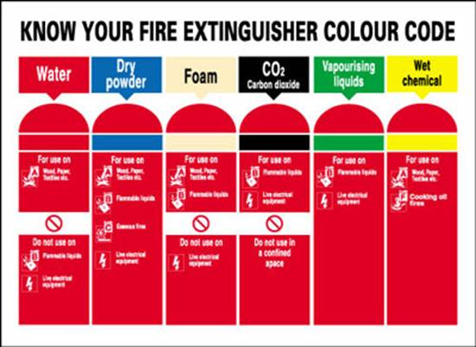
Fire extinguisher colour code
These are some of the fire extinguishers used in BMSCE PG Block
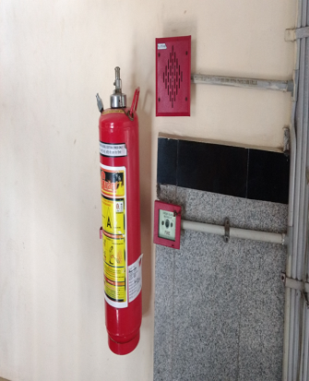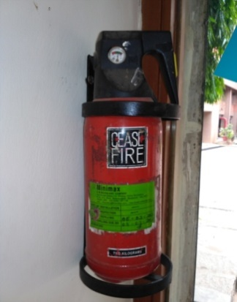
FOR CLASS A FIRE EXTINGUISHER CEASE FIRE TYPE
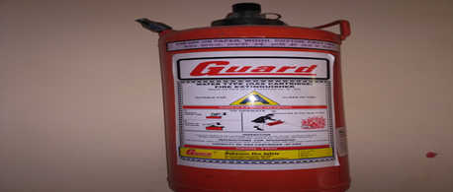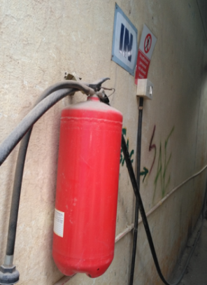
FOR CLASS A FIRE EXTINGUISHER CO₂ FIRE EXTINGUISHER

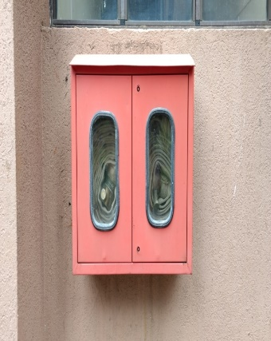
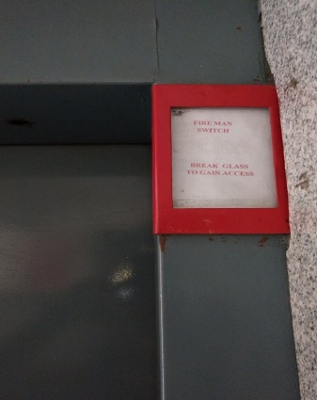
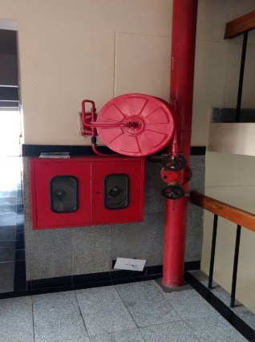
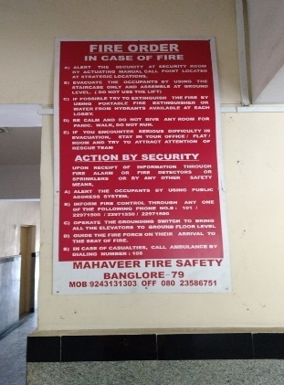
Fire Fighting Equipment’s

Fire sprinkler Fire Fighting Station in
BMSCE CAMPUS
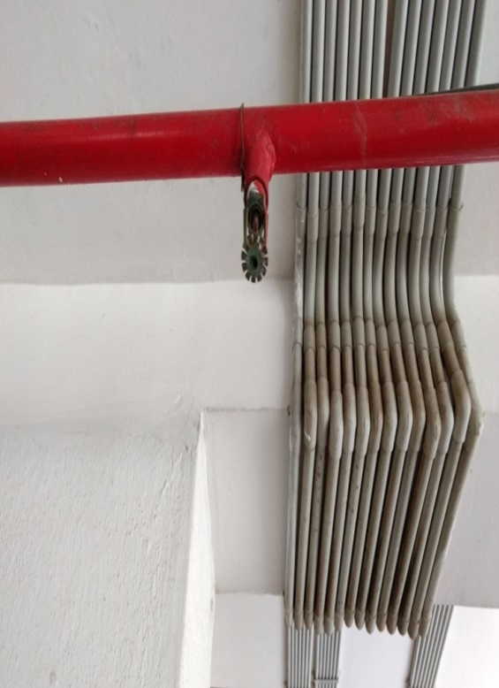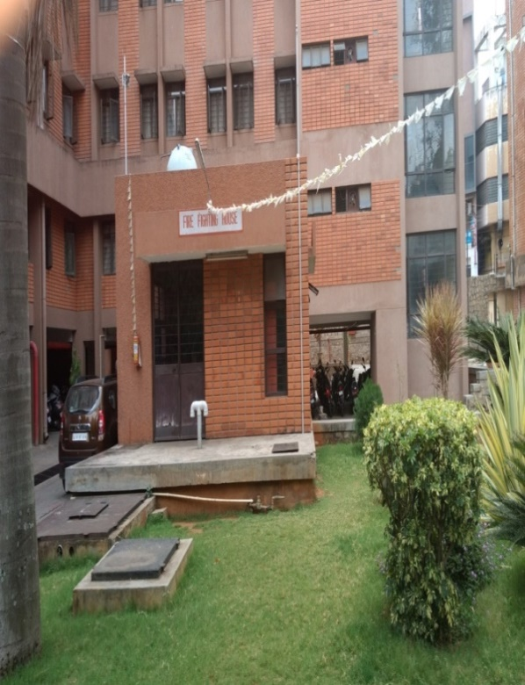
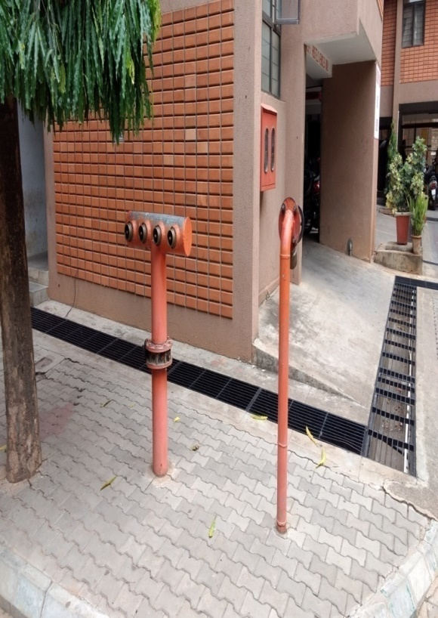
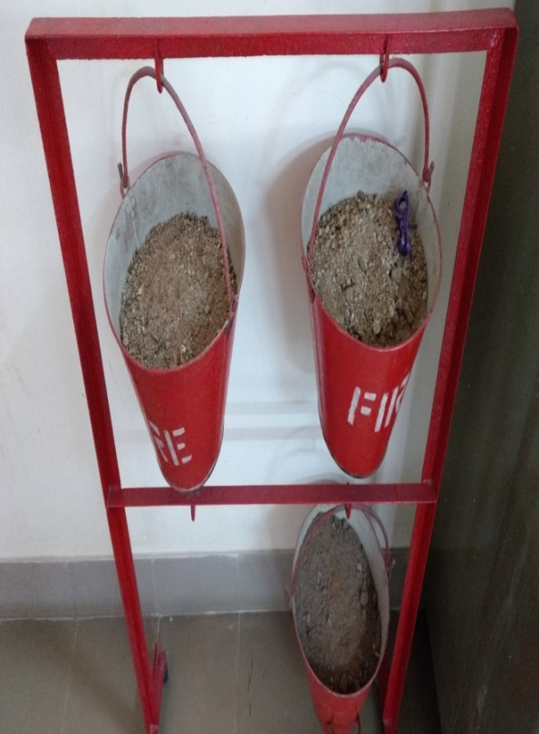

Safety Regulations Sign Board

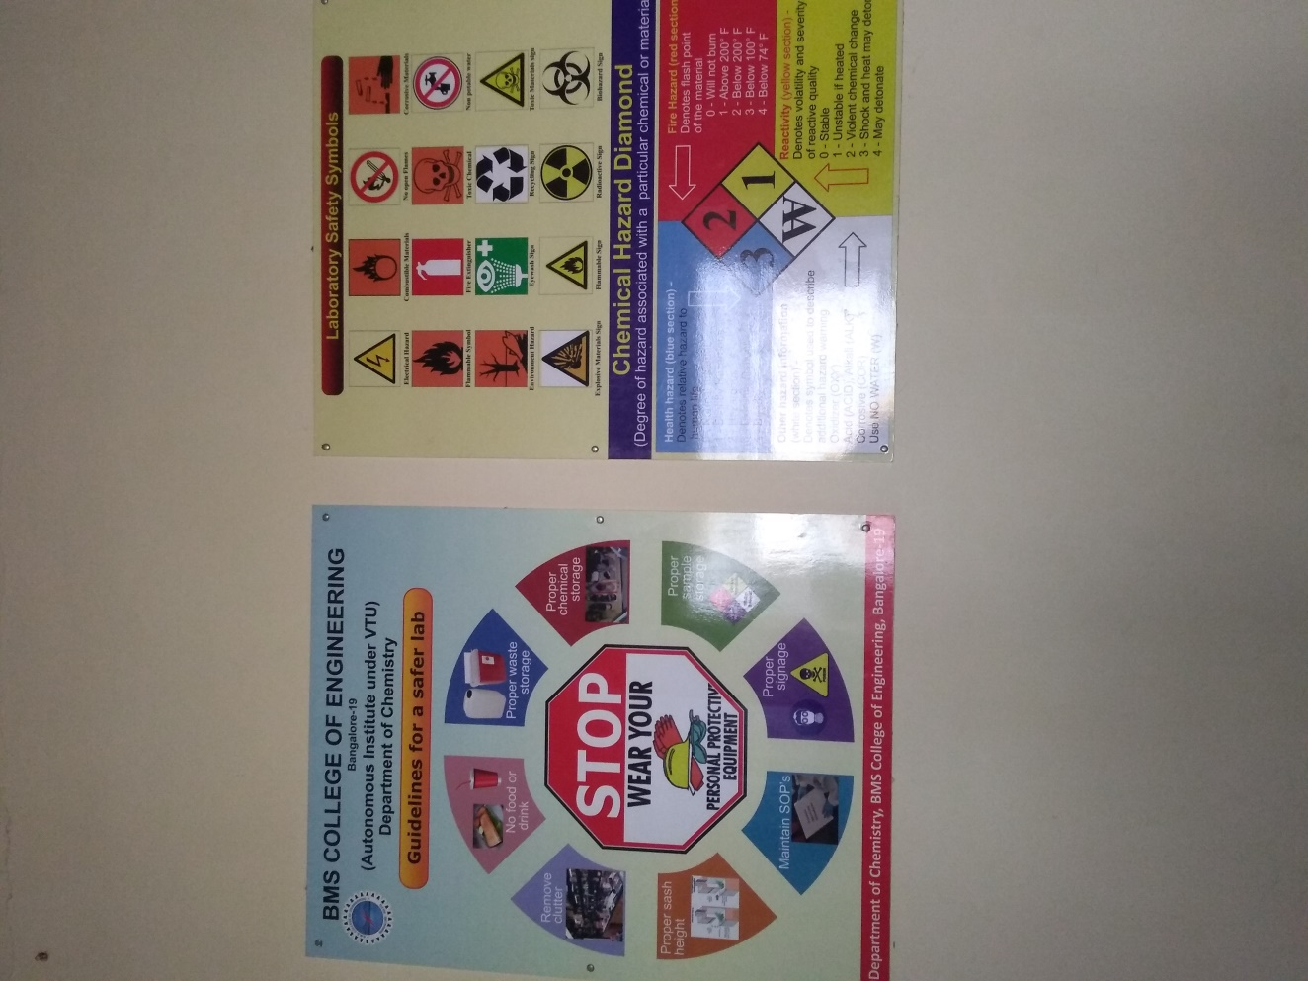
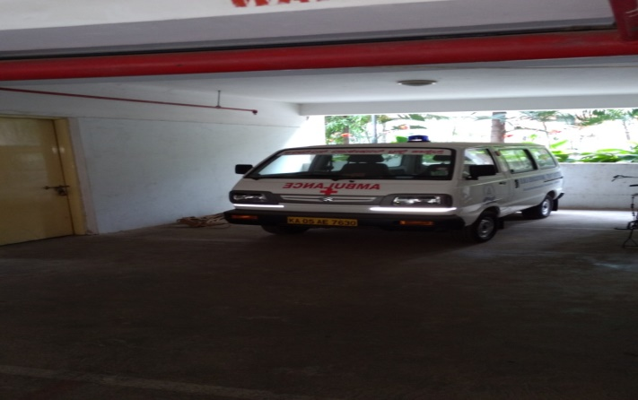
Ambulance Facility in BMSCE

Fire emergency procedures
The safety procedures discussed here are in line with the Indian Standard IS14435/1997
If you discover a fire:
- Activate the nearest fire alarm.
- Notify the fire department by dialling 101. Give your location, the nature of the fire, and your name.
- Notify Head of the Department and other occupants.
Fight the fire ONLY if:
- The fire department has been notified of the fire.
- The fire is small and confined to its area of origin
- You have a way out and can fight the fire with your back to the exit
- You have the proper extinguisher, in good working order and know how to
use it.
If you are not sure of your ability or the fire extinguisher capacity to
contain the fire, leave the area.
If you hear a fire alarm:
- Evacuate the area. Close windows, turn off gas jets, and close doors as you leave.
- Leave the building and move away from exits and out of the way of emergency operations.
- Assemble in a designated area (Safe assembly area).
- Report to the campus security so he can determine that all personnel have evacuated your area.
- Remain outside until competent authority states that it is safe to re-enter.
- Evacuation Routes
- Learn at least two escape routes, and emergency exits from your area.

Chapter 7 – Chemical and Biohazards
CHEMICAL and BIOHAZARD

Introduction
The specific rules and procedures for working with hazardous chemicals, outlined in this chapter, give an insight into the proper methods for handling materials, which pose significant hazards due primarily to their chronic toxicity. However, these specific rules and procedures, along with the general rules for working with chemicals, do not address some of the basic physical hazards, which may stem from acute exposure to different types of laboratory chemicals. This chapter offers some specific guidelines for working with common laboratory chemicals that, for varying reasons, are acutely toxic in the sense that they may cause considerable harm to human life and health pending short term exposures. The Chapter addresses five fundamental classes of laboratory chemicals: flammables, corrosives, oxidizers, reactive and compressed gases.

Flammable solvents
Flammable liquids are the most common chemicals found in a laboratory. The primary hazard associated with flammable liquids is, of course, their ability to readily ignite and burn. One should note that it is the vapour of a flammable liquid, not the liquid itself that ignites and causes a fire. Examples of flammable liquids are acetone, ethyl ether, toluene, methyl format, etc. In general, the vapours of many flammables are irritating to mucous membranes of the respiratory system and eyes, and in high concentrations are narcotic.
- The rate at which a liquid vaporizes is a function of its vapour pressure. In general, liquids with high vapour pressures evaporate at a higher rate compared to liquids of lower vapour pressure. It should be noted that the vapour pressure increases rapidly as the temperature is raised, as does the evaporation rate. A reduced-pressure environment also accelerates the rate of evaporation.
- The flash point of a liquid is the lowest temperature at which a liquid gives off vapor at such a rate as to form an air: vapour mixture that will ignite but will not sustain ignition. Many commonly used flammable solvents have flashpoints significantly lower than room temperature. The table 6.1 shows the flash point of few commonly used solvents.
Table 6.1. Flash point of few commonly used solvents
Compound | Flash Point (°C)
Diethyl ether | -45.0
Acetone | -17.8
Isopropyl alcohol | 11.7

- The limits of flammability or explosivity define the range of fuel air mixtures that will sustain combustion. The lower limit of this range is called the Lower Explosive Limit or LEL, and the higher limit of this range is called the Upper Explosive Limit or UEL. Materials with very broad flammability ranges (e.g., acetylene, LEL = 3%, UEL = 65%) are particularly treacherous due to the fact that virtually any fuel air combination may form an explosive atmosphere.
- The vapour density of a flammable material is the density (mass to volume ratio) of the corresponding vapour relative to air under specific temperature and pressure conditions. Flammable vapours with densities greater than unity (and thus "heavier" than air) are potentially lethal because they will accumulate at floor level and flow, with remarkable ease, in much the same manner that a liquid would. The obvious threat is that these mobile vapours may eventually reach an ignition source, such as an electrical outlet or a Bunsen burner at another student's bench.

Use and storage.
- Flammable liquids that are not in active use must be stored in safe containers inside fire resistant storage cabinets designed for flammables, or inside storage rooms.
- Minimize the amount of flammable liquids stored in the lab.
- Use flammables only in areas free of ignition sources.
- The transfer of material to or from a metal container is generally accompanied by an accumulation of static charge on the container. This fact must be kept in mind when transferring flammable liquids, since the discharge of this static charge could generate a spark, thereby igniting the liquid. To make these transfers safer, flammable liquid dispensing and receiving containers must be bonded together before pouring. Large containers such as drums must also be grounded when used as dispensing or receiving vessels. All grounding and bonding connections neighbours must be metal to metal. (The aforementioned bonding and grounding wires may be found in most lab safety catalogues).
- Never heat flammables with an open flame. Instead, use steam baths, water baths, oil baths, hot air baths, sand baths or heating mantles.
- Do not store flammable liquids in a refrigerator unless it is approved for such storage. Such refrigerators are designed with non-sparking components to avoid an explosion.

First aid
The first aids to be given to a person in case of exposure to flame/ flammable solvents are presented in table 6.2.
Table 6.2. The first aids to a person in case of exposure to flame/flammable solvents
Inhalation Exposures | • Remove person from the contaminated area if it is safe to Inhalation do so.  • Get medical attention and do not leave person unattended.
Ingestion Exposures | • Remove the person, if possible, from the source of contamination.  • Get medical attention
Dermal Exposures | •Remove person from source of contamination  • Remove clothing, jewellery, and shoes from the affected areas.  • Obtain medical attention.
Eye Contact | • Remove person from the source of contamination.  • Flush the eyes with water for at least 15 minutes.  • Obtain medical attention.

Personal protective equipment
Always use a fume hood while working with flammable liquids. Nitrile and neoprene gloves are effective against most flammables. Wear a non-flammable lab coat to provide a barrier to your skin and goggles if splashing is likely to occur.

Oxidizers
Oxidizers or oxidizing agents pose fire and explosion hazards on contact with combustible materials. Depending on the class, an oxidizing material may increase the burning rate of combustibles with which it comes in contact; It cause the spontaneous ignition of combustibles with which it comes in contact; or undergo an explosive reaction when exposed to heat, shock, or friction. Oxidizers are generally corrosive, and many are highly toxic. Some examples of common oxidizers include peroxides, nitrites, nitrates, perchlorates, chlorates, chlorites, hypochlorites, dichromates, among others.

Use and storage
- In general, store oxidizers away from flammables, organic compounds, and combustible materials.
- Strong oxidizing agents like chromic acid should be stored in glass or some other inert container, preferably unbreakable. Corks and rubber stoppers should not be used.
- Reaction vessels containing appreciable amounts of oxidizing material should never be heated in oil baths, but rather on a heating mantle or sand bath.

Use and storage of perchloric acid
Perchloric acid is an oxidizing agent of particular concern. The oxidizing power of perchloric acid increases with an increase in concentration and with an increase in temperature. Cold, 70% perchloric acid is a strong, non-oxidizing corrosive. A 72% perchloric acid solution at elevated temperatures is a strong oxidizing agent. An 85% perchloric acid solution is a strong oxidizer at room temperature.
  - Do not attempt to heat perchloric acid if you do not have access to a properly functioning perchloric acid fume hood. Perchloric acid can only be heated in a hood specially equipped with a washdown system to remove any perchloric acid residue. The hood should be washed down after each use, and it is preferred to dedicate the hood to perchloric acid use only.
  - Whenever possible, substitute a less hazardous chemical for perchloric acid.
  - Perchloric acid can be stored in a perchloric acid fume hood. Keep only the minimum amount necessary for your work. Another acceptable storage site for perchloric acid is on a metal shelf or in a metal cabinet away from 45 organic or flammable materials. A bottle of perchloric acid should also be stored in a glass secondary container to contain leakage.
  - Do not allow perchloric acid to come in contact with any strong dehydrating agents such as sulphuric acid. The dehydration of perchloric acid is a severe fire and explosion hazard.
  - Do not order or use anhydrous perchloric acid. It is unstable at room temperature and can decompose spontaneously with a severe explosion. Anhydrous perchloric acid will explode upon contact with wood.

First aid
In general, if a person has inhaled, ingested, or come into direct contact with these materials, the person must be removed from the source of contamination as quickly as possible when it is safe to do so. Medical help must be obtained. In the case of an exposure directly to the skin or eyes it is imperative that the exposed person be taken to an emergency shower or eyewash immediately. Flush the affected area for a minimum of 15 minutes, and then get medical attention.

Personal protective equipment
In many cases, the glove of choice will be neoprene, polyvinyl chloride (PVC), or nitrile. Be sure to consult a glove compatibility chart to ensure the glove material is appropriate for the particular chemical you are working with. Goggles must be worn if the potential for splashing exists or if exposure to vapor or gas is likely.
Always use these materials in a chemical fume hood as most pose a hazard via inhalation. Cylinders of compressed gases should be kept in ventilated cabinets.

Corrosives

General characteristics
- Corrosives are most commonly acids and alkalis, but many other materials can be severely damaging to living tissue.
- Corrosives can cause visible destruction or irreversible alterations at the site of contact. Inhalation of the vapor or mist can cause severe bronchial irritation. Corrosives are particularly damaging to the skin and eyes.
- Certain substances considered non-corrosive in their natural dry state are corrosive when wet such as when in contact with moist skin or mucus membranes. An example of these materials is lithium chloride, halogen fluorides, and allyl iodide.
- Sulphuric acid is a very strong dehydrating agent and nitric acid is a strong oxidizing agent. Dehydrating agents can cause severe burns to the eyes due to their affinity for water.
Examples of corrosives include sulphuric acid, chromic acid, ammonium bifluoride, bromine, ammonium hydroxide, among others.
All corrosives possess the property of being severely damaging to living tissues and also attack other materials such as metal. Skin contacts with alkali metal hydroxides, e.g., sodium hydroxide and potassium hydroxide, is more dangerous than with strong acids. Contact with alkali metal hydroxides normally causes deeper tissue damage because there is less pain than with an acid exposure. The exposed person may not wash it off thoroughly enough or seek prompt medical attention.
All hydrogen halides are acids that are serious respiratory irritants and also cause severe burns. Hydrofluoric acid is particularly dangerous. At low concentrations, hydrofluoric acid does not immediately show any signs or symptoms upon contact with skin. It may take several hours for the hydrofluoric acid to penetrate the skin before you would notice a burning sensation. However, by this time permanent damage, such as second and third degree burns with scarring, can result.

Use and storage
- Always store acids separately from bases. Also, store acids in acid storage cabinets away from flammables since many acids are also strong oxidizers.
- Do not work with corrosives unless an emergency shower and continuous flow
eyewash is available.
- Add acid to water, but never add water to acid. This is to prevent splashing from the acid due to the generation of excessive heat as the two substances mix.
- Never store corrosives above eye level. Store on a low shelf or cabinet.
- It is a good practice to store corrosives in a tray or bucket to contain any leakage.
- When possible, purchase corrosives in containers that are coated with a protective plastic film that will minimize the danger to personnel if the container is dropped.
- Store corrosives in a wooden cabinet or one that has a corrosion-resistant lining. Corrosives stored in an ordinary metal cabinet will quickly damage it. If the cabinet supports that hold up the shelves become corroded, the result could be serious. Acids should be stored in acid storage cabinets specially designed to hold them and Nitric acid should be stored in a separate cabinet or compartment.

Use and storage of hydrofluoric acid
- Hydrofluoric acid is extremely hazardous and deserves special mention. Hydrofluoric acid can cause severe burns and inhalation of anhydrous hydrogen
fluoride can be fatal. Initial skin contact with hydrofluoric acid may not produce any symptoms.
- Only persons fully trained in the hazards of hydrofluoric acid should use it.
- Always use hydrofluoric acid in a properly functioning fume hood. Be sure to wear personal protective clothing!
- If you suspect that you have come in direct contact with hydrofluoric acid: wash the area with water for at least 15 minutes, remove clothing, then promptly seek medical attention. If hydrogen fluoride vapours are inhaled, move the person immediately to an uncontaminated atmosphere (if safe to do so), keep the person warm, and seek prompt medical attention.
- Never store hydrofluoric acid in a glass container because it is incompatible with glass.
- Store hydrofluoric acid separately in an acid storage cabinet and keep only that amount necessary in the lab.
Creams for treatment of hydrofluoric acid exposure are commercially available.

First Aid
The first aids to be provided to a person in case of exposure to hydrochloric acid are presented in table 6.3.
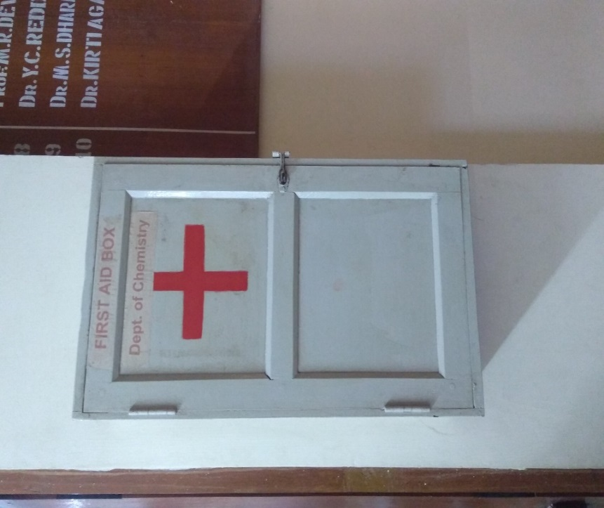 | 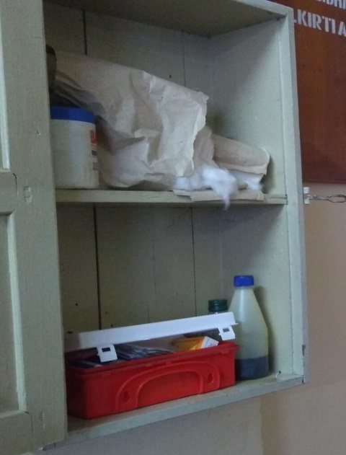

Personal protective equipment
Always wear the proper gloves when working with acids. Neoprene and nitrile gloves are effective against most acids and bases. Polyvinyl chloride (PVC) is also effective for most acids. A rubber coated apron and goggles should also be worn. If splashing is likely to occur, wear a face shield over the goggles. Always use corrosives in a chemical fume hood.

Reactive

General characteristics
Reactive chemicals are grouped as a category primarily because of the safety hazards associated with their use and storage and not because of similar acute or chronic health
effects. For health hazard information on specific reactive materials consult the MSDS, or the manufacturer. However, there are some hazards common to the use of reactive materials. Incident can occur due to heat or flames, inhalation of fumes, vapours, and reaction products, and flying debris.
Table 6.3. The first aids to a person in case of exposure to hydrochloric acid

Inhalation | • Remove person from source of contamination if safe to do so.  • Get medical attention.  • Keep person warm and quiet and do not leave unattended.  Inhalation
Ingestion | • Remove person from source of contamination.  • Get medical attention and inform emergency responders of  the name of the chemical swallowed.
Skin Contact | • Remove person from source of contamination and take  immediately to an emergency shower or source of water.  • Remove clothing, shoes, socks, and jewellery from affected  areas as quickly as possible, cutting them off if necessary.  • Be careful not to get any chemical on your skin or to inhale  the vapours.  • Flush the affected area with water for a minimum of 15  minutes. Get medical attention.
Eye Contact: | • Remove person from source of contamination and take  immediately to an eyewash or source of water.  • Rinse the eyes for a minimum of 15 minutes. Have the person  look up and down and from side to side.  • Get medical attention. Do not let the person rub their eyes or  keep them tightly shut.

Polymerization reactions:
Polymerization is a chemical reaction in which two or more molecules of a substance combine to form repeating structural units of the original molecule. This can result in an extremely high or uncontrolled release of eat. An example of a chemical which can undergo a polymerization reaction is styrene.
Water reactive materials:
- When water reactive materials come in contact with water, one or more of the following can occur: liberation of heat which may cause ignition of the chemical itself if it is flammable, or ignition of flammables that are stored nearby; release of a flammable, toxic, or strong oxidizing gas; release of metal oxide fumes; and formation of corrosive acids.
- Water reactive chemicals can be particularly hazardous to firefighting personnel responding to a fire in a lab because water is the most commonly used fire extinguishing medium. Examples of water reactive materials include lithium, sodium, potassium, magnesium, zinc, alkyl-aluminium, among others.
Peroxide-forming materials:
Peroxides are very unstable and some chemicals that can form them are commonly used in laboratories. This makes peroxide-forming materials some of the most hazardous substances found in a lab. Peroxide-forming materials are chemicals that react with air, moisture, or impurities to form peroxides. The tendency to form peroxides by most of these materials is greatly increased by evaporation or distillation. Organic peroxides are extremely sensitive to shock, sparks, heat, friction, impact, and light. Many peroxides formed from materials used in laboratories are more shock sensitive than TNT. Just the friction from unscrewing the cap of a container of ether that has peroxides in it can provide enough energy to cause a severe explosion. Examples of peroxide-forming materials (the first group listed is the most hazardous): diisopropyl ether divinylacetylene, sodium amide, potassium amide, dioxane diethyl ether, tetrahydrofuran vinyl ethers, acrylonitrile styrene, among others.
Other shock-sensitive materials:
These materials are explosive and sensitive to heat and shock. Examples of shock sensitive materials: chemicals containing nitro groups, fulminates, hydrogen peroxide (30%+), ammonium perchlorate, benzoyl peroxide (when dry), compounds containing the functional groups: acetylide, azide, diazo, halamine, nitroso, and ozonide.

Use and storage
- A good way to reduce the potential risks is to minimize the amount of material used in the experiment. Use only the amount of material necessary to achieve the desired results.
- Always substitute a less hazardous chemical for a highly reactive chemical whenever possible. If it is necessary to use a highly reactive chemical, order only the amount that is necessary for the work.
- Store pyrophoric in an isolated part of the lab and in a clearly marked cabinet. Be sure to routinely check the integrity of the container and have the material disposed of through ENVIRONMENTAL if the container is corroded or otherwise damaged.
- Do not open the chemical container if peroxide formation is suspected. The act of opening the container could be sufficient to cause a severe explosion. Visually inspect liquid peroxide-forming materials for crystals or unusual viscosity before opening. Pay special attention to the area around the cap. Peroxides usually form upon evaporation, so they will most likely be formed on the threads under the cap.
- Date all peroxide forming materials with the date received, and the expected shelf life. Chemicals such as diisopropyl ether, divinyl acetylene, sodium amide and vinylidene chloride should be discarded after three months. Chemicals such as dioxane, diethyl ether, and tetrahydrofuran should be submitted to ENVIRONMENTALC for disposal after one year
- Store all peroxide-forming materials away from heat, sunlight, and sources of ignition. Sunlight accelerates the formation of peroxides.
- Secure the lids and caps on containers of peroxide-forming materials to discourage the evaporation and concentration of these chemicals.
- Never store peroxide-forming materials in glass containers with screw cap lids or glass stoppers. Friction and grinding must be avoided. Also, never store these chemicals in a clear glass bottle where they would be exposed to light.
- If you notice crystal formation in the container or around the cap, do not attempt to open or move the container. Proper disposal should be carried out.
- Never distill ether unless it is known to be free of peroxides.
- Store other shock sensitive materials separately from other chemicals and in a clearly labelled cabinet.
Never allow picric acid to dry out, as it is extremely explosive. Always store picric acid in a wetted state

First aid
- If someone is seriously injured the most important step to take is to contact emergency responders as quickly as possible. This is best accomplished by directly calling them at 108. Explain the situation and describe the location clearly and accurately.
- If someone is severely bleeding, apply a sterile dressing, clean cloth, or handkerchief to the wound. Then put protective gloves on and place the palm of your hand directly over the wound and apply pressure and keep the person calm. Continue to apply pressure until help arrives.
- If a person's clothes are on fire, he or she should drop immediately to the floor and roll. If a fire blanket is available, put it over the individual. An emergency shower, if one is immediately available, can also be used to douse flames.
- If a person goes into shock, have the individual lie down on their back if safe to do so and raise the feet about one foot above the floor.

Personal protective equipment
- Wear appropriate personal protective clothing while working with highly reactive materials. This might include impact resistant safety glasses or goggles, a face shield, gloves, a lab coat (to minimize incident from flying glass or an explosive flash), and a shield.
- Conduct work within a chemical fume hood as much as possible and pull down the sash as far as is practical. While the experiment does not require you to reach into the fume hood, keep the sash closed.
- Barriers can offer protection of personnel against explosions and should be used. Many safety catalogs offer commercial shields which are commonly polycarbonate and are weighted at the bottom for stability. It may be necessary to secure the shields firmly to the work surface.

LABORATORIES
- Chemical Technology lab
- Material testing and Engineering lab
- Environmental Engineering lab
- Fluid and particle mechanics lab
- Heat transfer operation lab
- Process control and reaction Engineering lab
- Mass transfer operation lab
- Research lab
- Process simulation lab

Biohazard Safety
- Biohazard Waste Examples
  - Under certain circumstances (e.g., if work or substances could transfer infectious agents to animals, plants, and/or humans), the following materials are biohazardous:
  - Recombinant DNA materials
  - Genetically modified organisms including transgenic animals or plants.
  - Oncogenic viruses
  - Infectious agents
  - Blood and blood-contaminated materials
  - Animal carcasses and parts (excluding materials which can be rendered or composted)
  - Infectious animal bedding and materials
  - Human and nonhuman primate tissues, bodily fluids, and tissue cultures
  - HEPA filters from biological safety cabinets and BSL-3 facility exhaust ducts
  - Sharps (needles, syringes, scalpels, lancets, etc., regardless of whether contaminated or not)
- Nonbiohazard Waste Examples - The following materials are not considered to be biohazards:
  - Noninfectious animal carcasses that can be rendered or composted.
  - Noninfectious animal bedding and materials
  - Noninfectious filters
- Biohazard Waste Treatment and Disposal
  - Principal investigators or supervisors must evaluate each research project or medical procedure to determine safe disposal methods for potentially biohazardous materials. BMSCE provides five separate management options for biohazard waste treatment and disposal:
    - On-site treatment
    - Shipment through an Authorized agency
    - Incineration
    - Composting
  - On-Site Treatment
    - Departments may use Institutional Biosafety Committee (IBC)-approved on-site treatment methods for deactivation of biological materials in certain wastes or contaminated materials. After treatment such wastes or materials may be disposed of as regular solid or liquid waste.
  - Autoclaving
    - Departments may sterilize allowable material by autoclave or other means and then dispose of regular garbage and refuse.
  - Requirements
    - Use clear plastic autoclave bags and green autoclave labels available from Stores. Place bags that are to be gradually filled over an extended period in biohazard-labeled containers, e.g., boxes or pails. Do not use orange biohazard bags to autoclave waste that will not be incinerated.
    - After autoclaving, label autoclave bags with the following information:
      - The name of the PI.
      - The room number where the waste was generated.
      - Identification of the contents.
      - Affix the green autoclave labels to the bags and dispose of the bags with regular solid waste.
      - For all RG2 and RG3 agents, departments must check the autoclaves periodically for effectiveness using a biological indicator.
  - Shipment Through an authorized agency
    - The building section team may ship biohazard waste through a licensed shipper of medical and pathological waste. Authorized Agency provides material collection boxes and labels. Boxes vary based on the type of material to be collected. Note: Building Section department, notifies departments when material is to be shipped through Authorized Agency and provides packaging materials and instructions. Departments must use Authorized Agency boxes and labels only to package material submitted to Authorized Agency for shipment.
- Nonbiohazard Waste Disposal /Nonbiohazard Animal Blood
  - Departments must dispose of nonbiohazard animal blood by either pouring or rinsing the fluid into a sanitary sewer drain.
- Other Nonbiohazard Materials
  - Material that has not been identified as biohazard is not to be placed in biohazard bags or boxes. If nonbiohazard waste material is placed in an orange biohazard bag, the material must be repackaged so it is not in a biohazard bag and properly disposed of as regular solid waste.
  - Nonbiohazard animal carcasses must not be placed into dumpsters or the solid waste stream because the solid waste transfer station and landfill will not accept them.
  - Animal carcasses that researchers determine are nonbiohazards may be disposed by the following methods:
  - Nonbiohazard rats, mice, and birds are accepted by the Veterinary Teaching Hospital
  - Other nonbiohazard animal carcasses must be either rendered or composted, instead of incinerated, if possible
  - Carcasses that cannot be rendered, e.g., wild ungulates, must be incinerated.

Laboratory safety
All students must read and understand the information in this document with regard to laboratory safety and emergency procedures prior to the first laboratory session. Students must adhere to written and verbal safety instructions throughout the academic term. Since additional instructions may be given at the beginning of laboratory sessions, it is important that all students arrive at each session on time.

Personal and General laboratory safety
- Never eat, drink, or smoke while working in the laboratory.
- Read labels carefully.
- Do not use any equipment unless you are trained and approved as a user by your supervisor.
- Wear safety glasses or face shields when working with hazardous materials and/or equipment.
- Wear gloves when using any hazardous or toxic agent.
- Clothing: When handling dangerous substances, wear gloves, laboratory coats, and safety shield or glasses. Shorts and sandals should not be worn in the lab at any time. Shoes are required when working in the machine shops.
- If you have long hair or loose clothes, make sure it is tied back or confined
- Keep the work area clear of all materials except those needed for your work. Coats should be hung in the hall or placed in a locker. Extra books, purses, etc. should be kept away from equipment, which requires air flow or ventilation to prevent overheating.
- Disposal- Students are responsible for the proper disposal of used material if any in appropriate containers.
- Equipment Failure- If a piece of equipment fails while being used, report it
immediately to your lab assistant or tutor. Never try to fix the problem
yourself because you could harm yourself and others.
- If leaving a lab unattended, turn off all ignition sources and lock the doors.
- Never pipette anything by mouth.
- Clean up your work area before leaving.
- Wash hands before leaving the lab and before eating.

Electrical safety
- Obtain permission before operating any high voltage equipment.
- Maintain an unobstructed access to all electrical panels.
- Wiring or other electrical modifications must be referred to the Electronics Shop or the Building Coordinator.

Mechanical safety
- When using compressed air, use only approved nozzles and never directs the air towards any person.
- Guards on machinery must be in place during operation.
- Exercise care when working with or near hydraulically or pneumatically driven equipment. Sudden or unexpected motion can inflict serious injury.

Chemical safety
- Treat every chemical as if it were hazardous.
- Make sure all chemicals are clearly and currently labeled with the substance name, concentration, date, and name of the individual responsible.
- Never return chemicals to reagent bottles. (Try for the correct amount and share any excess.)
- Comply with fire regulations concerning storage quantities, types of approved containers and cabinets, proper labelling, etc. If uncertain about regulations, contact the building coordinator.
- Use volatile and flammable compounds only in a fume hood. Procedures that produce aerosols should be performed in a hood to prevent inhalation of hazardous material.
- Never allow a solvent to come in contact with your skin. Always use gloves.
- Never "smell" a solvent!! Read the label on the solvent bottle to identify its contents.
- Dispose of waste and broken glassware in proper containers.
- Clean up spills immediately.
- Do not store food in laboratories.

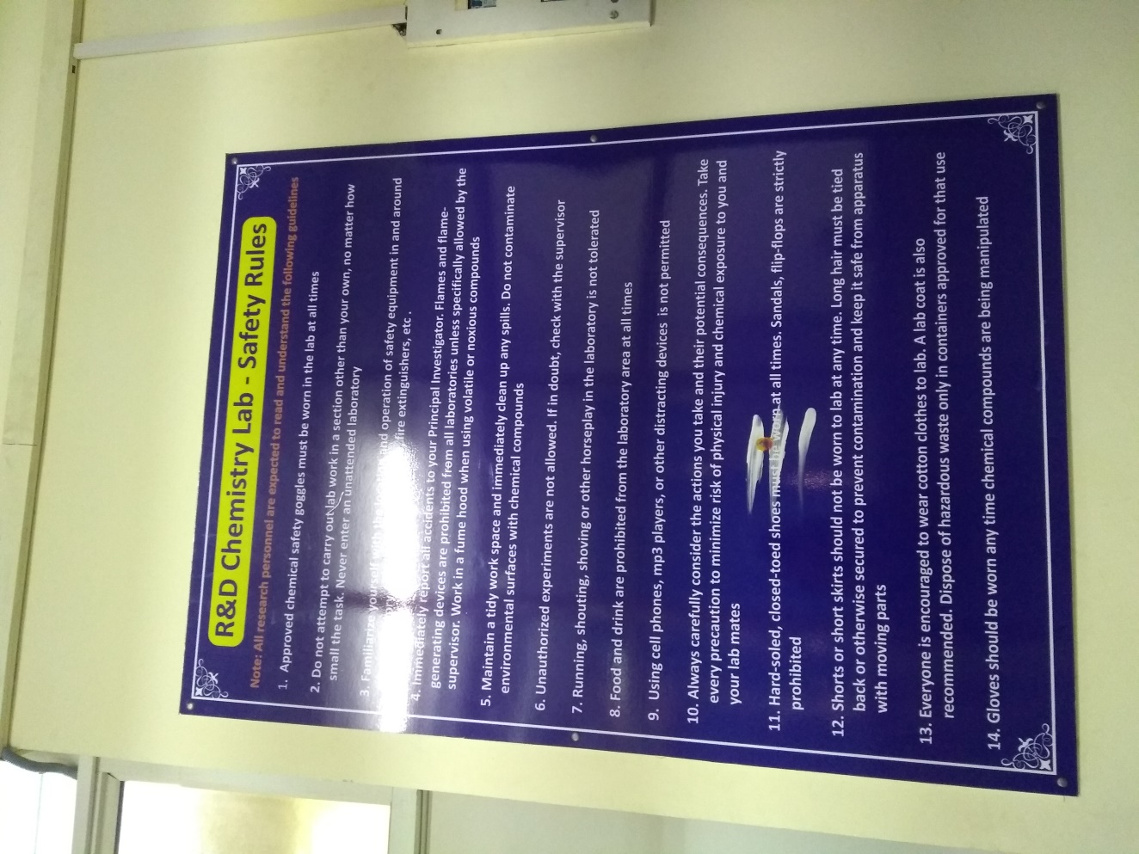

Compressed Gas Cylinders
Cylinders of compressed gases can pose a chemical as well as a physical hazard. If the valve were to break off a cylinder, the amount of force present could propel the cylinder trough a brick wall.

Use and storage
- Whenever possible, use flammable and reactive gases in a fume hood or other ventilated enclosure. Certain categories of toxic gases must always be stored and used in ventilated enclosures.
- Always use the appropriate regulator on a cylinder. If a regulator will not fit a cylinder's valve, replace the cylinder, not the regulator. Do not attempt to adapt or modify a regulator to fit a cylinder it was not designed for. Regulators are designed to fit only specific cylinder valves to avoid improper use.
3. Inspect regulators, pressure relief devices, valves, cylinder connections.
- Never use a cylinder that cannot be positively identified. Color-coding is not a reliable way of identifying a cylinder because the colours can vary from supplier to supplier.
- Do not use oil or grease on any cylinder component of an oxidizing gas because a fire or explosion can result.
- Never transfer gases from one cylinder to another. The gas may be incompatible with the residual gas remaining in the cylinder or may be incompatible with the cylinder material.
- Never completely empty cylinders during lab operations; rather, leave approximately 25 psi of pressure. This will prevent any residual gas in the cylinder from becoming contaminated.
- Place all cylinders so that the main valve is always accessible.
- Close the main cylinder valve whenever the cylinder is not in use.
- Remove regulators from unused cylinders and always put the safety cap in place to protect the valve.
- Always secure cylinders, whether empty or full, to prevent them from falling over and damaging the valve (or falling on your foot). Secure cylinders by chaining or strapping them to a wall, lab bench, or other fixed support.
- Oxygen should be stored in an area that is at least 6 m away from any flammable or combustible materials or separated from them by a non- combustible barrier at least 2 m high and having a fire-resistance rating of at least 1/2 hour.
- To transport a cylinder, put on the safety cap and strap the cylinder to a hand truck in an upright position. Never roll a cylinder.
- Always clearly mark empty cylinders and store them separately.
- Be careful while handling compressed gas cylinders and never drop or strike a cylinder against anything.
- Use only wrenches or other tools supplied by the cylinder supplier to open a
valve. Open cylinder valves slowly.
- Only compatible gases should be stored together in a gas cylinder cabinet.
- Flammable gases must be stored in properly labelled, secured areas away from possible ignition sources and kept separate from oxidizing gases.
- Do not store compressed gas cylinders in areas where the temperature can exceed 50°C.

Chapter 8 – Electrical Safety and Energy Management
ELECTRICAL SAFETY and ENERGY MANAGEMENT

Introduction
In many laboratories, electrically powered equipment can pose a significant hazard to laboratory workers, particularly when mishandled or not well maintained. Many laboratories electrical devices have high voltage or high-power requirements, carrying even more risk. Electrical shock and fire are the major hazards associated with electricity.

Electrical Hazards
The severity and effects of an electrical shock depend on a number of factors, such as:
• The pathway through the body
• The amount of current
• The length of time of the exposure
• Whether the skin is wet or dry.
The table 7.1 shows the general relationship between the degree of injury and amount of current for a 50-60 cycle hand-to-foot path of one second's duration of shock. While reading this chart, keep in mind that most electrical circuits can provide, under normal conditions, up to 20,000 Milliamperes of current flow. Keeping in mind that the electrical shock hazards and sparks from electrical equipment can serve as an ignition source for flammable or explosive vapours or Combustible materials.
Table 7.1 General relationship between the degree of injury and amount of current
Current | Reaction
1 Milliampere | Perception level
5 Milliamperes | Slight shock felt, not painful but disturbing
6-30 Milliamperes | Painful shock; "let go" range
50-150 Extreme pain | respiratory arrest, severe muscular
1000-4,300 Milliamperes | Ventricular fibrillation
10,000+ Cardiac arrest | severe burns and probable death
Source, University of Princeton

Power loss
The following hazardous situations can be created due to the Loss of electrical power:
- If magnetic or mechanical stirrers fail to operate, safe mixing of reagents may be compromised.
- Fume hoods may cease to operate, allowing vapours to be released into the laboratory
- Flammable or toxic vapours may be released as a chemical warm when a refrigerator or freezer fails

Electrical Fires harming Environment
- Electrical hazards if not managed can lead to Fire.

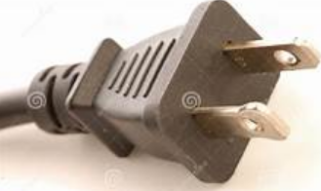
Fig. 7.1 Two prong plug

Preventing Electrical Hazards
There are various ways of protecting people from the hazards caused by electricity, guarding insulation, guarding, grounding, and electrical protective devices.

Insulation
All electrical cords should have sufficient insulation to prevent direct contact with wires. In a laboratory, it is particularly important to check all cords before each use since corrosive chemicals or solvents may erode the insulation. Damaged cords should be repaired or taken out of service immediately.

Guarding
Live parts of electric equipment operating at 50 volts or more must be guarded against accidental contact. Proper shields may be used to protect against exposed live parts.

Grounding
Only equipment with three-prong plugs (Fig 7.2) should be used in the laboratory instead of a two-prong plug (Fig 7.1). The third prong provides a path to ground for internal electrical short circuits, thereby protecting the user from a potential electrical shock.
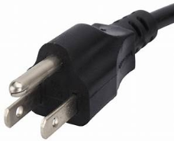
Fig. 7.2 Three prong plug

Circuit protection devices
Circuit protection devices, such as fuses, circuit breakers, ground-fault circuit interrupter, are designed to automatically shut off the flow of electricity in the event of a ground-fault, overload, or short circuit in the wiring system.

Fig. 7.3 MCB

• Fuses and circuit breakers like the one shown in fig 7.3 prevent over-heating of wires and components that might otherwise create fire hazards. They disconnect the circuit when it becomes overloaded. This overload protection is very useful for equipment that is left Fig. 7.3 MCB on for extended periods of time, such as stirrers, vacuum pumps, drying ovens, and other electrical equipment.

• The ground-fault circuit interrupter, or GFCI, is designed to shutoff electric power if a ground fault is detected, protecting the user from a potential electrical shock. The GFCI is particularly useful near sinks and wet location.

Motors
All newly purchased equipment should have spark free induction motors. Any switches located on the device should be removed and insert a switch on the cord near the plug end. Laboratory workers can significantly reduce electrical hazards by following some basic precautions:
- Inspect wiring of equipment before each use. Replace damaged or frayed electrical cords immediately.
- Use safe work practices every time electrical equipment is used.
- Know the location and how to operate shut-off switches and/or circuit breaker panels. Use these devices to shut off equipment in the event of a fire or electrocution.
- Limit the use of extension cords. Use only for temporary operations and then only for short periods of time. In all other cases, request installation of a new electrical outlet.
- Multi-plug adapters must have circuit breakers or fuses.
- Place exposed electrical conductors (such as those sometimes used with electrophoresis devices) behind shields.
- Minimize the potential for water or chemical spills on or near electrical equipment.
- Motors have to be well maintained and ensure windings are in proper condition for energy efficiency.
- If new motors are being installed energy efficient and less noise motors have to be considered.

Static Electricity and Spark Hazards
- Proper grounding of equipment and containers is necessary to avoid sparks. Sparks may result in explosions in areas where flammable liquids are being used. Some common potential sources of sparks are:
- The making and braking of an electrical circuit when the circuit is energized.
- Metal tanks and containers.
- Plastic lab aprons.
- Metal clamps, nipples, or wire used with no conducting hoses.
- High-pressure gas cylinders upon discharge.

High Voltage or Current
- Only trained electricians should repair of high voltage or high current equipment. For further resources: "Electrical Safety: Safety and Health for Electrical Trades Student Manual"
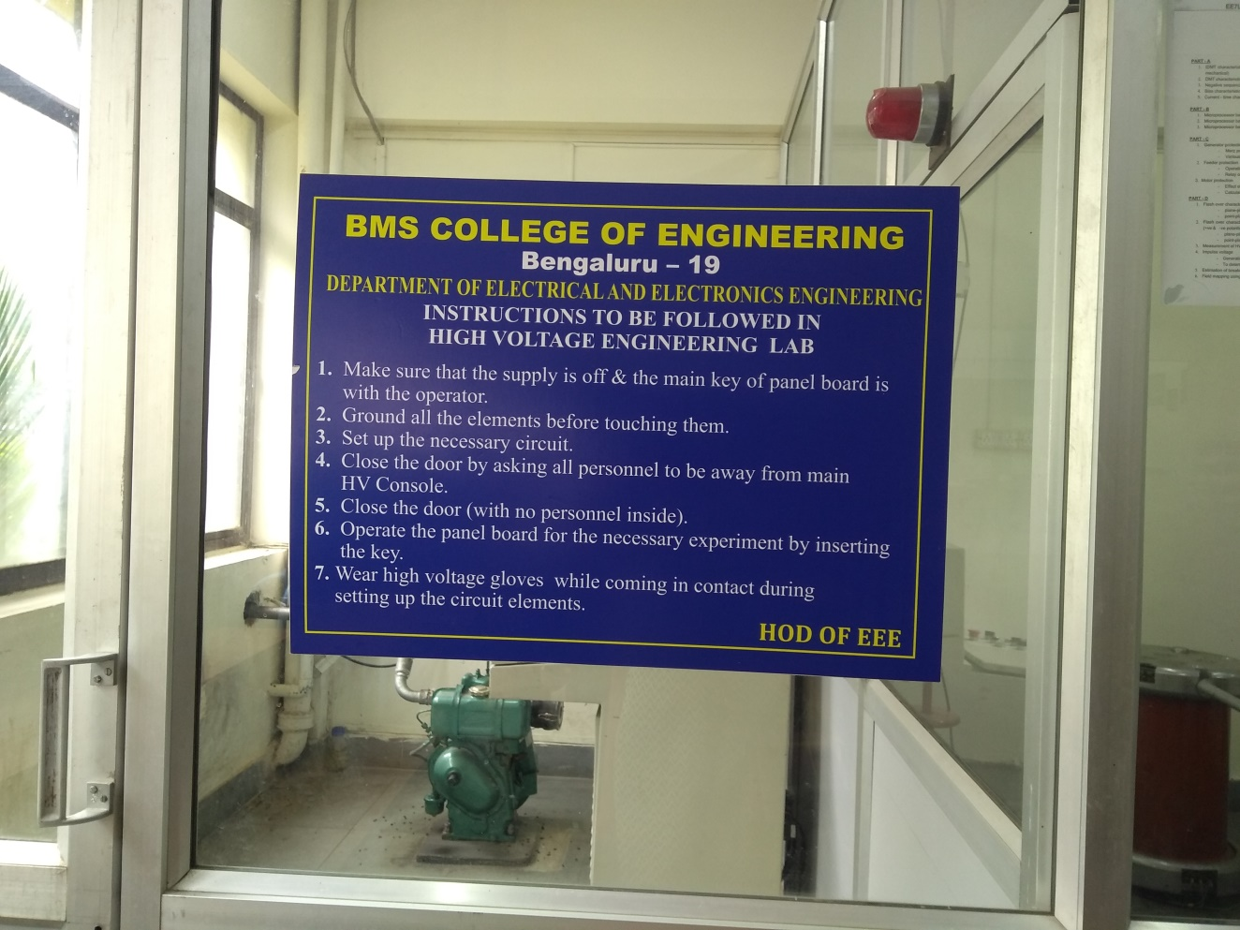

Safe Work Practices
The following are a list of rules for working with electrical equipment:
- Turn off the power to equipment before inspecting it.
- Check circuits for proper grounding with respect to the power source.
- Never change wiring with circuit plugged into power source.
- Never plug leads into power source unless they are connected to an established circuit.
- Keep access to electrical panels and disconnect switches clear and
- Tools and equipment with non-conducting handles should be used when working with electrical devices.
- All current transmitting parts of any electrical devices must be enclosed.
- When checking an operating circuit, keep one hand either in a pocket or behind your back to avoid making a closed circuit through the body.
- Avoid contacting circuits with wet hands or wet materials.
- Wet cells should be placed on a piece of non-conducting material.
- Do not insert another fuse of larger capacity if an instrument keeps blowing fuses -this is a symptom requiring expert repairs.
- Extension cords must be connected to a power strip equipped with a fuse.
- Maintain a workspace clear of extraneous material such as books, papers, and clothes.
- Do not use or store highly flammable solvents near electrical equipment.
- Multi-strip outlets (cube taps) should not be used in place of permanently installed receptacles. If additional outlets are required have them installed by an electrician.
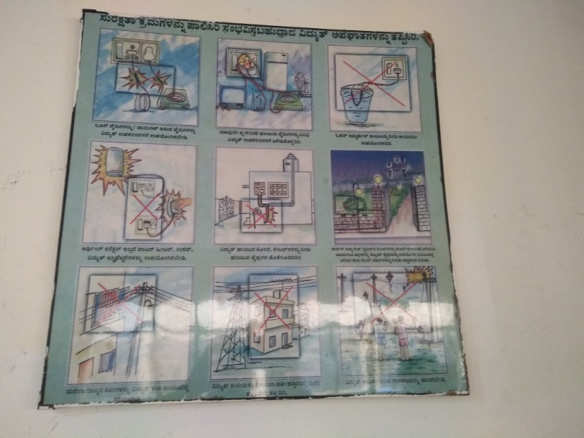
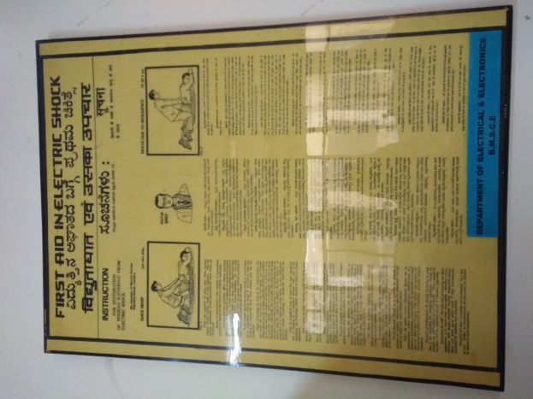

Energy management considerations
- Turn off lights and electrical equipment in any room when lights are no longer needed. Energy efficient / 3 star rated equipment
- When replacing, look for
- Turn off computers, monitors, printers, and photocopiers when you leave your office for the evening.
- Control operating hours of AC unit- use manual control, timers, automatic controls.
- Keep doors and windows closed when using the AC.
- Ensure that thermostat settings are not set too high or too low - aim for 24-25°C in winter and summer.
- Locate AC on shady side of building away from direct sunlight where possible.
- Avoid frequent opening of doors/windows of the room
- Regularly replace or clean the filter and have a mechanic clean the evaporator and condenser coils Clean and replace thermostat regularly.
- If your compressor doesn’t work properly, call a service person immediately.
- Turn off the fan when the room is not in use.
- Inspect the fan each year.
- Ensure fans are cleaned every month or two.
- Dust the areas surrounding the ceiling fan.
- Seal ductwork leaks
- Clean filters and allow free airflow to grills
- Seal unused building openings
- Insulate: doors, pipes, ductwork to avoid energy loss due to leakage
- Use automated lighting Controls- Timers o Outside lighting o Playgrounds o Parking lots o Restricted-access areas- Motion sensors o Rest rooms o Principal & senior staff offices of Low-traffic areas- Dimmers o Auditoriums o Meeting rooms- De-energize fixtures/ballasts not in use- Reduce lighting to minimum acceptable level for safety/security o Parking areas of Canteen o Corridors
- Clean lamps for maximum illumination ˚ Repair broken fixtures ˚ Replace non-working lamps/bulbs ˚ Install lowest acceptable wattage bulb ˚ Install energy-efficient ballasts ˚ Add reflectors to existing lighting ˚ Label panels and switches so lighting can be monitored, and controls can be accessed

Chapter 9 – Mechanical Safety
MECHANICAL SAFETY

Introduction
The safety of students, technicians and staff who are using workshop or laboratories in mechanical engineering department is our concern. Within all laboratories as well as the Mechanical Workshop at the BMS College of Engineering, Bengaluru, there are various hazards from rotating machinery, grind wheels, hand-held drilling machines, saws and cutting tools, guillotine, bending and punching tools etc. The prime rule of safety within a mechanical workshop as well as with other labs is that of good housekeeping and general tidiness. In addition, students are not permitted entrance to the mechanical workshop and labs unless approval has been obtained from the lab superintendent or technician.
Before starting with workshop or laboratories work you must know everything concerning your safety. Emergency situations should take more attention. You must locate and know all emergency exits. That will help you in case of emergency situations to flow smoothly and directly to the emergency exits outside of all the building and danger.
The tools and equipment are for student use in conducting class experiments or building approved projects. Safe operation is important to ensure successful project or experiment completion, but most importantly to ensure the personal safety of the operator and those observing. The following procedure will help to ensure the safe operation and avoid injury.

General safe working procedure
- Shemak and thoub dress are forbidden inside workshop.
- Safety shoes must be worn inside workshop.
- Suitable safety glasses must be worn when machines are running.
- Ask workshop supervisor before using any new equipment.
- Take care when using compressed air – do not waste
- Always keep machines cleaned after use.
- Hearing protection should be worn for noisy machines.
- Working alone after normal hours is not permitted.
- only use tools and machines for their intended purpose.
- Report all damaged equipment and do not use it until a qualified person has repaired it.
- do not operate a machine if you are wearing loose clothing.
- Long hair needs to be properly restrained.
- Always use clamps to hold a work piece in the drilling machine table. Do not attempt to hold the work piece by hand. Brass is particularly liable to seize on the drill bit unless the correct type of bit is used, and the bit kept sharp. Get advice from trained technical staff if you are at any time unsure. Do not take risks. Return all drill bits to their proper holder.
- Do not use hand tools of the wrong size and ensure that the hand tool (whether spanner or screwdriver etc.) fits the work correctly.
- Never use hand files unless they have a proper handle fitted. The pointed tang of a file can slip and pierce the palm of the hand.
- Ensure that hand-cutting tools are sharp - a blunt hand tool will slip easily and can cause injury. When using a hand tool remember to apply the force for cutting or filing in a direction away from the body.
- Keep machine tools, workbenches and surrounding areas clean of loose metal sward and chippings.
- If the machining operation requires you to do so, (e.g., drilling, grinding a tool) always use safety glasses as well as the machine guard.
- Abrasive grind wheels can cause serious eye incident due to grit being thrown from the grind wheel - wear appropriate eye protection. Grinding wheels are subject to additional legislation and must only be mounted and adjusted by a trained workshop technician.
- Never use compressed air for cleaning clothing and machinery.
- Only one person will operate a machine at any one time.
- Ensure the safety of yourself and others by being aware of your surroundings. If you see someone committing an unsafe act, report it to the supervisor immediately. As the machine operator you are responsible for the safety of the people in your immediate area. It is your responsibility to look around and be sure that everyone within your range is wearing safety glasses. Likewise, a welder must be sure not to start welding if people without welding helmets are watching him.
- Use hoisting and lifting equipment when moving heavy weights around. Make sure that slings are correctly placed. If you are not sure, ask and do not take risks.
- Always ensure that when you leave a machine or piece of equipment that it is in a safe condition for the next person to approach and use.
- You may not wear gloves while operating machinery. Holding objects with a rag near moving machinery is also not permitted. Gloves, rags, etc. can be easily caught in machines that are in motion, pulling the operator into the equipment.
- Machinery may not be left running unattended. You must be at the controls of the machine you are using whenever it is in motion.
- Observers must not distract the operator of a machine as this may cause serious injury to the operator or the observers.
- Observe the limitations of all machines.
NOTE 1: If you are in doubt about the operating procedures of any piece of technical equipment, find out before you switch it on, or attempt to use it, otherwise damage may be caused to the equipment or injury to yourself or some other person who may happen to be in the vicinity at that time.
NOTE 2: It is the responsibility of the supervisor in charge of the workshop to ensure that staffs who use the workshop only occasionally adopt the same safety precautions and procedures as full-time workshop personnel.

Hand Tools
Hand tools are non-powered. They include anything from axes to wrenches. The greatest hazards posed by hand tools result from misuse and improper maintenance.
- Hammers or mallets with broken handles or loose heads should not be used.
- Mushroom heads on chisels and punches should be "dressed" properly or the tool should be discarded.
- While chipping, use prescribed type of goggles and chip in a direction where flying chips can do no harm. Use a screen if necessary.
- All files should be equipped with handles.
- Use wrenches properly sized for the job. Be sure wrench jaws are not sprung, chipped, or have worn teeth. Never use a wrench as a hammer.
- Clean grease and oil from hands before using tools to prevent slipping. To prevent injury or damage to your project use only tools that are in good condition.
- Use tools only for the job that they were designed for. Screwdrivers are for turning screws; hammers are for striking objects; parallel bars are for holding material in place until clamped; etc.
- A chisel or punch head that becomes mushroomed should be given to the supervisor for repair. Mushroomed heads can chip off and cause incident.
- Cut away from your hands and body when using a knife or sharp object.
- Use a wrench on nuts and bolts, not pliers.
- Use open-end or adjustable wrenches that fit the nut snugly to prevent slipping and injuring fingers or damaging parts.
- Use the correct size tool for the job. That includes screwdrivers.
- All power tools must be turned off and have come to a complete stop before the operator can set them down. NO EXCEPTIONS.

Machine Tools
- Stand to one side-never directly in line-with work being fed through machines such as circular saws, jointers, or wood shapers.
- Revolving shafts, although apparently smooth, will catch loose or ragged clothing, gloves, jewellery, hair, or wiping rags. Proper clothes and caution are always necessary when working around any revolving machinery. Shirtsleeves should be rolled up. Neckties should not be worn.
- Goggles must be worn whenever flying chips, particles of material, liquids, chemicals, or sparks may cause eye injury.
- Whenever possible, ground all power tools.
- Machinery should be inspected regularly to insure cleanliness and proper operation.
- Machinery should be placed and anchored securely to prevent tipping or other movement.
- There should be a power shut-off switch within reach of the operator at each machine.
- Machinery should be equipped with an emergency stop button which is coloured red.
- Manually operated valves and switches controlling the operation of machines should be identified and readily accessible.
- Machines must be shut down before cleaning, repairing, or oiling. Disconnect or use Lock Out techniques.
- Keys or adjusting tools must never be left so that they may creep, be thrown, or fall when a machine is started.
- When drilling or tapping material sees that it is securely fastened by blocks or clamps so that it cannot spin or climb the drill. In no case should the operator rely on his hands to secure the material from turning.
- Use a brush, special tool, or hook to remove chips, shavings, or other material from work.
- Transparent guards should be kept clean.
- Keep fingers clear of a machine's point-of-operation by using special tools or devices, such as push sticks, hooks, or pliers.
- Energy efficient – well maintained power tools are used
- Power tools to be switched of when not in use

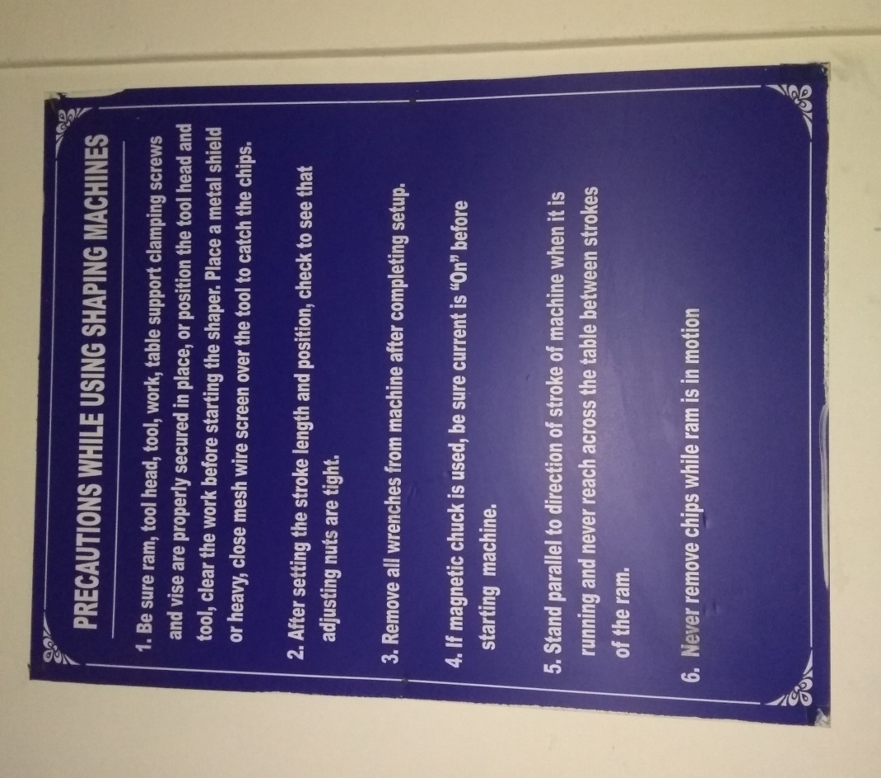

Drill press
- Check the drill press head and table for security and condition before starting.
- A centre punch will help locate the hole to be drilled in the correct place.
- Clamp material to be drilled securely to the drill-table before starting the machine.
- Tighten the chuck of the drill press and remove the release key before starting the machine or your arm may be twisted around the spindle. Never leave the key in the chuck.
- Use drills properly sharpened to cut the right size.
- Run drills only at the correct speed and do not force or feed too fast. Broken drills can cause serious injury.
- If your work should slip from the clamp, never attempt to stop it with your hands. Stop machine to make any adjustment or repair.
- Drill presses should never be forced by exerting excess pressure on the feed lever.
- Drive belts should be covered.
- Drive belts should be well lubricated and maintained to ensure optimising.
- Hands are to be kept clear of the revolving spindle, chuck, drill, and chips. When drilling large holes drill a pilot hole with a small appropriate drill and then step up in size to prevent drill chatter.
- Be sure the drill press is stopped before removing the work piece, chips, or cuttings.

Electric drill (handheld)
- Centre punch the hole to be drilled.
- Tighten the drill using the chuck key and remove the chuck key immediately.
- Hold the drill motor firmly and keep hands away from the revolving spindle and drill.
- Use a larger drill if a larger hole is needed. Using side pressure on the drill to "wobble" out the hole to increase the diameter will only damage the drill and cause it to break.
- Apply straight and steady pressure on the drill and ease up on the pressure as the drill begins to break through the material.
- With the motor still running back out the drill as soon as the hole is drilled.
- Turn off the drill and hold firmly until it comes to a complete stop before laying it on the workbench.

Bench Grinder
- Adjust the work rest to within 1/16 inch of the wheel face.
- Stand to the side of the grinder, not in line with the wheels, turning on a grinder and while the wheels are accelerating, this is the most common time for a damaged wheel to fly apart.
- Do not allow hands to come in contact with the grinding wheel while it is in motion.
- Dress the grinding wheel when it is worn uneven or out or round.
- Hold the work firmly and make grinding contact without bumping or impacting the grinder.
- Use only enough pressure to assure grinding, but not heavy pressure, as this will only cause overheating and grinder damage. If the work piece begins to get warm, quench it in water.
- Grind only on the face of the wheel. Grinding on the side can cause the grinder wheel to explode due to heat stress build-up.
- Keep the work piece in motion across the face of the wheel.
- Stone type grinding wheels are not for grinding aluminium, brass, or copper because the soft metal gets embedded in the stone which may get overheated and can explode.
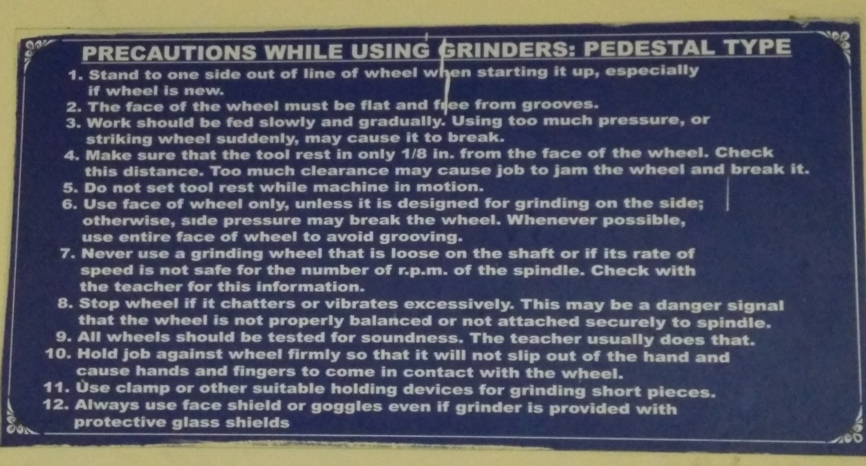

Disc grinder – Portable
- You must wear a face shield as well as safety glasses when using the disc grinder.
- Always be aware of the direction you are throwing the stream of sparks. It is your responsibility to be sure you are not throwing them on other people, in the vicinity of those without eye protection, or on potentially flammable items.
- Like all other hand tools, the disc grinder must be stopped (not moving) before it can be set down.

Engine lathe
- Ensure recommended waste management practices are followed to dispose waste arising from operation of equipment / maintenance of equipment
- Ensure no leakages from equipment – address any leakages immediately
- Switch off equipment when no longer in use
- Make sure that all gear and belt guards are in place.
- Never leave a chuck wrench in a chuck.
- Keep your hands off the chuck rims when a lathe is in operation.
- Do not attempt to screw the chuck onto the lathe spindle with the power on, as it may get cross-threaded and cause injury. Stop the machine, place a board under the chuck, and then screw on by hand.
- Steady rests should be properly adjusted to conform to the material being worked on.
- See that tailstock, tool holder, and work are properly clamped before turning on power.
- Never attempt to adjust a tool while the lathe is running.
- Never apply a wrench to revolving work or parts.
- Always use a brush to remove chips-never your hands.
- Roll up loose sleeves, and do not wear loose clothes such as sweaters or neckties while operating the lathe.
- Be certain the work piece is set up securely and tightly when using chucks and collets.
- Keep hands away from chips as they are very sharp and possibly hot.
- Complete cuts that are close to the chuck or against a shoulder by hand feeding to prevent machinery or work piece damage.
- Never move the speed selector controls while the spindle is rotating.
- Never push the reverse switch while a chuck is moving forward as this could cause the chuck to unscrew itself and fall off and cause serious injury.
- Regulate the depth of cut according to the size and type of material.
- Use tools that are properly ground for the particular job.
- You may never check measurements or surface finishes of the work piece while it is spinning.
- After you have chucked up your work piece and completed your tool setup you must spin the chuck by hand to ensure that the jaws of the chuck and the work piece will not hit the carriage of the lathe or the tool rest between the turning centres.
- Use only a Live Centre Chuck and Faceplate Turning.
- Counterbalance work piece on the faceplate if it is irregular in shape.
- Stand to one side of the revolving faceplate to avoid being hit by flying objects.

Milling machine
- Ensure recommended waste management practices are followed to dispose waste arising from operation of machine / maintenance of machine
- Switch off equipment when no longer in use
- Secure the work piece firmly in the vice or with appropriate clamps.
- Check the work piece, milling machine table, and holding device for clearance of the quill during the cutting.
- Set the machine for the proper depth of cut.
- Select the correct spindle speed for the type of material and the cutter being used.
- Select the proper direction of rotation for the cutter.
- Feed the work piece against or opposite the direction of rotation of the cutter.
- Keep hands on the controls while the machine is running.
- Never try to feel the finished surface while the cut is being taken.
- The milling machine is a precision piece of equipment, so it is important to not damage the table. The table is not a workbench or a place to put tools.
- Be sure you know how to stop the milling machine quickly before operating the machine.
- Be sure the power feed controls are in their "Neutral" position before turning on the machine.
- Handle cutters carefully. They are sharp. If they can cut metal, they can cut you.
- Use a soft hammer or mallet to seat the work piece against the parallel bars or bottom of the vice.

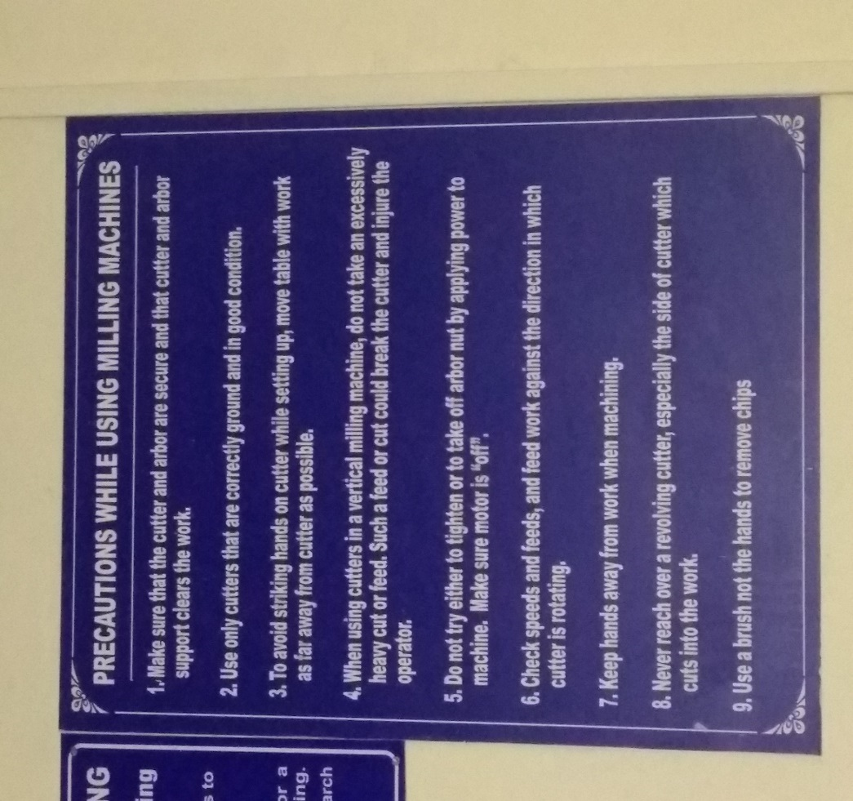

Oxygen-Acetylene Welding
- Signs reading "DANGER-NO SMOKING OR OPEN FLAMES" or the equivalent should be posted.
- Grounding of the machine frame and safety ground connections of portable machines should be checked periodically.
- Electrical power to the welder should be shut off when no one is present.
- Welding is to be done only by those employees who are qualified as welders.
- Always stand to one side and away from the gauge faces and front of the regulator when opening the cylinder valve. In case of an explosion, flying glass will not cut you.
- Oxygen is not a substitute for compressed air. Never use oxygen equipment around oily gloves, clothes, or oily surfaces. Oil or grease in presence of oxygen, under pressure, will ignite violently.
- Suitable fire extinguishing equipment should be available for instant use.
- Firewatchers should be assigned when welding or cutting is performed in locations where a serious fire might develop.
- Cylinders have exploded from what seemed to be slight jars. Be sure your cylinders are chained or strapped securely.
- Never use acetylene from a cylinder in a horizontal position. In this position, the acetone is drawn out of the cylinder with the acetylene.
- Use the cylinder valve-not the regulator-to turn the gas off. The regulator is not designed to be used as a shut-off valve.
- Do not watch the electric arc without welding glass. Ultraviolet and infrared rays are thrown off in concentrated form and can burn unprotected eyes.
- Local exhaust ventilation is recommended for most welding, cutting, and brazing. It is required when the following base metals, fluxes, coatings, plating, or filler metals are used:
- Beryllium
- Cadmium
- Chromium Fluorides
- Lead
- Mercury Zinc Inert gas welding
- Oxygen cutting of stainless steel
- Cylinders must always be fastened with a chain or other suitable device as a protection against falling or rolling.
- Keep the welding equipment free of oil and grease and away from oily rags. When oil comes in contact with oxygen it will explode.
- If leaks are detected in the equipment, they are to be reported immediately to lab superintendent or technician.
- Adequate ventilation is needed in the welding area before beginning.
- Keep all flammable material away from the work area.
- Never open an acetylene cylinder valve more than one-half (1/2) turns. Always keep the key on the acetylene cylinder valve. In case of a flashback or fire from a leaky cylinder connection, a gloved hand can withstand the heat long enough to close the valve.
- Eye protection helmets, hand shields, and goggles meeting the appropriate standards are required. Release the regulator pressure screw and open the cylinders slowly. The normal pressure setting for acetylene is 5 psi with a maximum of 15 psi.
- The oxygen cylinder valve should be opened all the way as it is a double seating valve. The normal pressure setting for oxygen is 10 psi with higher settings used for torch cutting.
- Point the torch away from yourself and observers before lighting the torch.
- Use a friction torch lighter (flint striker) to ignite the torch.
- A lighted torch should not be turned on concrete. Concrete always contains some moisture, which may cause the concrete to explode.
- Close the acetylene valve first if the torch backfires.
- Keep sparks and flames away from the gas cylinders and hoses.
- Close both cylinder valves and then release the pressure from the lines when you have finished the job.
- Hot metals are to be quenched rather than left lying on the table hot, or mark with chalk the word “HOT” if air cooling is desired.
- Clean your work area when completed and put scrap metals in the appropriate container.

Electric Welding
- Ensure recommended waste management practices are followed to dispose waste arising from operation of machine / maintenance of machine
- Switch off equipment when no longer in use
- A proper welding helmet, long sleeves or leather apron, long pants, and leather gloves (or cotton gloves if TIG welding) are required to protect the welder and observers from eye and skin damage due to the intense ultraviolet (UV) radiation that emanates from the arc.
- Do all welding in the welding area if at all possible. Shields and fire hazard precautions will need special attention if welding in other areas.
- Check for adequate ventilation before welding.
- Welding on zinc-plated metals is hazardous to your health and can be fatal. Do not weld on zinc-plated metal (galvanized metal). For assistance in setting up the welding equipment ask the supervisor.
- After your weld is complete, quench the work piece in water.
- Before you begin welding, you must set up the welding shields to protect others from the effects of the UV radiation on their eyes and skin.

Compressed Air
- Wear safety glasses, goggles, or face shield when using the blowgun.
- Switch off equipment when no longer in use
- Blowing compressed air at your skin or that of others can inject air bubbles into the blood stream and cause death.
- You are responsible for insuring that your use of the air hose does not injure others, (i.e., do not blow chips at someone without eye protection), LOOK FIRST.

Sheet Metal Shear
- Ensure recommended waste management practices are followed to dispose waste arising from operation of equipment / maintenance of equipment
- Ensure no leakages from equipment – address any leakages immediately
- Switch off equipment when no longer in use
- Follow the manufacturer's specifications as to gauge of sheet metal that can be safely cut.
- Keep fingers and measuring scales out of the way of the blade.
- Do not cut round stock or anything except sheet metal in the shear.
- Place the sheet against the guide and then clamp it in position with the clamp on the machine.
- The treadle is operated with one foot, and the other foot must be kept clear as the treadle comes down.
- Return the treadle to the up position slowly with foot pressure. Do not let it make a rapid return.
- Pick up the scrap pieces when you have completed cutting.
- Before using any wood tools, you must inspect your material for foreign metal objects, such as nails, screws, staples, etc.

Wood Tools
Before using any wood tools, you must inspect your material for foreign metal objects, such as nails, screws, staples, etc.

Abrasive Wheels
- Ensure recommended waste management practices are followed to dispose waste arising from operation of equipment / maintenance of equipment
- Grinding wheels should be equipped with tool rests that hold the work firmly.
- Bench and pedestal grinders should be permanently mounted or secured.
- Face shields should always be used when grinding.
- The maximum RPM rating of each abrasive wheel must be compatible with the RPM rating of the grinder motor.
- Each electrically operated grinder should be effectively grounded.
- Each grinder should have an individual “On” and “Off” control switch.
- Abrasive wheels must not be stored where they would be exposed to high temperature or humidity, water, or other liquids.
- Before new abrasive wheels are used, they should be visually inspected, and ring tested.
- Grinding of large parts, prolonged grinding, grinding of potentially toxic materials, and cutting of wheels all require mechanical exhaust ventilation.
- Defective abrasive wheels (cracked, broken, out of balance) should not be used.
- Abrasive wheels which have been discarded should not be re-used.
- Flanges should be of such design as to satisfactorily transmit the driving torque from the spindle to the grinding wheel.
- Flanges may be made of steel, cast iron, or other material of equal or greater strength and rigidity.
- Flanges shall be designed with respect to rigidity so that when tightened, the radial width of bearing surface of contact on the wheel is maintained.
- Abrasive wheels must have cover guards.

Metal-Cutting Guillotines
The following requirements apply to the safe use of metal-cutting guillotines:
- Ensure recommended waste management practices are followed to dispose waste arising from operation of equipment / maintenance of equipment
- Guards must be provided to prevent the operator's fingers from contacting the knife or clamp from either the front or rear of the machine. Only one person should be allowed to operate the machine at one time and where long material is being cut and cannot be adequately supported by the worktable, additional supports should be provided.
- A hand-operated guillotine should be made inoperative when not in use either by removal of the handle or by the use of a locking or similar device.
- The shear edges of the blades should be maintained in good condition and blade clearance must be adjusted in accordance with the manufacturer's recommendation appropriate to the thickness of the material being cut.
- Waste scrap metal provides a hazard for the hands and protective gloves should be worn when the metal is handled. A container should be provided for waste material from the guillotine.

Power Hacksaws
- An automatic knock-off switch should be used at all times and a regular check should be carried out to ensure it is in good order. The work must be secured, adequately supported and the length of any overhang should be clearly indicated to avoid it being a hazard to any other person.

Chapter 10 – Hazardous Waste management
WASTE MANAGEMENT
The purpose of environmentally sound disposal methods is to prevent harm to the human beings, animals, flora, fauna, water, land, and air.

Definitions
Waste: Any useless and valueless material that is to be discarded.
Generator: Any person, by site, who produces municipal hazardous waste or industrial solid waste; any person who possesses municipal hazardous waste or industrial solid waste to be shipped to any other person; or any person whose act first causes solid waste to become subject to regulation.
Solid waste: Any garbage, refuse, sludge from a waste treatment plant, water treatment plant, or air pollution control facility or other discarded material. Solid waste can be solid, liquid, semi-solid, or contained gaseous material resulting from industrial, municipal, commercial, mining, and agricultural operations, and from community and institutional activities.
Hazardous waste: Waste that poses substantial or potential threats to public health or the environment. It is any solid waste material exhibiting the characteristics of ignitability, corrosivity, reactivity or toxicity. Tables containing the listing and characteristics of hazardous wastes are shown at the end of this chapter, Table 9.1.
Mixed waste: Mixed waste contains both radioactive and (chemically) hazardous waste.
Disposal: The discharge, deposit, injection, dumping, spilling, or placing of any solid waste or hazardous waste (whether containerized or non-containerized) into or on any land or water so that such solid waste or any constituent thereof may enter the environment or be emitted into the air or discharged into any water, including ground waters.

Types of Hazardous Waste
An item is considered waste when the owner determines that the material is no longer useful and needs to be discarded. An item is considered to be hazardous waste if it meets one or more of the following characteristics:
1. A chemical component is listed as hazardous by Material Safety Data Sheet (MSDS)
2. Mixture contains a listed hazardous waste and a non-hazardous waste.
3. Material meets the definition of one of the following:
- Ignitability (flashpoint <60°C or supports combustion)
- Reactivity (e.g., water reactive, cyanides, explosives, unstable chemicals)
- Corrosivity (pH<4 or >10)
- Environmental Protection (EP) toxicity (e.g., pesticides, heavy metals, poisons)
4. Material is not excluded from regulations.
Individual lab superintendents are responsible for properly identifying the hazardous waste they generate and for following proper disposal procedures. Refer to the MSDS tables for list of regulated hazardous chemicals. Explosives and hazardous waste are listed in appendix I and appendix II.

Containers, Tags, and Collection
Proper containment, tagging, collection and disposal are essential to the success of the Hazardous Waste Program. The following sections discuss these areas.
Hazardous waste collection containers must be in good condition, must not leak, and must be compatible with their hazardous contents (e.g., do not use metal containers for corrosive waste or plastic containers for organic solvents). All containers must have suitable screw caps or other secure means of closure. If you are reusing a container to accumulate waste, destroy the original product label. EPA regulations require that waste containers be labelled with the accumulation start date, the identity of the contents, and the words "Hazardous Waste". Use a new label to identify the hazardous waste: do not use the disposal tag for this purpose.
Important: Never overfill hazardous waste containers. Expansion and excess weight can lead to spills, explosion, and extensive environmental exposure.
Hazardous waste containers for liquids are generally rated by volume capacity. Allow extra room in liquid containers to allow for contents expansion.
- Do not fill jugs and bottles past the shoulder of the container.
- Fill closed head cans (5 gallons or less) to leave approximately two inches of space between the liquid level and the top of the container.
- Fill closed head drums (Larger than 5 gallons) to leave approximately four inches of space.
Generally hazardous waste containers for solids are rated by their weight capacity and volume capacity. Take care not to exceed the weight capacity of a solid container. Weight is generally not a problem for jars and open head cans (5 gallons or less), but it can be a problem for open head drums (larger than 5 gallons). Depending on weight requirement, you may fill containers for solids within two inches of the closure.
Important: Keep all waste collection containers closed except when adding or removing material.

Disposing of Empty Containers
The disposing of empty containers must meet the following requirements:
- Product labels must be defaced or removed.
- Container lids or caps must be removed.
- Containers must not contain free liquid or solid residue.
- Containers must be triple rinsed.
- It is not necessary to break empty glass containers.
- Punch holes in the bottom of metal containers and plastic jugs before disposing of them in the regular trash.
Important: Containers that do meet the requirements mentioned here must be treated as hazardous waste.

Reduction of Waste Source
Lab superintendent should adhere to the following techniques to reduce waste sources.

Purchasing and inventory control
- Tracking systems to manage purchasing and control inventory should be used.
- The current inventory records should be maintained to prevent overstocking and to monitor the shelf life of remaining materials.
- A campus-wide chemical exchange network should be developed to promote chemical sharing and avoid redundant purchases.
- Compressed gases should be obtained from vendors who accept return of empty or partially full cylinders.
- Waste generation should be considered as a criterion in equipment selection.
- Chemical stocks should be rotated in order to use chemicals before their shelf life expires.

Chemical usage
- Spills and waste should be reduced by pre-weighing chemicals for undergraduate use.
- Proper labelling is requiring of all secondary containers.
- All deteriorating labels should be replaced on all containers.
- The use of heavy metals should minimize (e.g., silver, chromium, mercury, barium, cadmium, and lead).
- Alcohol or electronic thermal monitors should be used instead of mercury thermometers.
- "No-Chromix", detergents, or enzymatic cleaners should be used to clean laboratory glassware.
- Solvent waste should be minimized by recycling or substitution.

Waste Minimization Techniques
Lab Superintendents should follow these techniques to reduce hazardous waste:
- Review waste streams and recommend waste minimization procedures.
- Do not mix different types of waste.
- Do not put non-hazardous waste, such as a mixture of water, sodium bicarbonate, and acetic acid, into a waste container of hazardous waste.
- Do not combine inorganic heavy metal waste with organic solvents waste.
- Segregate halogenated waste solvents from non-halogenated waste solvents.
- Segregate waste streams by storing them in separate waste containers.
- Store waste containers separate from reagent containers being used to avoid accidental contamination.
- De-contaminate empty containers to make them non-hazardous.
- Neutralize or dilute acids and bases to make them non-hazardous and suitable for drain disposal.
- When possible, redesign experimental protocols so that harmful by-products are detoxified or reduced.
- Recycle chemicals via purification.

Waste Segregation
Many hazardous wastes, when mixed with other waste or materials, can produce effects which are harmful to human health and the environment, such as
- Heat or pressure
- Fire or explosion
- Violent reaction
- Toxic dusts, mists, fumes, or gases
- Flammable fumes or gases
Segregated waste is safer and easier to dispose of than non-segregated waste. Mixed waste as indicated above can result in severe consequences. Each lab superintendents who generates waste is personally responsible for the following:
- Ensuring that hazardous wastes are accumulated in safe, transportable containers.
- Ensuring that hazardous wastes are stored properly to prevent possible exposure.

Incompatible Waste
Given below are the examples of potentially incompatible wastes, waste components, and materials, along with the harmful consequences, which result from mixing materials in one group with materials in another group. This list is not intended to be exhaustive. A waste generator must, as the regulations require, adequately control his wastes so that he can avoid creating uncontrolled substances or reactions of the type listed below, whether they are listed below or not. It is possible for potentially incompatible wastes to be mixed in a way that precludes a reaction (e.g., adding acid to water rather than water to acid) or that neutralizes them (e.g., a strong acid mixed with a strong base), or that controls substances produced (e.g., by generating flammable gases in a closed tank equipped so that ignition cannot occur, and burning the gases in an incinerator). In the Table 9.1 below, the mixing of a Group-A material with a Group-B material may have the potential consequence as noted.
Table 9.1: Incompatible waste and consequences upon mixing.
Group A | Group B | Consequences
1-A) Acetylene sludge, Alkaline caustic liquids, Alkaline cleaner, Alkaline corrosive liquids Alkaline corrosive battery fluid, Caustic wastewater, Lime sludge and other corrosive alkalies, Lime wastewater, Lime and water Spent caustic | 1-B) Acid sludge, Acid and water, Battery acid, Chemical cleaners, Electrolyte, acid, Etching acid liquid or solvent, Pickling liquor, and other corrosive acids. Spent acid, spent mixed acid, Spent sulphuric acid | Potential consequences: Heat generation; violent, reaction.
2-A) Aluminium, Beryllium, Calcium, Lithium, Magnesium, Potassium, Sodium, Zinc powder, Other reactive metals, and metal hydrides | 2-B) Any waste in Group 1-A or 1-B | Potential consequences: Fire or explosion; generation, of  flammable  hydrogen gas
3-A) Alcohols, Water | 3-B) Any concentrated  waste in Groups 1-A or 1-  B, Calcium, Lithium,  Potassium, S02CI2,  SOCI2, PCI3, CH3SiCI3,  Other water-reactive waste  . | Potential consequences: Fire, explosion, or heat generation; generation of,  flammable or  toxic gases
4-A) Alcohols, Aldehydes, Halogenated hydrocarbons, Nitrated Unsaturated hydrocarbons, Other reactive organic compounds, and solvents | 4-B) Concentrated Group 1-A or 1- B wastes, Group 2-A wastes | Potential consequences: Fire, explosion, or violent reaction
5-A) Spent cyanide and sulphide solutions | 5-B) Group 1-B wastes | Potential consequences: Generation of  toxic hydrogen  cyanide or  hydrogen  sulphide gas
6-A) Chlorates, Chlorine, Chlorites, Chromic acid, Hypochlorites, Nitrates, Perchlorates, permanganates, Peroxides, Other strong oxidizers | 6-B) Acetic acid and other organic acids, concentrated mineral acids, Group 2-A wastes, Group 4-A wastes, another flammable and  combustible wastes | Potential consequences: Fire, explosion, or violent reaction

Segregation Classification
In addition to the guidelines for waste minimization and substitution, follow these guidelines for waste segregation:
- Segregate waste into the following groups:
- Halogenated solvents
- Non-halogenated solvents
- Acids
- Bases
- Heavy metals
- Poisons
- Reactives
- Do not mix non-hazardous waste, such as water, with hazardous waste.
- Do not combine inorganic heavy metal waste with organic solvent waste in hazardous waste containers.
- Double-bag dry materials contaminated with chemicals (paper, rags, towels, gloves, etc.) in heavy-duty plastic bags. Do not use biohazard bags. Dispose of these items in the same manner as hazardous waste.
- Encapsulate sharps (e.g., needles, razor blades, etc.) then place them in trash dumpsters.

Special Concerns
Persons who generate hazardous waste must maintain and control their hazardous waste accumulation areas. Special concerns for hazardous waste include the following:
- Unneeded chemicals that are to be discarded must be handled and managed as hazardous waste.
- Gas cylinders are extremely difficult to discard. They should be returned to the manufacturer or distributor whenever possible. Cylinders that cannot be returned should be tagged as hazardous waste as soon as possible.

Chapter 11 – Solid waste and water management
SOLID WASTE MANAGEMENT PRACTICES AND
RAINWATER HARVESTING

Solid Waste Management:
The dry solid waste is dumped by the respective departments in a collection pit located within the campus. This dry solid waste is collected every day in the morning by a BBMP approved contractor. The same is transported to the nearest land fill and solid waste management facility for proper disposal as per State Pollution Central Board norms. Sufficient quantity of waste bins, clearly marked as Dry Waste and Wet Waste, are placed at a number of places within the campus for the students to dispose the Dry and Wet Waste.
In every area, where relevant based on the nature of waste, atleast consider the min. of
- Compostable waste segregation
- Non Compostable – Non hazardous waste segreation
- E waste
- Hazardous waste
- Bio medical waste

Segregation And Primary Storage
Segregation of Solid Waste into different categories at source and storage-(1) Every Waste Generator including Bulk Waste Generators shall be required to segregate Solid Waste at source of generation into the following categories, as applicable, namely: -
- Bio-degradable Waste, also referred to as Wet Waste including Garden and horticulture waste
- Non-biodegradable Waste, also referred to as Dry Waste including bulky waste and E-waste,
- Domestic Hazardous Waste, including Sanitary Waste,
- Construction and Demolition (C&D) Waste,

E-waste management:
E-Waste is being disposed through outsourcing. BMSCE has entered into MOU with M/s CORAL Communications and Networks Pvt Ltd., Bengaluru who recycle the materials/equipment’s as per Environmental protection act and Hazardous waste management rules and issue Recycling certificate in accordance with E waste management rules.
NO e waste to be stored more than 180 days in facility

Effluent Disposal
Wherever the chemical and solvents effluents are generated they are collected in tanks and disposed to authorized agency in accommodate with prevention of water pollution act and rules, Hazardous waste management rules

Bio medical waste disposal
Wherever the Bio medical waste is generated they are collected in designated bins and disposed to authorized agency with Bio medical waste management rules, Solid waste management rules, prevention of water pollution act and rules, Hazardous waste management rules

Battery waste disposal
Wherever the Battery waste is generated they are stored in designated areas and disposed to authorized agency with Battery Waste Management Rules, Hazardous waste management rules

Oil Disposal
Wherever the Oil waste and oil-soaked waste are generated they are stored in designated areas and disposed to authorized agency with Hazardous waste management rules

Construction and Demolition Waste
Wherever the Construction and Demolition Waste are generated they are stored in designated areas and disposed to authorized locations through authorised personnel as per Construction and Demolition Waste Management Rules, Solid waste rules

Sewage disposal:
BMSCE Campus has a network of underground sewer lines and the sewage after treatment is connected to the main BWSSB manhole outside the campus. All the toilets are barrier free and separate for ladies and gents. All the toilets are well maintained by a dedicated House Keeping Staff. A separate user-friendly toilet for Physically Challenged ladies and gents is functional with all the necessary fittings and attachments.
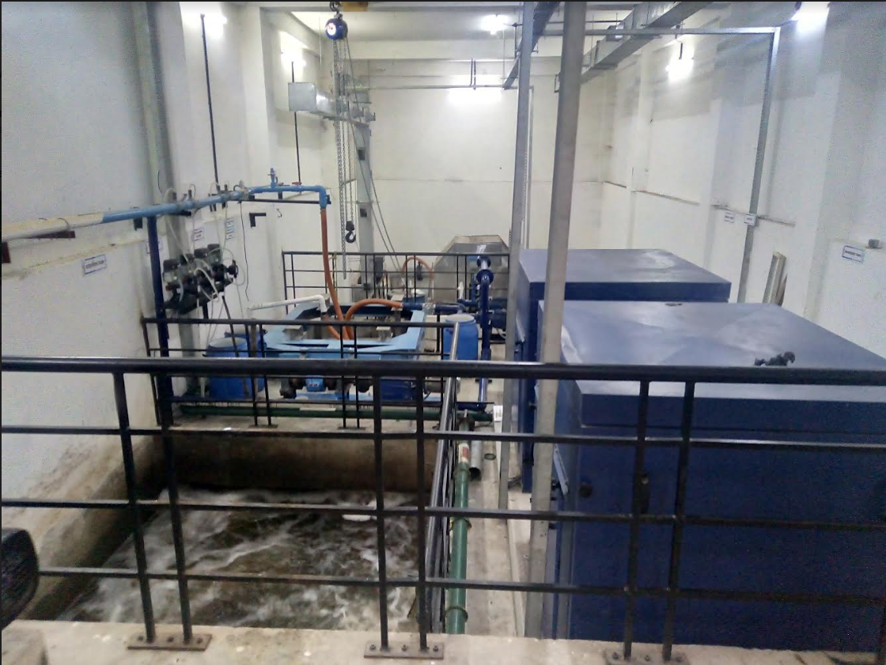
350 KLD sewage treatment plant units

Chemical waste:
The quantity of Chemical Waste generated is very minimal. However, small masonry tanks have been constructed in the four departments which generate chemical waste. A certain number of coagulants are added to facilitate precipitation of the suspended/ dissolved particles. The treated effluent is disposed into the BWSSB drains. The sludge settled at the bottom is collected once in a year and stored in an airtight container for further disposal to landfills through an authorized Hazardous Waste handler.

Bore Well Water Consumption, Rainwater harvesting structures and utilization:
There are 3 Nos bore wells. All three bore wells are maintained by BMSCE plumbers and gives yield of approximately 1.5 Lakh litres. These bore wells are supplying water to all bathrooms and common areas including Hostels at BMSCE Campus. Rainwater harvesting has been in place to assure an independent water supply during water restrictions. Campus utilizes the benefit of conservation of our natural resources by method of Rainwater Harvesting System. The campus is having two Rainwater Harvesting Tanks. One of 1,00,000 litres capacity tank is located at Boys Hostel No.3 and the other of 1,25,000 litres capacity tank is located at West side of P.G. Block. The same water is being used for Gardening Purpose. Conservation of water by the use of taps with sensors is in practice.

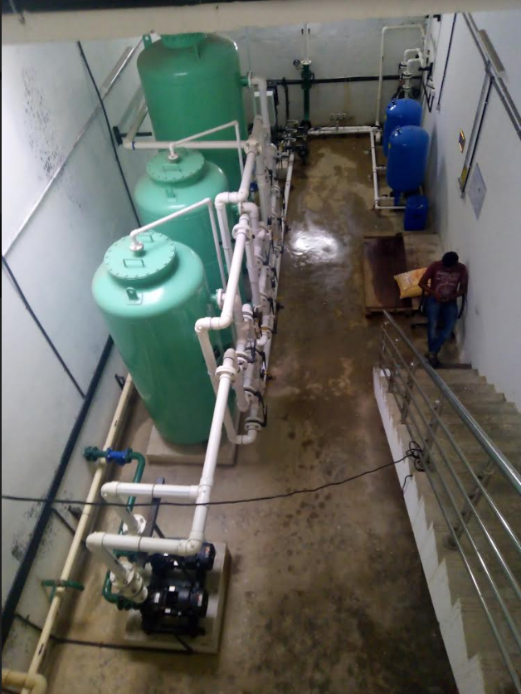
Water (bore well water + roof top rainwater) treatment plant
treating 2.5 lakh Liters of water per day

Chapter 12 - Miscellaneous activities - Environmental management systems

General
- Air pollution prevention
  - Ensure that the equipment (including computers) is well maintained.
  - Air monitoring is measured from equipment and respective areas to prevent it from causing environmental damage.
  - Samples are within the shop floor / operations area, and exterior to it.
  - Effective exhaust or collection systems are established to suck outsources of air pollution, in identified applicable areas where dust is generated.
  - Enable the efficient functioning of the exhaust systems.
  - Report to Department in charge / environmental committee in case of any fumes observed in computers, DG, compressors / anywhere in the operations causing uneasiness.
  - se approved refrigerant to prevent any leakage which may harm the Ozone layer.
    - Henceforth Procurement of only More than 3-star energy efficient rating equipment as applicable
    - Un harmful gaseous emissions from the equipment.
  - Procurement of ROHS Compliant / REACH compliant materials for use in operations.
  - All Vehicles Employed Directly / indirectly by the organization, shall be compliant to all emission norms.
  - Plantation and Promoting Green Plantations in and around the surrounding environments and taking essential care for the protection of their flora and fauna.
  - Ambient air and gaseous emissions from respective areas are measured annually once, to have a check and for taking appropriate corrective actions on the results.
  - Appropriate Chimney Systems are established for effective suction of air emission, treatment, and release to atmospheric air.
  - Appropriate Exhaust and suction systems are established for effective suction of process related emission to air.
- General waste
  - Always Collect waste in necessary waste Bins
    - Bio-degradable Waste, also referred to as Wet Waste including Garden and horticulture waste - - Green Color
    - Non-biodegradable Waste, also referred to as Dry Waste including bulky waste and E-waste, - Blue Color
    - Domestic Hazardous Waste, including Sanitary Waste, / Hazardous waste - Red Color
  - Segregation of waste at source should be made on a daily routine across the Organization.
  - Burrs and chips generated from machining should be disposed to the scrap yard.
  - Used grinding wheels, cutting tools to be disposed to the scrap yard.
  - Ensure that there is no degradation of waste in the scrap yard due to rain and other natural processes.
  - Care should be taken while handling waste and ensure no waste spillage over the floor/ground.
  - Measure the waste collected.
  - Ensure that waste is not scattered all around.
  - Maintenance waste (cables, wires, fuse, belts, etc.) to be segregated and disposed to the waste yard.
  - No paper waste should be burnt and is to be disposed of in the scrap yard.
  - Dispose Used Water, via proper drainage systems only.
  - Have a check on the effective functioning of the drainage systems.
- Hazardous Waste management
  - The hazardous waste must be stored in a closed area which is sealed and leak proof.
  - The hazardous waste storage area must be provided with an appropriate coating to prevent land contamination due to spillage/leakage of the waste.
  - The Hazardous waste storage area must be provided with a lock and key arrangement with a fire extinguisher in case of any emergency.
  - Paste Form-8 “LABELLING OF CONTAINERS OF HAZARDOUS AND OTHER WASTE “to all the hazardous waste storage drums.
  - Maintain a Register for recording the quantity of hazardous waste stored in the room in Form 3
- Disposal
  - Use only authorized vendors approved by KSPCB to dispose all Hazardous, and other waste etc. as applicable.
  - Records of the Vendor being Authorized for the same shall be maintained.
  - Maintain record of Disposal
  - Effectiveness of waste management, implementation reviewed during internal audits.
- Safe Handling of all Chemicals
  - Ensure the lid of the drum is intact and in good condition.
  - Avoid rough handling and dragging of containers.
  - Ensure all Chemicals are stored as per the MSDS of the respective chemical only.
  - Maintain the MSDS list of all the chemicals, hazardous materials, Laboratory Reagents, Solvents, and Raw Material used in the Organization.
  - Train all Employee’s / relevant process owners on MSDS and measure the effectiveness of training also.
  - Employ HMIS labels for intermediate. WIP chemical containers.
  - Ensure all Expired chemicals are handled as per appropriate waste disposal techniques only.
  - Ensure all the containers are placed in a vertical position with the lid up.
  - Avoid spillage of chemicals while transferring chemicals from the barrel by using pump.
  - Ensure no leakage or spillage of chemicals while storing/ transporting within the premises.
  - Ensure the operator uses safety PPEs like gloves and safety shoes while handling the barrels.
  - Make sure adequate safety and firefighting equipment are available in case of emergency.
  - Ensure only authorized persons enter the premises.
  - Enforce the "No Smoking" boards to be displayed in the designated area.
  - Ensure the display of “Danger” sign in the hazardous waste storage area.
  - Ensure that the operators are aware of emergency preparedness and response procedures.
  - It’s good practice to carry out regular checks for spillage or leakage of chemicals.
- Spill management
  - In case of leakage or spillage, clean the area immediately with the Spill Kits, and dispose of hazardous waste storage area.
  - Use proper secondary containments to collect the spillages.
  - Ensure that the chemical-soaked cotton waste / saw dust and other wastes generated due to spillage or leakage are segregated and disposed in the respective bins as per Hazardous waste (Management & Handling).
  - Report in case of spillage and record in the incident report.
- Water pollution prevention
  - The Process Used water is never disposed of in the surrounding Rainwater Drains in the Organization or Outside the Organization.
  - Barriers are constructed to ensure no contamination of process materials to storm water drains.
  - All Liquids contaminated in water are channelized through strong and durable pipeline system and collected to a sludge tank.
  - Areas where Sludge is removed manually, are through effective removal practices, collected in drums, and disposed into sludge tank.
  - Sludge tanks are constructed of impervious material and surrounding to ensure no seepage of hazardous sludge.
  - All Necessary Safety Precautions and PPE are adhered to handle such hazardous waste.
  - Authorized recyclers are used for disposing of such hazardous sludge waste.
- Water Conservation
  - Encourage the practice of Water Reuse and Recycling
  - Construct Rainwater Harvesting Pits
  - Encourage Water Recirculation
  - Report all significant water losses (broken pipes, open hydrants, sprinklers, etc.)
  - Arrest all possibilities of water leakages.
  - Encourage your friends and neighbors to be part of a water conscious.
- Energy Conservation
  - Regularly change (or clean if reusable) AC filters every month.
  - Use only min 3 ENERGY STAR electrical equipment.
  - Control direct sun through sunscreen on windows
  - Turn off lights (and other equipment) when not in use.
  - Replace incandescent light bulbs with ENERGY STAR LED Lightings
  - Adjust lighting to your actual needs; use free "daylight" during the day.
  - Prevent glare, eyestrain, and headaches, do not "over-light." Too much light can be as bad for visual quality as too little light - and it costs a lot more.
  - Turning off machines when they are not in use can result in enormous energy savings.
  - To maximize savings with a laptop, put the AC adapter on a power strip that can be turned off (or will turn off automatically)
  - Unplug battery chargers when the batteries are fully charged, or the chargers are not in use.
- Fuel / Materials Conservation
  - Ensure all Machines such as DG, Engines driven devices, etc. are maintained efficiently.
  - Use appropriate efficient methods for fuel transfer.
  - If Company Employees vehicles, ensure they are well maintained, encourage vehicle pooling.
- Use Secondary containment, to capture spillages, that can appropriately be reused based on suitability.
- Encourage Paperless operations.
  - Use both sides of paper for printing.
- Maintain machines and equipment in an effective manner and operate them most efficiently to ensure higher productivity from the equipment’s / machines for the purpose utilized in the organization.

Sports Room
- Power on equipment strategically - Switch off during off-peak hours.
- Regularly maintain your equipment
- When possible, replace it with energy-efficient equipment.
- Label light switches
- Install occupancy sensors.
- Install low-energy lighting.
- Use natural ventilation where possible.
- Close windows and doors when the A/C are on
- Institute a “dead band” on the thermostat
- Maintain equipment.
- conservation of natural resources using basic efforts such as reducing, reusing, and recycling. Specific green techniques include altering purchasing practices (e.g., buying in bulk, purchasing recycled goods)
- Segregate, Collect, Store, and dispose of waste as per BMSCE waste management practices described in this document.

Garden
- Composting – This is one of the best ways to handle organic waste. Mix the leaves, grass, and weeds with the food scraps in your compost bin.
- Switch off garden equipment when not in use.
- Read MSDS carefully before using chemicals for gardens, ensure all team members are trained in handling such chemicals.
- Conserve water – do not over water plants
- Use recycled treated FIT to USE water for watering to reduce load on water consumption.

Pest Control
- Read MSDS carefully before using chemicals for gardens, ensure all team members are trained in handling such chemicals.
- Use recycled treated FIT to USE water for water mixing to chemicals to reduce load on water consumption.
- Ensure air emissions are minimized during spraying to the extent possible
- Any waste arising from activities to be considered as hazardous waste and handled as per BMSCE waste management practices described in this document.

Utilities HVAC
- Switch off the equipment when it is no longer in use.
- Get Proper Duct Sizing - during design stage.
- Ensure all openings of HVAC system prevent foreign body entry and dust accumulation.
- Increase the Insulation of Your Space
- Use Aerosol Duct Sealing to Avoid Duct Leakage
- Install Programmable Controls and Thermostats
- HVAC unit shall be free from dust and debris is essential in maintaining an energy efficient unit. Dust, dirt, and debris can all clog a system and force it to work harder to push out hot and cold air.
- Perform Regular Maintenance
- changing / cleaning the filter regularly, you can ensure that your HVAC system always has a clean air filter, so it can function at its best.
- Clean Your Drain Line
- Trim Plants and Clean Gutters surrounding HVAC opening.
- Any waste arising from activities to be considered as e waste / hazardous waste and handled as per BMSCE waste management practices described in this document.
- HVAC energy management
  - Eliminate or reduce reheating whenever possible. • Use appropriate HVAC thermostat setback. • Use morning pre-cooling in summer and pre-heating in winter (i.e. -- before electrical peak hours). • Use building thermal lag to minimize HVAC equipment operating time. • In winter during unoccupied periods, allow temperatures to fall as low as possible without freezing water lines or damaging stored materials. • In summer during unoccupied periods, allow temperatures to rise as high as possible without damaging stored materials. • Improve control and utilization of outside air. • Use air-to-air heat exchangers to reduce energy requirements for heating and cooling of outside air. • Reduce HVAC system operating hours (e.g. -- night, weekend). • Optimize ventilation. • Ventilate only when necessary. To allow some areas to be shut down when unoccupied, install dedicated HVAC systems on continuous loads (e.g. -- computer rooms). • Provide dedicated outside air supply to kitchens, cleaning rooms, combustion equipment, etc. to avoid excessive exhausting of conditioned air. • Use evaporative cooling in dry climates. • Reduce humidification or dehumidification during unoccupied periods. • Use atomization rather than steam for humidification where possible. • Clean HVAC unit coils periodically and comb mashed fins. • Upgrade filter banks to reduce pressure drop and thus lower fan power requirements. • Check HVAC filters on a schedule (at least monthly) and clean/change if appropriate. • Check pneumatic controls air compressors for proper operation, cycling, and maintenance. • Isolate air-conditioned loading dock areas and cool storage areas using high-speed doors or clear PVC strip curtains. • Install ceiling fans to minimize thermal stratification in high-bay areas. • Relocate air diffusers to optimum heights in areas with high ceilings. • Consider reducing ceiling heights. • Eliminate obstructions in front of radiators, baseboard heaters, etc. • Check reflectors on infrared heaters for cleanliness and proper beam direction. • Use professionally designed industrial ventilation hoods for dust and vapor control. • Use local infrared heat for personnel rather than heating the entire area. • Use spot cooling and heating (e.g. -- use ceiling fans for personnel rather than cooling the entire area). • Purchase only high-efficiency models for HVAC window units. • Put HVAC window units on timer control. • Don't oversize cooling units. (Oversized units will "short cycle" which results in poor humidity control.) • Install multi-fueling capability and run with the cheapest fuel available at the time. • Consider dedicated make-up air for exhaust hoods. (Why exhaust the air conditioning or heat if you don't need to?) • Minimize HVAC fan speeds. • Consider desiccant drying of outside air to reduce cooling requirements in humid climates. • Consider ground source heat pumps. • Seal leaky HVAC ductwork. • Seal all leaks around coils. • Repair loose or damaged flexible connections (including those under air handling units). • Eliminate simultaneous heating and cooling during seasonal transition periods. • Zone HVAC air and water systems to minimize energy use. • Inspect, clean, lubricate, and adjust damper blades and linkages.
- Refrigeration
  - Use water-cooled condensers rather than air-cooled condensers. • Challenge the need for refrigeration, particularly for old batch processes. • Avoid oversizing -- match the connected load. • Consider gas-powered refrigeration equipment to minimize electrical demand charges. • Use "free cooling" to allow chiller shutdown in cold weather. • Use refrigerated water loads in series if possible. • Convert firewater or other tanks to thermal storage. • Don't assume that the old way is still the best -- particularly for energy-intensive low temperature systems. • Correct inappropriate brine or glycol concentration that adversely affects heat transfer and/or pumping energy. If it sweats, insulate it, but if it is corroded, replace it first. • Adjust minimize hot gas bypass operation. • Inspect moisture/liquid indicators. • Consider changing the refrigerant type if it improves efficiency. • Check for correct refrigerant charge level. • Inspect the purge for air and water leaks. • Establish a refrigeration efficiency-maintenance program. Start with an energy audit and follow-up, then make a refrigeration efficiency-maintenance program a part of your continuous energy management program.
- Cooling towers
  - Control cooling tower fans based on leaving water temperatures. • Control to the optimum water temperature as determined from cooling tower and chiller performance data. • Use two-speed or variable-speed drives for cooling tower fan control if the fans are few. Stage the cooling tower fans with on-off control if there are many. • Turn off unnecessary cooling tower fans when loads are reduced. • Cover hot water basins (to minimize algae growth that contributes to fouling). • Balance flow to cooling tower hot water basins. • Periodically clean plugged cooling tower water distribution nozzles. • Install new nozzles to obtain a more-uniform water pattern. • Replace splash bars with self-extinguishing PVC cellular-film fill. • On old counterflow cooling towers, replace old spray-type nozzles with new square spray ABS practically non-clogging nozzles. • Replace salt-type drift eliminators with high-efficiency, low-pressure-drop, self-extinguishing, PVC cellular units. • If possible, follow manufacturer's recommended clearances around cooling towers and relocate or modify structures, signs, fences, dumpsters, etc. that interfere with air intake or exhaust. • Optimize cooling tower fan blade angle on a seasonal and/or load basis. • Correct excessive and/or uneven fan blade tip clearance and poor fan balance. • Use a velocity pressure recovery fan ring. • Divert clean air-conditioned building exhaust to the cooling tower during hot weather. • Re-line leaking cooling tower cold water basins. • Check water overflow pipes for proper operating level. • Optimize chemical use. • Consider side stream water treatment. • Restrict flows through large loads to design values. • Shut off loads that are not in service. • Take blowdown water from the return water header. • Optimize blowdown flow rate. • Automate blowdown to minimize it. • Send blowdown to other uses (Remember, the blowdown does not have to be removed at the cooling tower. It can be removed anywhere in the piping system.) • Implement a cooling tower winterization plan to minimize ice build-up. • Install interlocks to prevent fan operation when there is no water flow. • Establish a cooling tower efficiency-maintenance program. Start with an energy audit and follow-up, then make a cooling tower efficiency-maintenance program a part of your continuous energy management program.

Utilities DG
- Optimize loading • Use waste heat to generate steam/hot water /power an absorption chiller or preheat process or utility feeds. • Use jacket and head cooling water for process needs • Clean air filters regularly • Insulate exhaust pipes to reduce DG set room temperatures • Use cheaper heavy fuel oil for capacities more than 1MW

Utilities Sewage / Water treatment Plant
- Water & Wastewater
  - Recycle water, particularly for uses with less-critical quality requirements. • Recycle water, especially if sewer costs are based on water consumption. • Balance closed systems to minimize flows and reduce pump power requirements. • Eliminate once-through cooling with water. • Use the least expensive type of water that will satisfy the requirement. • Fix water leaks. • Test for underground water leaks. (It's easy to do over a holiday shutdown.) • Check water overflow pipes for proper operating level. • Automate blowdown to minimize it. • Provide proper tools for washing down -- especially self-closing nozzles. • Install efficient irrigation. • Reduce flows at water sampling stations. • Eliminate continuous overflow at water tanks. • Promptly repair leaking toilets and faucets. • Use water restrictors on faucets, showers, etc. • Use self-closing type faucets in restrooms. • Use the lowest possible hot water temperature. • Do not use a central heating system hot water boiler to provide service hot water during the cooling season -- install a smaller, more-efficient system for the cooling season service hot water. • Consider the installation of a thermal solar system for warm water. • If water must be heated electrically, consider accumulation in a large, insulated storage tank to minimize heating at on-peak electric rates. • Use multiple, distributed, small water heaters to minimize thermal losses in large piping systems. • Use freeze protection valves rather than manual bleeding of lines. Consider leased and mobile water treatment systems, especially for deionized water. • Seal sums to prevent seepage inward from necessitating extra sump pump operation. • Install pretreatment to reduce TOC and BOD surcharges. • Verify the water meter readings. (You'd be amazed how long a meter reading can be estimated after the meter breaks or the meter pit fills with water!) • Verify the sewer flows if the sewer bills are based on them

Buildings Electrical and Energy management
- Buildings
  - Seal exterior cracks/openings/gaps with caulk, gasketing, weatherstripping, etc. • Consider new thermal doors, thermal windows, roofing insulation, etc. • Install windbreaks near exterior doors. • Replace single-pane glass with insulating glass. • Consider covering some window and skylight areas with insulated wall panels inside the building. • If visibility is not required but light is required, consider replacing exterior windows with insulated glass block. • Consider tinted glass, reflective glass, coatings, awnings, overhangs, draperies, blinds, and shades for sunlit exterior windows. • Use landscaping to advantage. • Add vestibules or revolving doors to primary exterior personnel doors. • Consider automatic doors, air curtains, strip doors, etc. at high-traffic passages between conditioned and non-conditioned spaces. Use self-closing doors if possible. • Use intermediate doors in stairways and vertical passages to minimize building stack effect. • Use dock seals at shipping and receiving doors. • Bring cleaning personnel in during the working day or as soon after as possible to minimize lighting and HVAC costs.
- Electricity Distribution System
  - Optimize the tariff structure with utility supplier • Schedule your operations to maintain a high load factor • Shift loads to off-peak times if possible. • Minimize maximum demand by tripping loads through a demand controller • Stagger start-up times for equipment with large starting currents to minimize load peaking. • Use standby electric generation equipment for on-peak high load periods. • Correct power factor to at least 0.90 under rated load conditions. • Relocate transformers close to main loads. • Set transformer taps to optimum settings. • Disconnect primary power to transformers that do not serve any active loads • Consider on-site electric generation or cogeneration. • Export power to grid if you have any surplus in your captive generation • Check utility electric meter with your own meter. • Shut off unnecessary computers, printers, and copiers at night.
- Motors
  - Proper size to the load for optimum efficiency. (High efficiency motors offer 4 - 5% higher efficiency than standard motors) • Use energy-efficient motors were economical. • Use synchronous motors to improve power factor. • Check alignment. • Provide proper ventilation (For every 10 oC increase in motor operating temperature over recommended peak, the motor life is estimated to be halved) • Check for under-voltage and over-voltage conditions. • Balance the three-phase power supply. (An imbalanced voltage can reduce 3 - 5% in motor input power) • Demand efficiency restoration after motor rewinding. (If rewinding is not done properly, the efficiency can be reduced by 5 - 8%)
- Drives
  - Use variable-speed drives for large variable loads. • Use high-efficiency gear sets. • Use precision alignment. • Check belt tension regularly. • Eliminate variable-pitch pulleys. • Use flat belts as alternatives to v-belts. • Use synthetic lubricants for large gearboxes. • Eliminate eddy current couplings. • Shut them off when not needed.
- Fans
  - Use smooth, well-rounded air inlet cones for fan air intakes. • Avoid poor flow distribution at the fan inlet. • Minimize fan inlet and outlet obstructions. • Clean screens, filters, and fan blades regularly. • Use aero foil-shaped fan blades. • Minimize fan speed. • Use low-slip or flat belts. • Check belt tension regularly. • Eliminate variable pitch pulleys. • Use variable speed drives for large variable fan loads. • Use energy-efficient motors for continuous or near-continuous operation • Eliminate leaks in ductwork. • Minimize bends in ductwork • Turn fans off when not needed.
- Blowers
  - Use smooth, well-rounded air inlet ducts or cones for air intake. • Minimize blower inlet and outlet obstructions. • Clean screens and filters regularly. • Minimize blower speed. • Use low-slip or no-slip belts. • Check belt tension regularly. • Eliminate variable pitch pulleys. • Use variable speed drives for large variable blower loads. • Use energy-efficient motors for continuous or near-continuous operation. • Eliminate ductwork leaks. • Turn blowers off when they are not needed.
- Pumps
  - Operate pumping near the best efficiency point. • Modify pumping to minimize throttling. • Adapt to wide load variation with variable speed drives or sequenced control of smaller units. • Stop running both pumps -- add an auto-start for an on-line spare or add a booster pump in the problem area. • Use booster pumps for small loads requiring higher pressures. • Increase fluid temperature differentials to reduce pumping rates. • Repair seals and packing to minimize water waste. • Balance the system to minimize flows and reduce pump power requirements. Use siphon effect to advantage: don't waste pumping head with a free-fall (gravity) return.
- Compressors
  - Consider variable speed drive for variable load on positive displacement compressors. • Use a synthetic lubricant if the compressor manufacturer permits it. • Be sure lubricating oil temperature is not too high (oil degradation and lowered viscosity) and not too low (condensation contamination). • Change the oil filter regularly. • Periodically inspect compressor intercoolers for proper functioning. • Use waste heat from a very large compressor to power an absorption chiller or preheat process or utility feeds. • Establish a compressor efficiency-maintenance program. Start with an energy audit and follow-up, then make a compressor efficiency-maintenance program a part of your continuous energy management program.
- Compressed air
  - Install a control system to coordinate multiple air compressors. • Study part-load characteristics and cycling costs to determine the most-efficient mode for operating multiple air compressors. • Avoid oversizing -- match the connected load. • Load up modulation-controlled air compressors. (They use almost as much power at partial load as at full load.) • Turn off the back-up air compressor until it is needed. • Reduce air compressor discharge pressure to the lowest acceptable setting. (Reduction of 1 kg/cm2 air pressure (8 kg/cm2 to 7 kg/cm2) would result in 9% input power savings. This will also reduce compressed air leakage rates by 10%) • Use the highest reasonable dryer dew point settings. • Turn off refrigerated and heated air dryers when the air compressors are off. • Use a control system to minimize heatless desiccant dryer purging. • Minimize purges, leaks, excessive pressure drops, and condensation accumulation. (Compressed air leak from 1 mm hole size at 7 kg/cm2 pressure would mean power loss equivalent to 0.5 kW) • Use drain controls instead of continuous air bleeds through the drains. • Consider engine-driven or steam-driven air compression to reduce electrical demand charges. • Replace standard v-belts with high-efficiency flat belts as the old v-belts wear out. • Use a small air compressor when major production load is off. • Take air compressor intake air from the coolest (but not air conditioned) location. (Every 50C reduction in intake air temperature would result in 1% reduction in compressor power consumption) • Use an air-cooled aftercooler to heat building makeup air in winter. • Be sure that heat exchangers are not fouled (e.g. -- with oil). • Be sure that air/oil separators are not fouled. • Monitor pressure drops across suction and discharge filters and clean or replace filters promptly upon alarm. • Use a properly sized compressed air storage receiver. Minimize disposal costs by using lubricant that is fully demulsible and an effective oil-water separator. Consider alternatives to compressed air such as blowers for cooling, hydraulic rather than air cylinders, electric rather than air actuators, and electronic rather than pneumatic controls. • Use nozzles or venture-type devices rather than blowing with open compressed air lines. • Check for leaking drain valves on compressed air filter/regulator sets. Certain rubber type valves may leak continuously after they age and crack. • In dusty environments, control packaging lines with high-intensity photocell units instead of standard units with continuous air purging of lenses and reflectors. • Establish a compressed air efficiency-maintenance program. Start with an energy audit and follow-up, then make a compressed air efficiency-maintenance program a part of your continuous energy management program.
- Chillers
  - Increase the chilled water temperature set point if possible. • Use the lowest temperature condenser water available that the chiller can handle. (Reducing condensing temperature by 5.5 0C, results in a 20 - 25% decrease in compressor power consumption) • Increase the evaporator temperature (5.50C increase in evaporator temperature reduces compressor power consumption by 20 - 25%) • Clean heat exchangers when fouled. (1 mm scale build-up on condenser tubes can increase energy consumption by 40%) • Optimize condenser water flow rate and refrigerated water flow rate. • Replace old chillers or compressors with new higher-efficiency models. • Use water-cooled rather than air-cooled chiller condensers. • Use energy-efficient motors for continuous or near-continuous operation. • Specify appropriate fouling factors for condensers. • Do not overcharge for oil. • Install a control system to coordinate multiple chillers. • Study part-load characteristics and cycling costs to determine the most-efficient mode for operating multiple chillers. • Run the chillers with the lowest energy consumption. It saves energy cost, fuels a base load. • Avoid oversizing -- match the connected load. • Isolate off-line chillers and cooling towers. • Establish a chiller efficiency-maintenance program. Start with an energy audit and follow-up, then make a chiller efficiency-maintenance program a part of your continuous energy management program.

Utilities Mess / Kitchen / Pantry
- Disposal of Food Waste (in Food Areas)
  - Remove food waste and other waste materials from the areas where the food is being handled cooked or manufactured in a routine manner.
  - Provide refuse or dustbin of adequate size and with a cover in the premises for collection of waste. A bin should have a mechanism for opening it without having to touch it.
  - Has the dustbin been emptied and washed daily with disinfectant and dried before next use?
  - Separate liquid and solid waste at the time of placing them in the bins.
- Locate your garbage cans in such a manner that it does not lead to contamination of the
  - food process
  - food storage area
  - environment inside and outside your premises
- Keep all waste in covered containers, get it removed at regular intervals as per local law.
- Internal garbage bins should be all collected daily at an assigned collection point where they can be emptied into a public garbage collection system.
- Place the bins at a sufficient distance to prevent contamination.
- Dispose food waste in such a way that it does not attract dogs, cats, birds, rodents, and flies. Garbage cans must have covers.
- Follow the rules and regulations including those for plastics and other non-environment friendly materials.
- Storage of Waste and Inedible Material
  - Provide enough storage facility for storing of waste and inedible material prior to removable from the premises.
  - Ensure there is no pest and rodent access to waste of inedible material.
  - Ensure that stored and inedible material does not contaminate.
  - potable water
  - equipment used for food preparation.
  - or building/premises
- There should be an arrangement of separation of the biodegradable and non-biodegradable waste before placing it in separate bins.
- Mark waste trolleys and bins with defining symbols or have different colors for biodegradable and non-biodegradable waste/refuse bins.
- All waste to be disposed of as per FSSAI guidelines.

OH&C center.
- Make a provision within the premises for a safe, ventilated, and secured location for storage of segregated biomedical waste.
- Provide training to all its health care workers and others involved in handling of bio medical waste at the time of induction and thereafter at least once every year.
- Immunize all its health care workers and others involved in handling of bio-medical waste for protection against diseases including Hepatitis B and Tetanus that are likely to be transmitted by handling of bio-medical waste,
- Bio-medical waste is classified in to 4 categories based on treatment options.
  - Untreated human anatomical waste, animal anatomical waste, soiled waste and,
- Bio waste shall not be stored beyond a period of forty–eight hours, to disposed to authorised agency

Chapter 13 – Green Practices
GREEN PRACTICES
The institution has excellent infrastructural facilities like spacious classrooms, laboratories, workshops, libraries, faculty rooms, conference halls, auditoriums administrative block and other units. The campuses have aesthetically designed buildings, surrounded by gardens making it highly conducive for learning. The campus also houses separate hostels for men and women. The campus has a beautiful landscape, nurtured gardens, and lawns. Dustbins have been provided along all major corridors for collection and disposal of waste. Water services have been provided both for gardening and drinking. Fire utility services have been installed all around the campus as per the regulatory norms suggested during the approval for the building plans. A separate engineering division (Building Section) in the institute ensures the maintenance of the campus with sufficient human resources. The campus has adopted Rainwater Harvesting, has lush lawns and well grown trees thus making the institute, eco-friendly.

CARBON NEUTRALITY
Various initiatives have been taken towards greening the campus. Plantation drives, environmental awareness programs, energy saving initiatives are regularly undertaken to achieve within the campus and communities. The vehicle traffic is restricted within the campus in view to reduce carbon emission. Well grown plants around the campus are maintained to reduce the effect of pollution. The greenery initiation has been implemented in a phased manner. Details of plants present in the campus are:

BIODIVERSITY PROTECTION

ORNAMENTAL PLANTS
Name of the Trees | Total Nos.
Crotons | 2200 | Biguniya | 400
Palm Tree | 1800 | Tuja | 20
Diffan Bakiya | 2000 | Aareliya | 600
Maranta | 800 | Sakus | 220
Total |  |  | 8040

WELL GROWN TREES
SNO | Name of the Trees | Nos. |  | SNO | Name of the Trees | Nos.
1 | Plumeria Alba | 1 |  | 19 | Jacaranda Mimosifolia | 2
2 | Pterocarpus Acerifolium | 1 |  | 20 | Pithecellobium Saman | 4
3 | Brassaia Actinophylla | 2 |  | 21 | Terminalia Catappa | 6
4 | Annona Reticulata | 2 |  | 22 | Artocarpus Heterophyllus | 2
5 | Alstonia Scholaris | 1 |  | 23 | Syzygium Cumini | 1
6 | Polyathia Pendula | 20 |  | 24 | Michelia Champaca | 4
7 | Plumeria Rubra Linn. | 2 |  | 25 | Mangifera Indiaca | 1
8 | Tabebuia Rosea | 6 |  | 26 | Tamarindus Indica | 1
9 | Tabebubia Pallida | 1 |  | 27 | Pongamia Pinnata | 6
10 | Tabebubia Impetiginosa | 20 |  | 28 | Ficus Racemosa | 1
11 | Tabebubia Impetiginosa | 20 |  | 29 | Muntingia Calabura | 4
12 | Cassia Javanica | 1 |  | 30 | Ficus Krishnae | 1
13 | Ertythrina Variegata | 2 |  | 31 | Adenanthera Pavonina | 1
14 | Couroupita guianensis | 2 |  | 32 | Millingtonia Hootensis | 4
15 | Tabebuia Aurea | 8 |  | 33 | Tabebuia Argentea | 8
16 | Ficus Elastica | 2 |  | 34 | Caesalpinia Pulcherrima | 1
17 | Spathodea Campanulata | 1 |  | 35 | Delonix Regia | 1
18 | Roystonea Regia | 20 |  | Total |  | 160

The institute has planted tree saplings to commemorate the 125th Birth Anniversary celebrations of Bharat Ratna Dr. B. R. Ambedkar on 25th May 2016.

PLASTIC FREE AND PAPERLESS OFFICE
Signage boards saying, “Plastic Free Zone” in each block are put for non-usage of plastics in BMSCE Campus”. Awareness programs on ill-effects of usage of plastics and other environmental hazards are conducted by the College. The college conducts anti plastic awareness every year on occasion of the annual Kadlekai Parishe (Annual fare) and produced an educational video to discourage the use and distribution of plastic bags. Further this was followed by distribution of Jute bags to the visitors purchasing in various stalls put-up on the occasion.
Mails are extensively used to ensure that the office is paperless to a large extent. Most of the verbal communication in the college is done though the intercom facility which is available in all laboratories, offices, faculty rooms as well as canteen and hostels. Most of the official communications like notices, programme communications, minutes are shared through emails. Most of the office files are shared through softcopies on computers.

Public transport
As the college is situated in the heart of the city, it is well connected with regard to public transport. Several students and staff members commute using public transport.

Pedestrian friendly roads
The campus comprises of a good network of bitumen roads with shoulders paved using paver blocks. As the shoulders are wide and maintained regularly, it is very safe for the users in the campus. A neatly marked divider on the roads ensures lane discipline. Thus, the campus has been provided with pedestrian friendly roads.
The NSS Unit of the college conducts many eco-friendly and go-green initiatives. The NSS unit also conducts campaign against harmful honking effects with an aim to make campus honk free.
With an aim to assess the green practices, a Green Audit of the Campus was conducted during 2017-18.
Institution is providing many accessible facilities to take care of the physically challenged
students and elderly persons viz.,
- Provision for Lift
- Ramps/Rails (Every Building should have one entrance accessible to the handicapped. The entrance can be approached through a ramp together with the stepped entry.
- Special toilets (with rails and ramp facility)
- Scribes for Examination
- Facilitate admission for disabled persons in various courses
- Assist the disabled graduates to gain employment
- Wheelchair facility for limited walking abilities
- The campus is provided with pedestrian friendly roads.

Chapter 14 – Records in EMS

Formats and Templates for EMS
- List of emergency team – EMS OCP / F 01
- List of fire extinguishers – EMS OCP / F 02
- List of First Aid Boxes and inventory – EMS OCP / F 03
- Environmental Incident Tracker – EMS OCP / F 04
- EMS Statistics – EMS OCP / F 05
- Waste generation record – EMS OCP / F 06
- Competence Skill Matrix – EMS OCP / F 07
- Training Plan – EMS OCP / F 08
- Training Record – EMS OCP / F 09
- EMS communication Log – EMS OCP / F 10
- MSDS Binder – EMS OCP / F 11
- List of chemical spill kits – EMS OCP / F 12
- Mockdrill Format – EMS OCP / F 13
- Master list of Equipment Maintenance Checklists – EMS OCP /F 14
- Calibration Record – EMS OCP /F 15
- External testing Schedule – EMS OCP /F 16
- Legal Compliance Responsibility – EMS OCP /F 17

Chapter 15 - Appendix
Appendix

APPENDIX I
- IS 14435: Code of practice for fire safety in educational institutions to be adhered

APPENDIX II
List of Explosives
- Ammonium nitrate-fuel oil mixture.
- Ammonium nitrate, (with more than 0.2 percent combustible substances)
- Ammonium perchlorate.
- Ammonium picrate, (dry or wetted with less than 10 percent water, by mass)
- Azodiisobutyroitrile.
- Barium azide (dry or wetted with less than 50 percent water, by mass) Barium styphnate.
- Cyclotetramethylenetetranitramine, desensitized (or) Octogen, desensitized (or) HMX, desensitized.
- Cyclotetramethylenetetranitramine, wetted (or) HMX, wetted (or) Octogen, wetted (with not less than 15 percent water, by mass).
- Cyclotrimethylenetrinitramine, desensitized (or) Cyclonite, desensitized (or) Hexogen desensitized (or) RDX, desensitized, Hexogen, RDX, desensitized
- Cyclotrimethylenetrinitramine, wetted (or) Cyclonite, wetted (or) Hexogen, wetted (or)RDX, wetted (with not less than 15 percent water, by mass).
- Deflagrating metal salts of aromatic nitro derivatives.
- 2-Diazo-1 -Naphthol-4-S ulpho chloride.
- 2-Dtazo-l -Naphthol-S-SuIpho-ChIoride.
- Diazodinitrophenol, wetted with not less than 40 percent water or mixture of alcohol and water, by mass.
- Diethyleneglycoldinitrate, desensitized (with not less than 25 percent non-volatile water insoluble phlegmatizer, by mass.
- Dinitroglycoluril (or) Dingu.
- Dinitrophenol, (dry or wetted with less than 15 percent water, by mass).
- Dinitrophenolates (alkali metals, dry or wetted with less than 15 percent water, by mass).
- Dinitroresorcinol, (dry or wetted with less than 15 percent water, by mass).
- N, N'-Dinitroso-N-N'-dimethyl terephthalamide not more than 72% is a paste.
- N, N'-Dinitrosopentamethylenetetraamine not more than 82% with phlegmetizerDinitrosobenzene.
- Dipicryl sulphide, (dry or wetted with less than 10 percent water, by mass).
- Guanylnitrosaminoguanylidene hydrazine, wetted (with not lesl than 30 percent water, by mass).
- Guanylnitrosaminoguanyltetrazene, wetted (or) Tetrazane, wetted (with not less than 30 percent water or mixture of alcohol and water, by mass).
- Hexanitrodiphenylamine (Dipicrylamine; Hexyl)
- Hexanitrostilbene
- Hexatonal, cast
- Hexolite, (dry or wetted with less than 15 percent water, by mass).
- Lead azide wetted (with not less than 20 percent water or mixture of alcohol and water by mass).
- Lead mononitroresorcinate.
- Lead styphnate, wetted (or) Lead trinitroresorcinate, wetted (with not less than 20 percent water or mixture of alcohol and water, by mass).
- Mannitol hexanitrate (Nitromannite), wetted (with not less than 40 percent water, bymass or mixture of alcohol and water).
- 5-Mercaptotetrazol-1 -acetic acid.
- Mercury fulminate wetted (with not less than 20 percent water, or mixture of alcohol and water, by mass.
- Nitro urea.
- 5-Nitrobenzotriazol.
- Nitrocellulose (dry or wetted with less than 25 percent water [or alcohol], by mass).
- Nitrocellulose plasticized (with not less than 18 percent plasticizing substance, by mass).
- Nitrocellulose, (unmodified or plasticized with less than 18 percent plasticizing substance, by mass).
- Nitrocellulose wetted (with not less than 25 percent alcohol, by mass).
- Nitroglycerin desensitized (with not less than 40 percent non-volatile water in soluble phlegmatizer, by mass).
- Nitroglycerin, solution in alcohol, (with more than 1 percent but not more than 10 percent nitrogylcerin).
- Nitroguanidine (or) Picrite, (dry or wetted with less than 20 percent water, by mass).
- Nitrosoguanidine.
- Nitrostarch (dry or wetted with less than 20 percent water, by mass).
- Nitrotriazolone (or) NTO
- Octolite (or) Octol, (dry or wetted with less than 15 percent water, by mass).
- Pentaerythritetetranitrate (or) Pentaerythritoltetranitrate (or) PETN, wetted (with not less than 25 percent water, by mass (or) Pentaerythritetetranitrate (or)
- Pentaerythritoltetranitrate (or) PETN, desensitized (with not less than 15o/o Phlegmetizer).
- Pentaerythritetetranitrate (or) Pentaerythritoltetranitrate (or) PETN, (with not less than 7 percent wax by mass).
- Pentolite, (dry or wetted with less than 15 percent water, by mass).
- Potassium salts of aromatic nitro-derivatives, explosive.
- RDX and HMX mixtures, wetted (with not less than 15 percent water by mass) (or) RDX and HMX mixtures, desensitized (with not less than 10 percent phlegmatizer by mass).
- Sodium dinitro-o-cresolate, (dry or wetted with less than 15 percent water, by mass).
- Sodium picramate, (dry or wetted with less than 20 percent water, by mass).
- Sodium salts of aromatic nitro-derivatives, explosive.
- Tetranitroaniline.
- Tetrazol-1 -acetic acid.
- Trinitro-meta-cresol.
- Trinitroaniline (or) Picramide.
- Trinitroanisole.
- Trinitrobenzene, (dry or wetted with less than 30 percent water, by mass).
- Trinitrobenzenesulphonic acid.
- Trinitrobenzoic acid, (dry or wetted with less than 30 percent water, by mass).
- Trinitrochlorobenzene (or) Picryl chloride.
- Trinitrofluorenone.
- Trinitronaphthalene
- Trinitrophenetole.
- Trinitrophenol (or) Picric acid, (dry or wetted with less than 30 percent water, by mass).
- Trinitrophenylmethylnitramine (or) Tetryl
- Trinitroresorcinol (or) Styphnic acid, (dry mixture of alcohol and water, by mass). or wetted with less than 20 percent water, or Trinitrotoluene and Trinitrobenzene mixtures (or) Trinitrotoluene (or) TNT and trinitrobenzene mixtures (or) TNT and hexanitrostilbene mixtures and Hexanitrostilbene mixtures.
- Trinitrotoluene mixtures containing Trinitrobenzene and Hexanitrostilbene (or) TNT mixtures containing trinitrobenzene and hexanitrostilbene.
- Trinitrotoluene (or) TNT, (dry or wetted with less than 30 percent water, by mass)
- Tritonal.
- Urea nitrate, (dry or wetted with less than 20 percent water, by mass).
- Zirconium picramate, (dry or wetted with less than 20 percent water, by mass).

APPENDIX III

Definition of Hazardous Waste
In addition to a number of "listed" solvents, acutely hazardous, and extremely hazardous substances, chemical wastes may be regulated as hazardous by the Environmental Protection Agency if they exhibit any of the following characteristics:
Ignitability: A waste exhibits the characteristic of ignitability if a representative sample of the waste has any of the following properties:
• It is a liquid, other than an aqueous solution containing less than 24 percent alcohol by volume and has flash point less than 60"C (140"F), as determined by a Pensky-Martens Closed Cup Tester or a Set a Flash Closed Cup Tester, or as determined by an equivalent test method approved by the EPA.
• It is not a liquid and is capable, under standard temperature and pressure, of causing fire through friction, absorption of moisture, or spontaneous chemical changes and, when ignited, burns so vigorously and persistently that it creates a hazard.
• It is an ignitable compressed gas.
• It is an oxidizer.

Corrosivity: A waste exhibits the characteristic of corrosivity if a representative sample of the waste has either of the following properties:
• It is aqueous and has a pH less than or equal to 2, or greater than or equal to 12.5, as determined by a pH meter using either an EPA test method or an equivalent test method approved by the EPA.
• It is a liquid and corrodes steel (SAE 1020) at a rate greater than 6.35 mm (0.250 inch) per year at a test temperature of 55"C (130'F), or in an equivalent test method approved by the EPA.

Reactivity: A waste exhibits the characteristic of reactivity if a representative sample of the waste has any of the following properties:
- normally unstable and readily undergoes violent change without detonating, e.g., explosive polymerization.
• reacts violently with water.
• forms potentially explosive mixtures with water.
• When mixed with water, it generates toxic gases, vapours, or fumes in a quantity sufficient to present a danger to human health or the environment.
• is a cyanide or sulphide bearing waste which, when exposed to pH conditions between 2 and 12.5, can generate toxic gases, vapours, or fumes in a quantity sufficient to present a danger to human health or the environment.
• It is capable of detonation or explosive reaction if it is subjected to a strong initiating source or if heated under confinement.
• It is readily capable of detonation or explosive decomposition or reaction at standard temperature and pressure.
• is a forbidden explosive, a Class A explosive, or a Class B explosive.

Toxicity: A waste exhibits the characteristic of toxicity if a representative sample of the waste has any of the following properties
• Any chemical at the right dose could be toxic to humans. However, there are some chemicals that are known to be hazardous at very low concentrations, over a very short exposure time, or after repeated exposures. These chemicals are the toxins, poisons, and carcinogens.
• A toxin may be mutagenic and cause a heritable change in the gene structure or may also be teratogenic and cause a malformation of an embryo. Pregnant women and persons in their childbearing years should not work with or, at a minimum, use extreme caution while handling these materials.
• The toxicity of a material is due to its ability to interfere with the metabolism of living tissue. An acute toxin can cause an adverse effect after a single or short duration exposure. A chronic toxin causes an adverse effect after repeated exposures, after a long duration single exposure, or after a long latency period. Carcinogens are examples of chronic toxins that have a long latency period before the effects of the exposure are observed. The list of toxic substances is given as follows.

Arsenic 1,4-Dichlorobenzene Methoxychlor, Barium 1,2-Dichloroethane Methyl ethyl ketone, Benzene 1,1-Dichloroethylene Nitrobenzene, Cadmium, Carbon tetrachloride, 2,4-Dinitrotoluene, Pentrachlorophenol, Endrin 72-20-8 Pyridine, Chlordane Heptachlor (and its epoxide), Selenium, Chlorobenzene, Silver, Chloroform, Hexachlorobenzene, Tetrachloroethylene, Chromium, Hexachlorobutadiene, Toxaphene, o-Cresol, Hexachlorethane 1, Trichloroethylene, m-Cresol, Lead, 2,4,*Trichlorophenol, p-Cresol, Lindane, 2,4,6-Trichlorophenol, Cresol, Mercury, 2,4,*TP (Silvex), 2,4-D Vinyl chloride.

Definitions of Biohazard waste
BSL-1: Biosafety Level 1 BSL-1 agents are defined as well-characterized agents not known to consistently cause disease in immunocompetent adult humans, and present minimal potential hazard to laboratory personnel and the environment. (Centers for Disease Control (CDC) Biosafety in Microbiological and Biomedical Laboratories (BMBL), 5th edition)
RG1: Risk Group 1 Agents RG1 agents are defined as agents that are not associated with disease in healthy adult humans. (National Institutes of Health (NIH) Guidelines)
BSL-2: Biosafety Level 2 BSL-2 agents are defined as agents that pose moderate hazards to personnel and the environment. (CDC BMBL, 5th edition)
RG2: Risk Group 2 Agents RG2 agents are defined as agents that are associated with human disease which is rarely serious and for which preventive or therapeutic interventions are often available. (NIH Guidelines)
BSL-3: Biosafety Level 3 BSL-3 agents are defined as indigenous or exotic agents that may cause serious or potentially lethal disease through inhalation route exposure. (CDC BMBL, 5th edition)
RG3: Risk Group 3 Agents RG3 agents are defined as agents that are associated with serious or lethal human disease for which preventive or therapeutic interventions may be available (high individual risk but low community risk). (NIH Guidelines)
BSL-4: Biosafety Level 4 BSL-4 agents are defined as dangerous and exotic agents that pose a high individual risk of life-threatening disease, aerosol transmission, or related agents with unknown risks of transmission. (CDC BMBL, 5th edition)
RG4: Risk Group 4 Agents RG4 agents are defined as agents that are likely to cause serious or lethal human disease for which preventive or therapeutic interventions are not usually available (high individual risk and high community risk). (NIH Guidelines)

Chapter 16 - References

References
The Noise Pollution (Regulation and Control) Rules, 2000
Pollution Control Acts, Rules, and Notifications (Green Book)
The Environment (Protection) Act
The Environment (Protection) Rules
Hazardous and other Wastes (Management & Transboundary Movement) Rules
Motor Vehicles Act - Central Motor Vehicles Rules
The Electricity Act – Electricity rules
The Ozone Depleting substances (Regulation and Control) Rules
FSSAI guidelines
Lifts, Escalators and Passenger Conveyors Rules, 2015
The Air (Prevention and Control of Pollution) Act
The Air (Prevention and Control of Pollution) Rules
National Ambient Air Quality Standards, Notification
The Water (Prevention and Control of Pollution) Act
Solid Waste Management Rules
Bio-medical Waste (Management & Handling) Rules
Plastic Waste Management Rules
Battery Waste Management Rules
E-Waste Rules
Construction and Demolition Waste Management Rules
American National Standards Institute Inc., American National Standards Fundamentals Governing the Design and Operation of Local Exhaust Systems, ANSI 29.2-1979, American National Standards institute, NY, 1979.
American Conference of Governmental industrial Hygienists, industrial Ventilation, l6th Edition, Lansing, MI, 1980.
American chemical society, Laslon, pa, 1ao0z, vol. l, 1967; vol. 1' ,1971; Vol. 111,1974.
American National Standards institute (ANSI), 14i10 Broadway, New York, NY 10018.
American Society for Testing and Materials (ASTM), 1926 Race Street, Philadelphia
American Conference of Governmental industrial Hygienists, Threshold Limit Values for Chemical Substances, and physical Agents in the Workroom Environment with intended changes, po Box 1937 Cincinnati, OH 45201 (latest Edition).

ARC Scientific publications Series, Oxford University Press, New York (latest edition). The Merck index: An Encyclopaedia of Chemicals and Drugs, Merck and Company Inc., Rahway, NJ, 1976 (or latest edition)'
Best company, best safety Directory, Vols. land ll, oldwick, NJ, 1981.
Bretherick, L., Hazards in the Chemical Laboratory,3'd edition, Royal Society ofChemistry, London, 1979'
Code of Federal Regutafions, 29CFR part 1910 subparz., U.S. Govt. Printing Office, Washington, DC 20402 (latest edition)'
Fawcett, H.H. and W.S. Wood, Safety and Accident Prevention in Chemical Operations, 2nd edition, Wiley-lnterscience, New York, 1982.
Flury, Patricia A., Environmental Environmental in thte Hospital Laboratory, Charles C. Thomas Publisher, Springfield, l1, 1978.
Fire Protection Guide on Hazardous Materiats, 7th Edition, National Fire Protection Association, Batterymarch Park, Quincy, MA 02269, 1978.
Green, Michael E. and Amos Turk, Safety in Working with Chemicals, Mac Millan Publishing Co., NY, 1978.
Institutional Environment, Environmental manual, Government College of Engineering, Kannur, Kerala.
Instituitional Health, Safety and Environment Manual, College of Engineering, Govt. College of Engineering, Kunnur, Kerala.
IARC Monographs on the Evaluation of the Carcinogenic Risk of Chemicals to Man, World Health Organization Publications Centre, 49 Sheridan Avenue, Albany, New York12210 (latest edition).
Imad, A. P. and C. L. Watson, "Ventilation index An Easy Way to Decide About Hazardous Liquids", Professional Safety, pp. 15-18. April 1980.
Kaufman, James A., Laboratory Safety Guidelines, Dow Chemical Co., Box 1713, Midland, Ml 48640, 1977.
National Building Code of India 2005, Part 4.
National lnstitute of Health, NIH Guidelines for the Laboratory Use of Chemical Carcinogens, NIH Pub.No. 81-2385, Government Printing Office, Washington, DC 20402, 1981.
National Research Council, Prudent Practices for Disposal of Chemicals from Laboratories, National Academy Press, Washington, DC, 1983.
National Research Council, Prudent Practices for Handling Hazardous Chemicals in Laboratories, National Academy Press, Washington, DC, 1981.
National Toxicology program, U.S. Department of Health and Human Services, Annual Report on Ca, rcin6gens, -Public Health Service, U.S. Govt. Printing Office, Washington DC, (latest edition).
NTOSH/OSHA pocket Guide to Chemical Hazards, NIOSH Pub. No. 85-114, U-S. Govt Printing Office, Washington, DC, 1985 (or latest edition).
National Fire Protection Association, Fire Protection for Laboratories Using Chemicals, NFPA-4s, 1982.
National Fire Protection Association, Safety Standard for Laboratories in Health Related lnstitutions, NFPA-56c, 1980.
OHSAS 18001:2007
Occupational Health Guidelines, NIOSH Pub. No. 81 -123, U.S. Govt. Printing Office, Washington, DC, 1981.
Patty, F. A., Industrial Hygiene and Toxicology, John Wiles & Sons, nc., New York, NY, (five volumes).
Proctor, N., James P. Hughes, and Michael L. Fischman, Chemical Hazards of the Workplace, J.B. Lippincott Co., New York, 2nd Edition, 1988.
Renfrew, Marcom, ed., safety inthe chemical Laboratory, J. chem. Ed., Vol. lV, American Chemical Society, Easlon, PA, l98l.
Registry of Toxic Effects of Chemical Substances, U.S. Department of Health and Human Services, Public Health Service, Centers for Disease Control, National lnstitute for Occupational Safety and Health, Revised Annually, for sale from Superintendent of Documents U.S. Govt. Printing Office, Washington, DC 20402.
School of Engineering Safety Manual A Reference Guide for Faculty and Staff, University of Dayton.
Steere, Norman V., Handbook of Laboratory Safety, The Chemical Rubber Company, Cleveland, OH, 1971.
Steere, Normanv., ed., safety in the chemical Laboratory, J. chem. Ed.,
Sax, N.t., Dangerous Properties of industrial Materials,8th Edition, Van Nostrand Reinhold, NY, 1979.
Shepard, Thomas H., Catalog of Teratogenic Agents,6th Edition, Johns Hopkins University Press, Baltimore, 1989.
Sitting, Marshall, Handbook of Toxic and Hazardous Chemicals, Noyes Publications, ParkRidge, NJ, 1981.
Scientific Apparatus Makers Association (SAMA), Standards for Laboratory Fume Hoods, SAMA LF7,1101 16th Street, NW., Washington, DC 20036, 1980.
Young, Jay A., ed., improving safety in the chemical Laborato4y, John wiley& sons, lnc., New York, 1987.

